# Vegetation Analysis Report

## 1. Introduction

This report presents a comprehensive analysis of vegetation data collected from multiple plots. The primary objectives of this study were to:

* Assess the vegetation composition and structure within each plot.
* Quantify the canopy cover and Leaf Area Index (LAI) using hemispherical photography.
* Estimate the Aboveground Biomass (AGB) and sequestered CO₂ for the tree species identified.
* Provide a detailed, plot-by-plot summary of the findings.

The results of this analysis can be used to understand the ecological characteristics of the study area and to inform land management and conservation strategies.

## 2. Methodology

The analysis pipeline consists of three main stages: data processing, canopy analysis, and ecological analysis.

### 2.1. Data Processing

The raw vegetation survey data was cleaned and preprocessed to ensure consistency and accuracy. The key steps in this process include:

* Renaming columns for clarity.
* Filling missing values for quadrant IDs.
* Standardizing plant type descriptions (e.g., ‘Saplings’ to ‘Sapling’).
* Assigning a unique ID to each plant entry.
* Converting relevant columns to numeric types.
* Calculating the effective Diameter at Breast Height (DBH) for multi-stemmed trees.

import pandas as pd  
import numpy as np  
import os  
import logging  
from app.core.config import (  
 RAW_WOODY_DATA,  
 RAW_HERB_DATA,  
 CLEANED_VEG_FULL_PATH,  
 CLEANED_VEG_TREES_PATH,  
)  
  
logger = logging.getLogger(__name__)  
  
def clean_vegetation_data():  
 """  
 Cleans and preprocesses vegetation survey data from separate woody and herb files,  
 using paths from the central config.  
 """  
 logging.info(f"Starting data cleaning process for woody: {RAW_WOODY_DATA}, herb: {RAW_HERB_DATA}")  
  
 # Create output directory if it doesn't exist  
 os.makedirs(os.path.dirname(CLEANED_VEG_FULL_PATH), exist_ok=True)  
 os.makedirs(os.path.dirname(CLEANED_VEG_TREES_PATH), exist_ok=True)  
  
 # Load woody vegetation data  
 woody_df = pd.read_csv(RAW_WOODY_DATA)  
 woody_df.rename(columns={  
 'Quad_ID': 'Quadrant',  
 'Species_Scientific': 'Species',  
 'Growth_Form': 'Type',  
 'GBH_Stem1_cm': 'Girth_cm_Stem1',  
 'GBH_Stem2_cm': 'Girth_cm_Stem2',  
 'Height_m': 'Height_m',  
 'Tree_ID': 'ID',  
 'Plot_ID': 'Plot'  
 }, inplace=True)  
 woody_df['Number'] = 1 # Each row represents one individual  
 woody_df['ID'] = woody_df['ID'].astype(str) # Ensure ID is string  
 # Add placeholder for Girth_cm_Stem3 if it doesn't exist (for consistency)  
 if 'Girth_cm_Stem3' not in woody_df.columns:  
 woody_df['Girth_cm_Stem3'] = np.nan  
  
 # Load herb floor vegetation data  
 herb_df = pd.read_csv(RAW_HERB_DATA)  
 herb_df.rename(columns={  
 'Layer_Type': 'Type',  
 'Species_or_Category': 'Species',  
 'Count_or_Cover%': 'Number', # Note: This is a percentage, not a count  
 'Avg_Height_cm': 'Height_m',  
 'Plot_ID': 'Plot'  
 }, inplace=True)  
 # Map Subplot_ID to Quadrant  
 subplot_to_quadrant_map = {  
 'SP1': 'Q1',  
 'SP2': 'Q2',  
 'SP3': 'Q3',  
 'SP4': 'Q4'  
 }  
 herb_df['Quadrant'] = herb_df['Subplot_ID'].map(subplot_to_quadrant_map)  
 herb_df['Height_m'] = herb_df['Height_m'] / 100 # Convert cm to meters  
 herb_df['Girth_cm_Stem1'] = np.nan # No girth for herbs  
 herb_df['Girth_cm_Stem2'] = np.nan # No girth for herbs  
 herb_df['Girth_cm_Stem3'] = np.nan # No girth for herbs  
 herb_df['ID'] = herb_df['Type'] + '_' + herb_df['Subplot_ID'].astype(str) # Create a unique ID  
 herb_df['ID'] = herb_df['ID'].astype(str) # Ensure ID is string  
  
 # Combine the dataframes  
 df = pd.concat([woody_df, herb_df], ignore_index=True)  
 df['Plot'] = 'Plot-' + df['Plot'].astype(str) # Standardize plot names to 'Plot-P01', 'Plot-P02', etc.  
  
 # Ensure all expected columns are present, filling missing ones with NaN  
 expected_cols = [  
 'Plot', 'Quadrant', 'ID', 'Type', 'Number', 'Species', 'Girth_cm_Stem1',  
 'Girth_cm_Stem2', 'Girth_cm_Stem3', 'Height_m'  
 ]  
 for col in expected_cols:  
 if col not in df.columns:  
 df[col] = np.nan  
  
 # Reorder columns to match the original script's expected structure as much as possible  
 df = df[expected_cols + [col for col in df.columns if col not in expected_cols]]  
  
 # The rest of the cleaning logic remains largely the same, operating on the combined 'df'  
 # Rename columns for consistency (some already done above, but keeping for robustness)  
 df.rename(columns={  
 'Quadrant ID': 'Quadrant', # This might be from original data, ensure it's handled  
 'GBH (Girth at Breast Height) - First Branch': 'Girth_cm_Stem1',  
 'GBH (Girth at Breast Height) - Second Branch': 'Girth_cm_Stem2',  
 'GBH (Girth at Breast Height) - Third Branch': 'Girth_cm_Stem3',  
 'Height (m)': 'Height_m'  
 }, inplace=True)  
  
 df_cleaned = df.copy()  
 df_cleaned.loc[:, 'Quadrant'] = df_cleaned['Quadrant'].ffill()  
 df_cleaned['Type'] = df_cleaned['Type'].str.strip().replace('Saplings', 'Sapling')  
   
 numeric_cols = ['Number', 'Girth_cm_Stem1', 'Girth_cm_Stem2', 'Girth_cm_Stem3', 'Height_m']  
 for col in numeric_cols:  
 df_cleaned[col] = pd.to_numeric(df_cleaned[col], errors='coerce')  
  
 # --- Data Cleaning for Species ---  
 df_cleaned['Species'] = df_cleaned['Species'].str.strip()  
 df_cleaned['Species'] = df_cleaned['Species'].replace('', np.nan)  
   
 # Save the full cleaned data  
 df_cleaned.to_csv(CLEANED_VEG_FULL_PATH, index=False)  
 logging.info(f"Full cleaned data saved to {CLEANED_VEG_FULL_PATH}")  
  
 df_trees = df_cleaned[df_cleaned['Type'] == 'Tree'].copy()  
 df_trees.dropna(subset=['Girth_cm_Stem1'], inplace=True)  
   
 # Calculate DBH for each stem  
 df_trees['DBH1_cm'] = df_trees['Girth_cm_Stem1'] / np.pi  
 df_trees['DBH2_cm'] = df_trees['Girth_cm_Stem2'] / np.pi  
 df_trees['DBH3_cm'] = df_trees['Girth_cm_Stem3'] / np.pi  
   
 # Calculate effective DBH  
 df_trees['Effective_DBH_cm'] = np.sqrt(  
 df_trees['DBH1_cm'].fillna(0)**2 +   
 df_trees['DBH2_cm'].fillna(0)**2 +   
 df_trees['DBH3_cm'].fillna(0)**2  
 )  
   
 df_trees.dropna(subset=['Height_m'], inplace=True)  
  
 # Save the cleaned trees data  
 df_trees.to_csv(CLEANED_VEG_TREES_PATH, index=False)  
 logging.info(f"Cleaned tree data saved to {CLEANED_VEG_TREES_PATH}")  
   
 return df_cleaned, df_trees

### 2.2. Canopy Analysis

Canopy cover and LAI were estimated from hemispherical photographs using the following procedure:

* Each image was converted to grayscale.
* Otsu’s thresholding method was applied to create a binary image, separating sky from canopy.
* Canopy cover was calculated as the percentage of canopy pixels.
* Gap fraction (the proportion of sky pixels) was used to estimate the LAI.
* A visual representation of the analysis was generated for each image.

import cv2  
import numpy as np  
import os  
import math  
import csv  
import logging  
from app.core.config import (  
 CANOPY_IMAGES_DIR,  
 CANOPY_RESULTS_PATH,  
 CANOPY_IMAGE_DIR,  
)  
  
logger = logging.getLogger(__name__)  
  
def analyze_canopy_image(image_path, plot_id, csv_writer):  
 """Analyzes a single canopy image and writes the results to a CSV."""  
 base_filename = os.path.basename(image_path)  
   
 gray_image = cv2.imread(str(image_path), cv2.IMREAD_GRAYSCALE)  
 if gray_image is None:  
 logging.error(f"Could not read image {image_path}")  
 return  
  
 _, binary_image = cv2.threshold(gray_image, 0, 255, cv2.THRESH_BINARY + cv2.THRESH_OTSU)  
  
 total_pixels = binary_image.size  
 sky_pixels = np.sum(binary_image == 255)  
 canopy_pixels = total_pixels - sky_pixels  
 canopy_cover_percent = (canopy_pixels / total_pixels) * 100  
 gap_fraction = sky_pixels / total_pixels  
  
 if gap_fraction > 0:  
 estimated_lai = -2 * 0.537 * math.log(gap_fraction)  
 else:  
 estimated_lai = float('inf')  
  
 # --- Create new visualization ---  
  
 # 1. Create the base color mask  
 gray_bgr = cv2.cvtColor(gray_image, cv2.COLOR_GRAY2BGR)  
 color_mask = np.zeros_like(gray_bgr)  
 color_mask[binary_image == 0] = [0, 180, 0] # Green for canopy  
 color_mask[binary_image == 255] = [200, 50, 50] # Blue for sky  
  
 # 2. Create the semi-transparent overlay  
 alpha = 0.6 # Transparency factor  
 blended_image = cv2.addWeighted(gray_bgr, 1 - alpha, color_mask, alpha, 0)  
  
 # 3. Add contour lines for sky gaps  
 contours, _ = cv2.findContours(binary_image, cv2.RETR_TREE, cv2.CHAIN_APPROX_SIMPLE)  
 cv2.drawContours(blended_image, contours, -1, (50, 255, 255), 1) # Bright yellow contours  
  
 # 4. Add footer with results  
 footer_height = 60  
 footer = np.zeros((footer_height, blended_image.shape[1], 3), dtype=np.uint8)  
 text = f"Plot: {plot_id} | Canopy Cover: {canopy_cover_percent:.2f}% | Estimated LAI: {estimated_lai:.2f}"  
 cv2.putText(footer, text, (10, 35), cv2.FONT_HERSHEY_SIMPLEX, 0.8, (255, 255, 255), 2)  
  
 # 5. Combine the blended image and the footer  
 final_image = cv2.vconcat([blended_image, footer])  
   
 # Save the final visual analysis image  
 plot_output_dir = os.path.join(CANOPY_IMAGE_DIR, plot_id)  
 os.makedirs(plot_output_dir, exist_ok=True)  
 output_image_path = os.path.join(plot_output_dir, f"analysis_{base_filename}")  
 cv2.imwrite(str(output_image_path), final_image)  
  
 csv_writer.writerow([plot_id, base_filename, canopy_cover_percent, estimated_lai, gap_fraction])  
 logging.info(f"Canopy analysis complete for {os.path.join(plot_id, base_filename)}")  
  
 # Explicitly delete large image objects to free up memory  
 del gray_image, binary_image, gray_bgr, color_mask, blended_image, footer, final_image  
  
def run_canopy_analysis():  
 """  
 Runs the canopy analysis for all images in a directory,   
 processing subdirectories as separate plots.  
 """  
 logging.info("Starting canopy analysis with subdirectory processing.")  
 os.makedirs(os.path.dirname(CANOPY_RESULTS_PATH), exist_ok=True)  
 os.makedirs(CANOPY_IMAGE_DIR, exist_ok=True)  
  
 with open(CANOPY_RESULTS_PATH, 'w', newline='') as csvfile:  
 csv_writer = csv.writer(csvfile)  
 csv_writer.writerow(['plot_id', 'filename', 'canopy_cover_percent', 'estimated_lai', 'gap_fraction'])  
  
 # Iterate through plot directories (e.g., 'Plot-1', 'Plot-2')  
 for plot_dir_name in sorted(os.listdir(CANOPY_IMAGES_DIR)):  
 plot_path = os.path.join(CANOPY_IMAGES_DIR, plot_dir_name)  
 # Check for both 'Plot-' and 'plot-' prefixes (case-insensitive)  
 if os.path.isdir(plot_path) and plot_dir_name.lower().startswith('plot-'):  
 # Standardize plot_id to 'Plot-PXX' format  
 try:  
 # Extract number, assuming format like 'plot-1' or 'Plot-01'  
 plot_number_str = plot_dir_name.split('-')[1]  
 plot_number = int(plot_number_str)  
 standardized_plot_id = f"Plot-P{plot_number:02d}"  
 except (IndexError, ValueError):  
 logging.warning(f"Could not parse plot number from directory name: {plot_dir_name}. Skipping.")  
 continue  
   
 canopy_images_path = os.path.join(plot_path, 'Canopy_Images')  
 if os.path.isdir(canopy_images_path):  
 for filename in sorted(os.listdir(canopy_images_path)):  
 if filename.lower().endswith(('.png', '.jpg', '.jpeg')):  
 image_path = os.path.join(canopy_images_path, filename)  
 analyze_canopy_image(image_path, standardized_plot_id, csv_writer)  
 else:  
 logging.warning(f"Canopy_Images directory not found in {plot_path}. Skipping.")  
 else:  
 logging.warning(f"Skipping non-plot directory or file: {plot_path}")  
  
 logging.info(f"Canopy analysis finished. Results saved to {CANOPY_RESULTS_PATH}")

### 2.3. Ecological Analysis

Aboveground Biomass (AGB) and CO₂ equivalent were calculated for each tree using established allometric equations:

* Wood density values were assigned to each tree species based on a predefined map.
* Two different allometric equations were used to estimate AGB:
  1. A height-inclusive model.
  2. A height-exclusive (DBH-only) model.
* The estimated AGB was then used to calculate the carbon stock and the corresponding CO₂ equivalent.

import pandas as pd  
import numpy as np  
import os  
import logging  
from app.core.config import CLEANED_VEG_TREES_PATH, ECO_RESULTS_PATH  
  
logger = logging.getLogger(__name__)  
  
def calculate_biomass_and_carbon():  
 """  
 Calculates biomass and carbon stock for trees, using paths from the central config.  
 """  
 logging.info(f"Starting ecological calculations for {CLEANED_VEG_TREES_PATH}")  
   
 os.makedirs(os.path.dirname(ECO_RESULTS_PATH), exist_ok=True)  
   
 df_trees = pd.read_csv(CLEANED_VEG_TREES_PATH)  
  
 # --- Ecological Calculations ---  
 wood_density_map = {  
 'Ficus racemosa': 0.48,   
 'Pongamia pinnata': 0.65,   
 'Indian drumstick': 0.45,  
 'Azadirachta indica': 0.58,  
 'Caesalpinia pulcherrima': 0.6, # Using a generic value for ornamental tree  
 'Hibiscus rosa-sinensis': 0.5, # Using a generic value for large shrub/small tree  
 'Neem': 0.58, # Synonym for Azadirachta indica  
 'default': 0.62  
 }  
 df_trees['Wood_Density_g_cm3'] = df_trees['Species'].map(wood_density_map).fillna(wood_density_map['default'])  
  
 # Method 1 (Height-Inclusive)  
 df_trees['AGB_M1_kg'] = 0.0673 * (df_trees['Wood_Density_g_cm3'] * df_trees['Effective_DBH_cm']**2 * df_trees['Height_m'])**0.976  
 df_trees['Carbon_Stock_M1_kg'] = (df_trees['AGB_M1_kg'] * 1.26) * 0.47  
 df_trees['CO2_Eq_M1_kg'] = df_trees['Carbon_Stock_M1_kg'] * (44/12)  
  
 # Method 2 (Height-Exclusive)  
 D = df_trees['Effective_DBH_cm']  
 rho = df_trees['Wood_Density_g_cm3']  
 # Ensure no log(0) or negative logs  
 D_safe = D.replace(0, np.nan).dropna()  
 rho_safe = rho.replace(0, np.nan).dropna()  
  
 df_trees['AGB_M2_kg'] = np.exp(-1.803 - 0.976 * np.log(rho_safe) + 2.673 * np.log(D_safe) - 0.0299 * (np.log(D_safe))**2)  
 df_trees['Carbon_Stock_M2_kg'] = (df_trees['AGB_M2_kg'] * 1.26) * 0.47  
 df_trees['CO2_Eq_M2_kg'] = df_trees['Carbon_Stock_M2_kg'] * (44/12)  
   
 df_trees.to_csv(ECO_RESULTS_PATH, index=False)  
 logging.info(f"Ecological calculations complete. Results saved to {ECO_RESULTS_PATH}")  
   
 return df_trees

## 3. Results and Discussion

### Plot-P01

**Summary Statistics** | Quadrant | Type | Number | Species | |:———–|:———-|———:|:————————————| | Q1 | Tree | 1 | Pongamia pinnata (Karanj) | | Q2 | Tree | 1 | Ficus racemosa | | Q2 | Tree | 1 | Pongamia pinnata (Karanj) | | Q2 | Tree | 1 | Ficus racemosa | | Q2 | Tree | 1 | Pongamia pinnata (Karanj) | | Q3 | Tree | 1 | Moringa oleifera (Indian drumstick) | | Q4 | Tree | 1 | Pongamia pinnata (Karanj) | | Q1 | Herb | 28 | Mixed Herbs | | Q1 | Grass | 28 | Mixed Grasses | | Q1 | Litter | 21 | Decomposing Matter | | Q1 | Bare Soil | 35 | Bare Ground | | Q2 | Herb | 25 | Mixed Herbs | | Q2 | Grass | 18 | Mixed Grasses | | Q2 | Litter | 18 | Decomposing Matter | | Q2 | Bare Soil | 45 | Bare Ground | | Q3 | Herb | 15 | Mixed Herbs | | Q3 | Grass | 21 | Mixed Grasses | | Q3 | Litter | 14 | Decomposing Matter | | Q3 | Bare Soil | 55 | Bare Ground | | Q4 | Herb | 41 | Mixed Herbs | | Q4 | Grass | 15 | Mixed Grasses | | Q4 | Litter | 46 | Decomposing Matter | | Q4 | Bare Soil | -4 | Bare Ground |

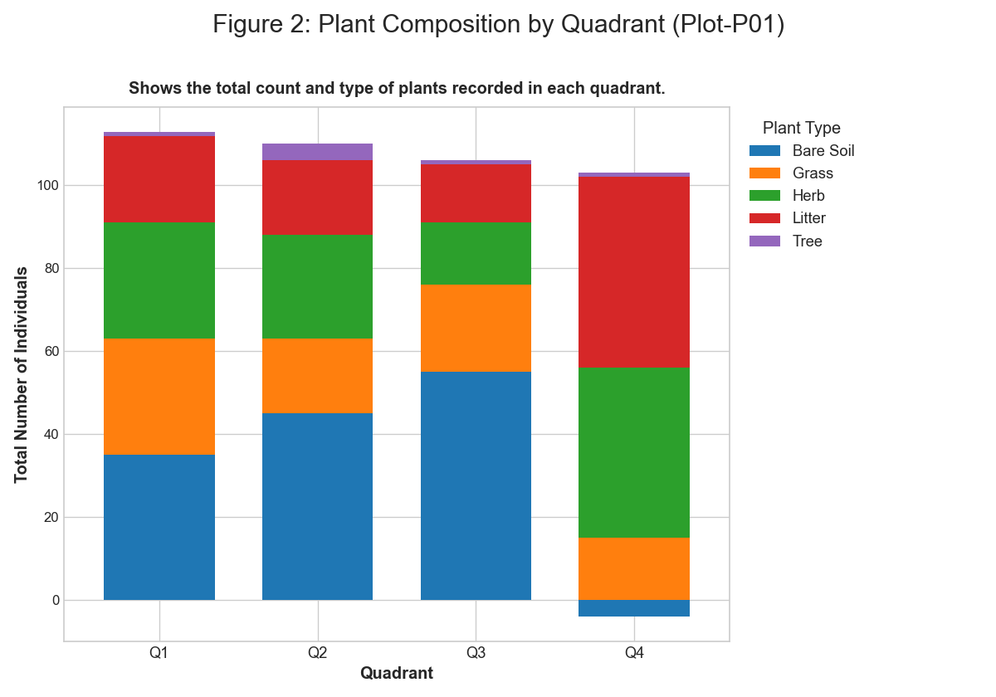 *Figure: figure 2 plant composition by quadrant*

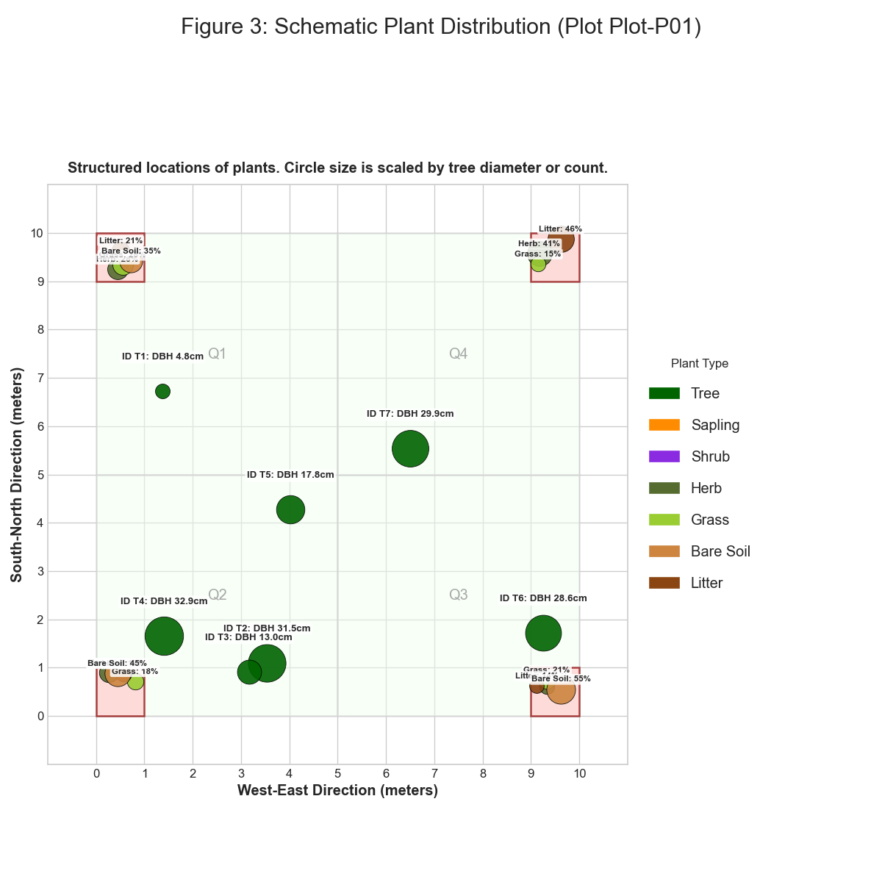 *Figure: figure 3 schematic plant distribution*

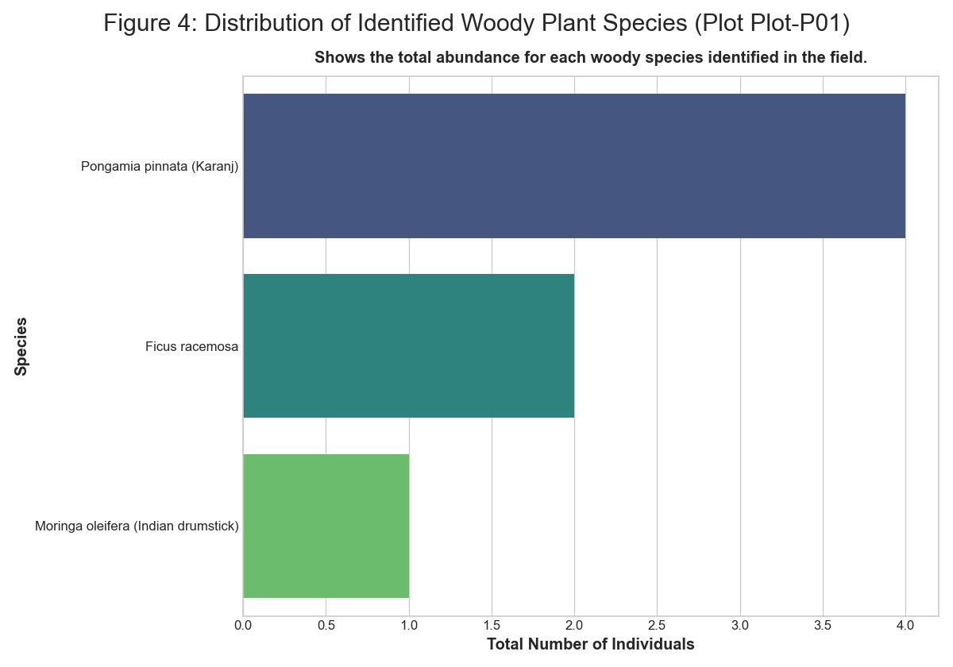 *Figure: figure 4 distribution of identified plant species*

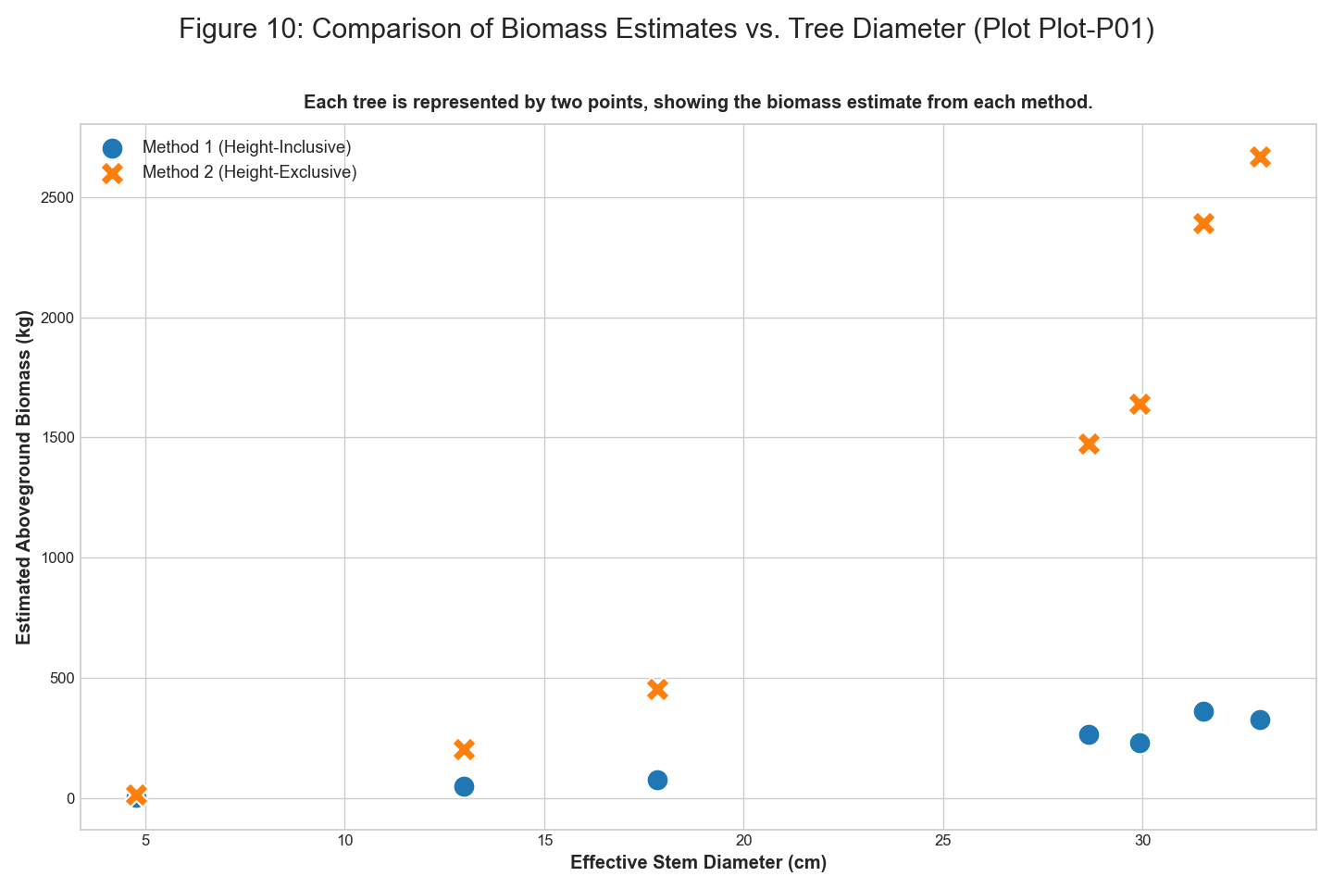 *Figure: figure 10 comparison of biomass estimates vs tree diameter*

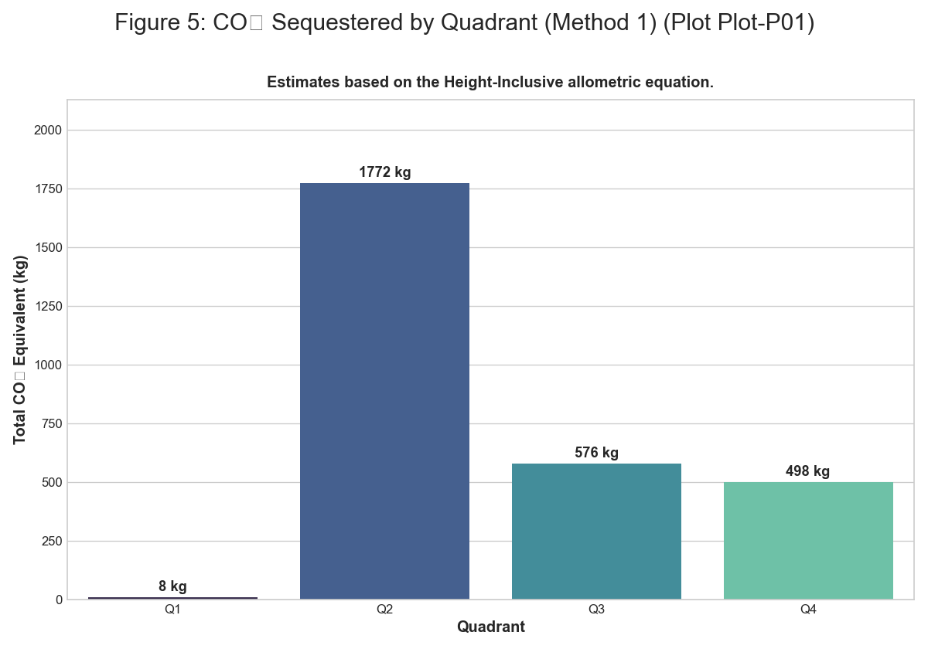 *Figure: figure 5 co2 sequestered by quadrant m1*

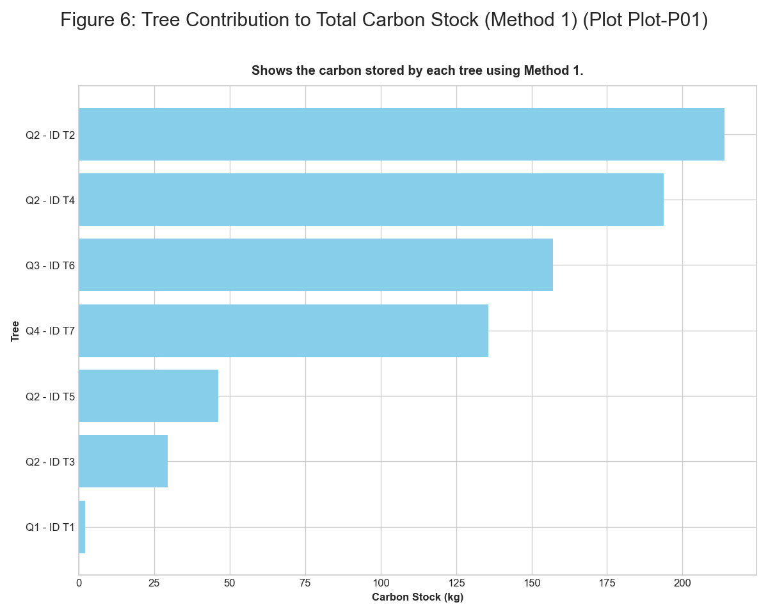 *Figure: figure 6 tree contribution to carbon stock m1*

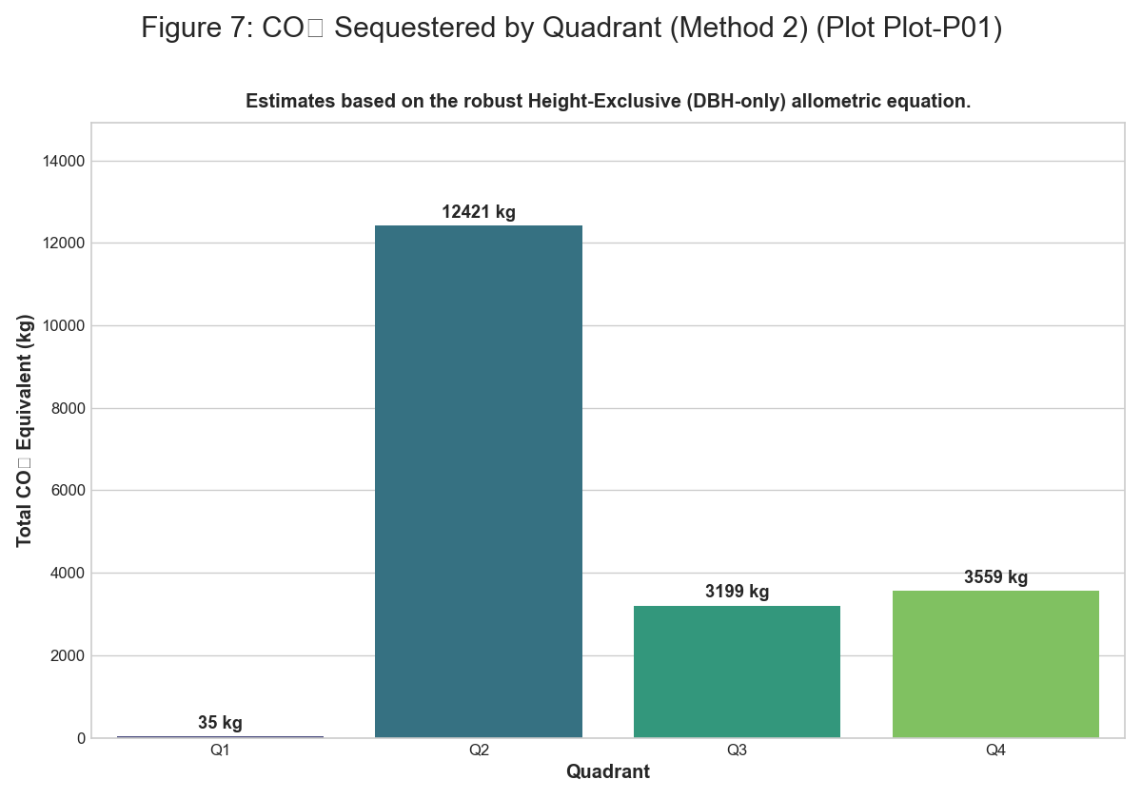 *Figure: figure 7 co2 sequestered by quadrant m2*

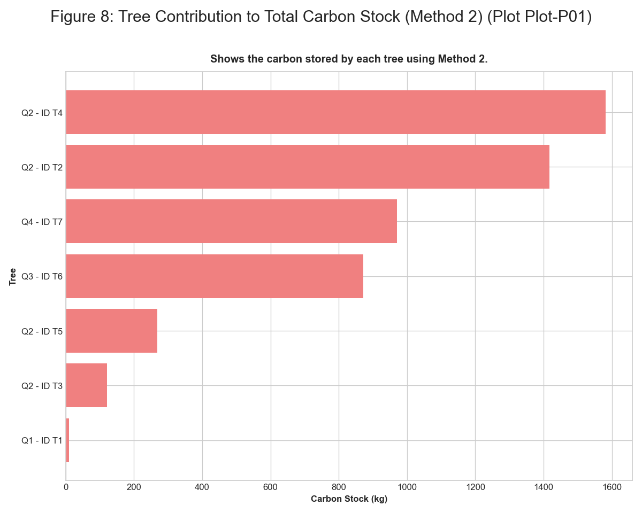 *Figure: figure 8 tree contribution to carbon stock m2*

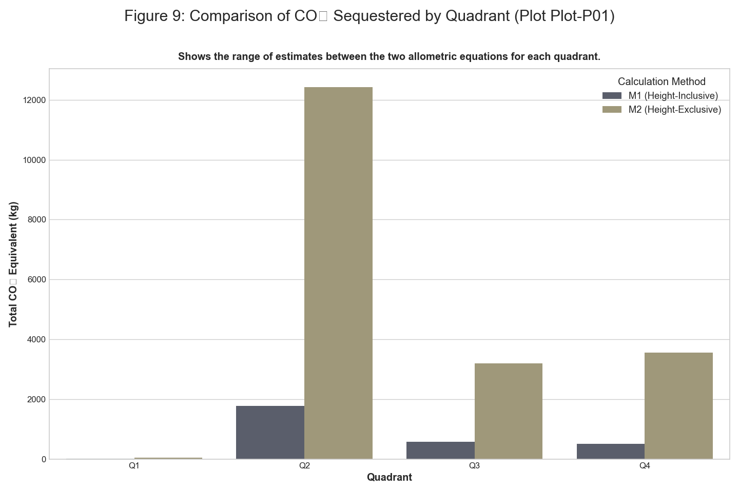 *Figure: figure 9 comparison of co2 sequestered by quadrant*

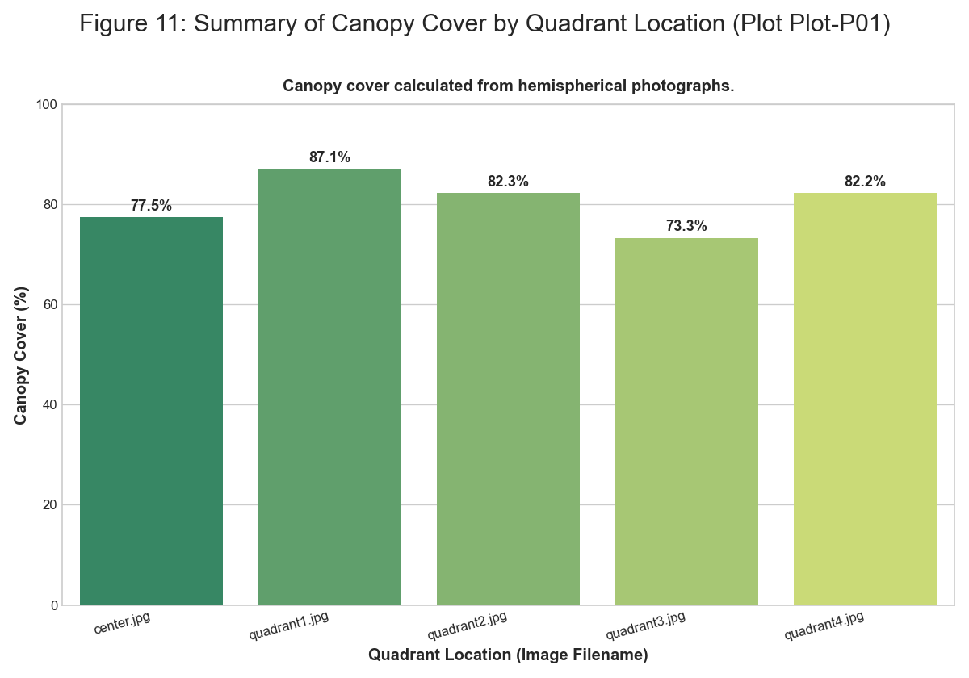 *Figure: figure 11 summary of canopy cover*

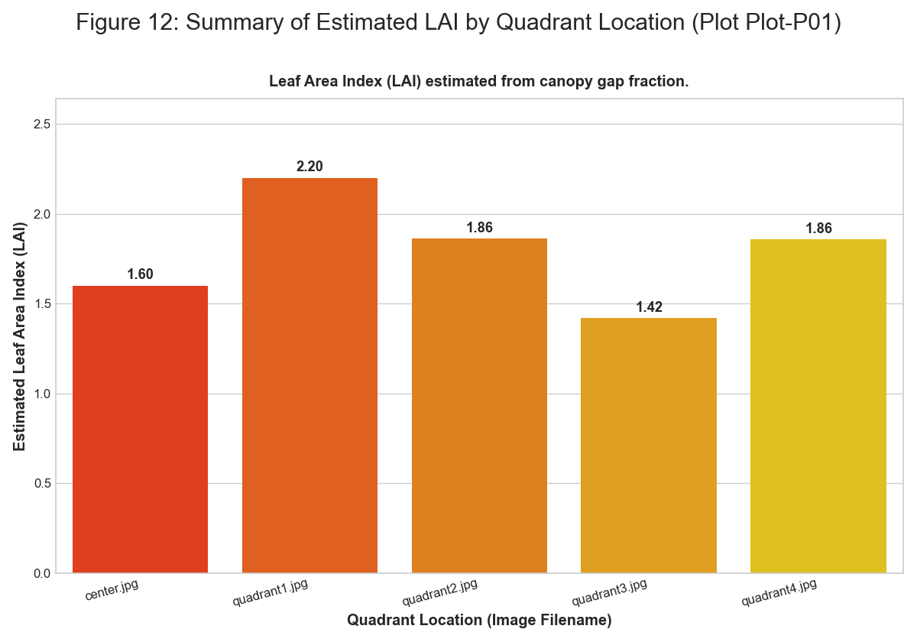 *Figure: figure 12 summary of estimated lai*

### Plot-P02

**Summary Statistics** | Quadrant | Type | Number | Species | |:———–|:———-|———:|:————————–| | Q1 | Tree | 1 | Azadirachta indica (Neem) | | Q1 | Tree | 1 | Caesalpinia pulcherrima | | Q2 | Tree | 1 | Hibiscus rosa-sinensis | | Q2 | Tree | 1 | Hibiscus rosa-sinensis | | Q2 | Tree | 1 | Hibiscus rosa-sinensis | | Q2 | Tree | 1 | Hibiscus rosa-sinensis | | Q3 | Tree | 1 | Hibiscus rosa-sinensis | | Q3 | Tree | 1 | Hibiscus rosa-sinensis | | Q3 | Tree | 1 | Hibiscus rosa-sinensis | | Q3 | Tree | 1 | Azadirachta indica (Neem) | | Q3 | Tree | 1 | Hibiscus rosa-sinensis | | Q3 | Tree | 1 | Hibiscus rosa-sinensis | | Q3 | Tree | 1 | Hibiscus rosa-sinensis | | Q3 | Tree | 1 | Hibiscus rosa-sinensis | | Q3 | Tree | 1 | Hibiscus rosa-sinensis | | Q4 | Tree | 1 | Caesalpinia pulcherrima | | Q4 | Tree | 1 | Caesalpinia pulcherrima | | Q4 | Tree | 1 | Caesalpinia pulcherrima | | Q1 | Herb | 13 | Mixed Herbs | | Q1 | Grass | 32 | Mixed Grasses | | Q1 | Litter | 17 | Decomposing Matter | | Q1 | Bare Soil | 46 | Bare Ground | | Q2 | Herb | 19 | Mixed Herbs | | Q2 | Grass | 26 | Mixed Grasses | | Q2 | Litter | 40 | Decomposing Matter | | Q2 | Bare Soil | 14 | Bare Ground | | Q3 | Herb | 22 | Mixed Herbs | | Q3 | Grass | 14 | Mixed Grasses | | Q3 | Litter | 44 | Decomposing Matter | | Q3 | Bare Soil | 35 | Bare Ground | | Q4 | Herb | 27 | Mixed Herbs | | Q4 | Grass | 22 | Mixed Grasses | | Q4 | Litter | 40 | Decomposing Matter | | Q4 | Bare Soil | 21 | Bare Ground |

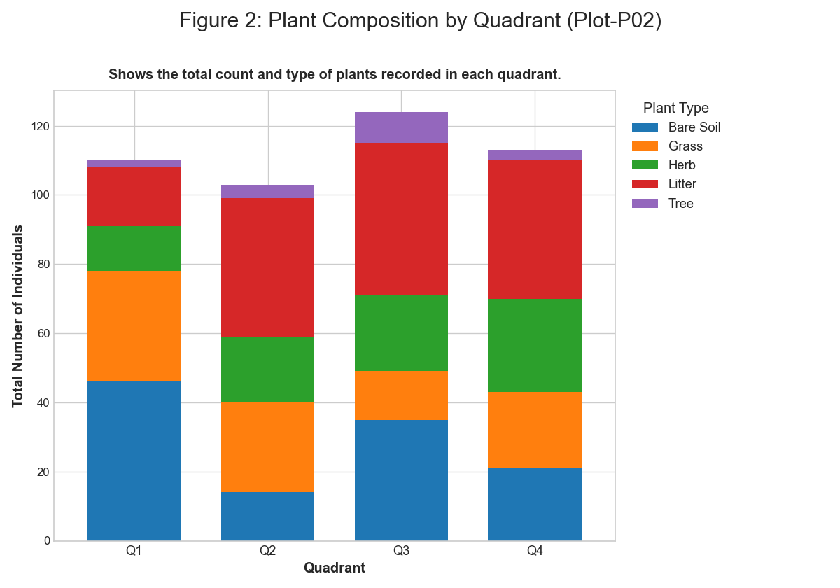 *Figure: figure 2 plant composition by quadrant*

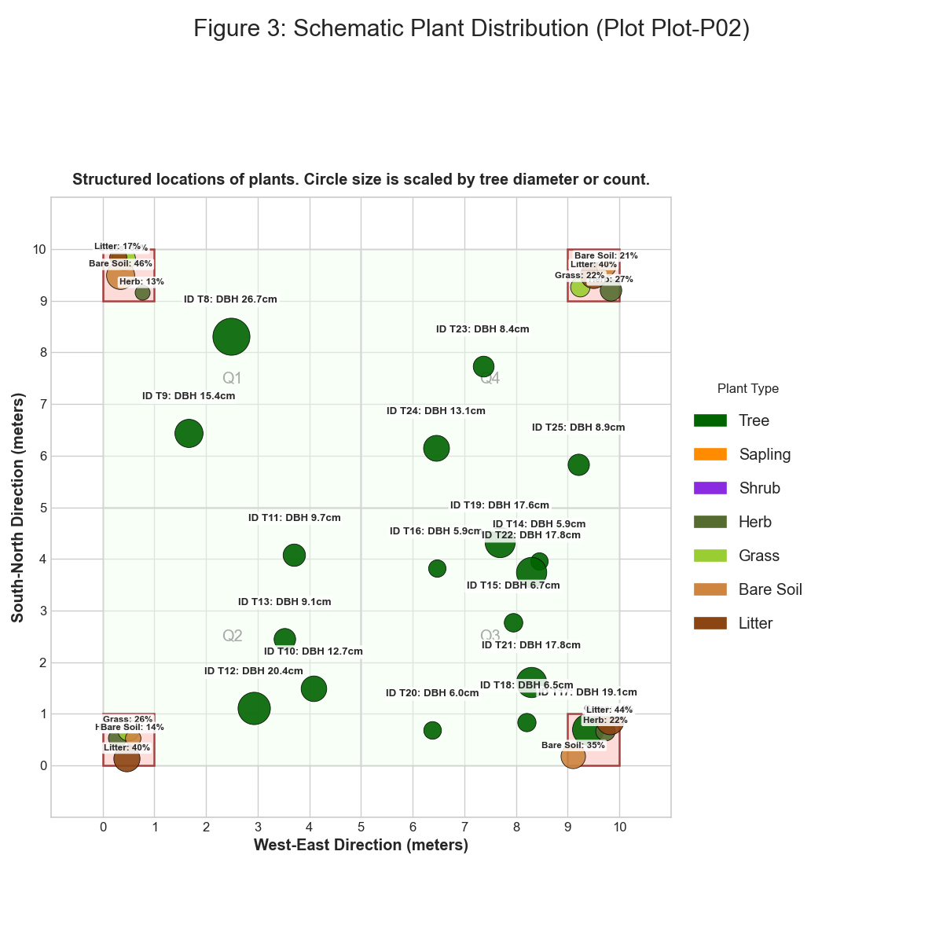 *Figure: figure 3 schematic plant distribution*

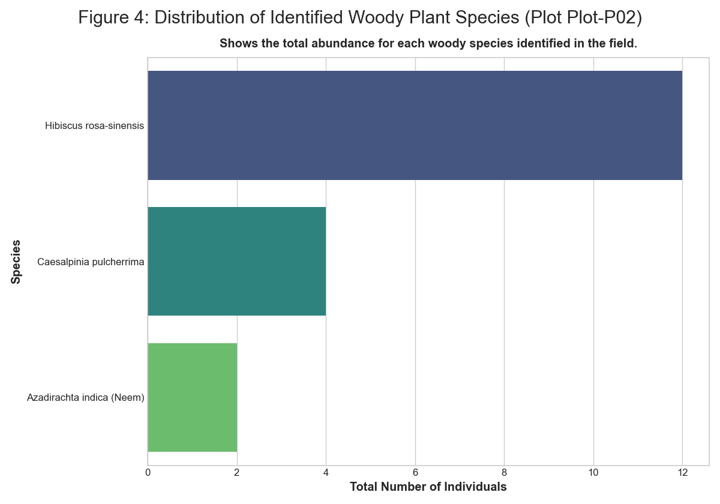 *Figure: figure 4 distribution of identified plant species*

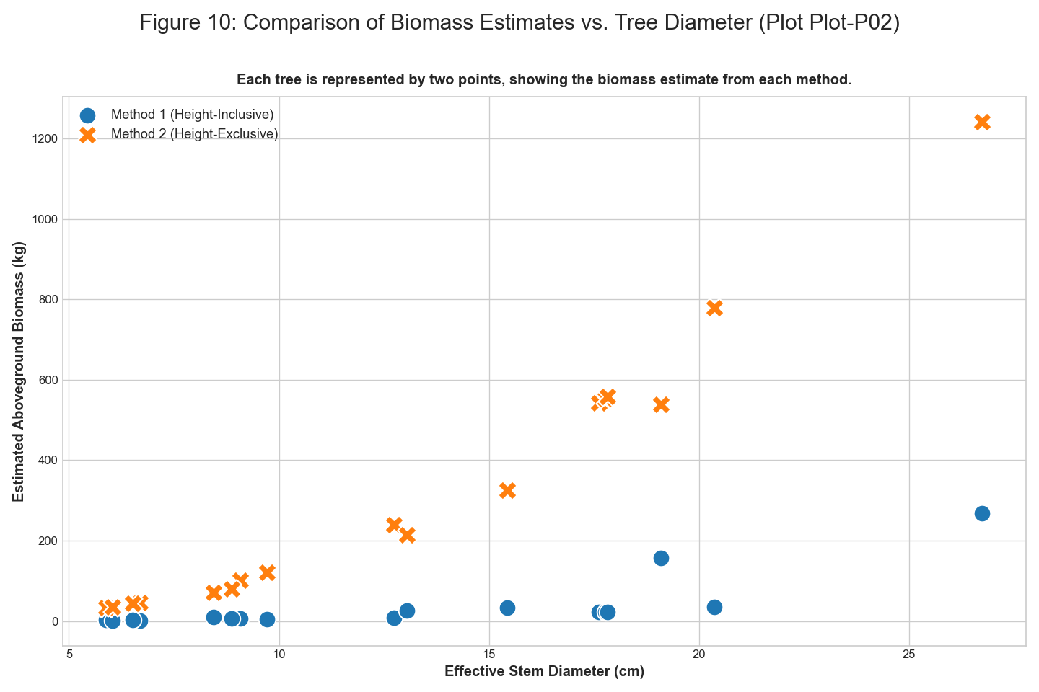 *Figure: figure 10 comparison of biomass estimates vs tree diameter*

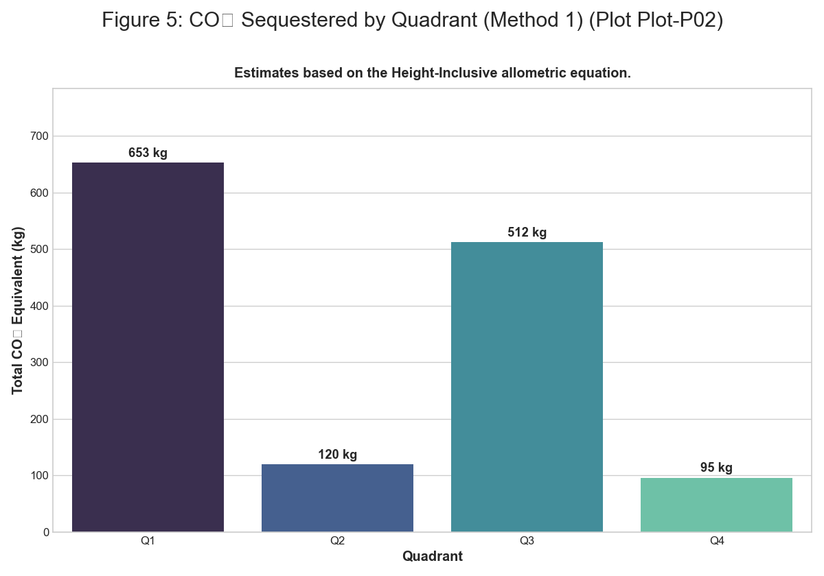 *Figure: figure 5 co2 sequestered by quadrant m1*

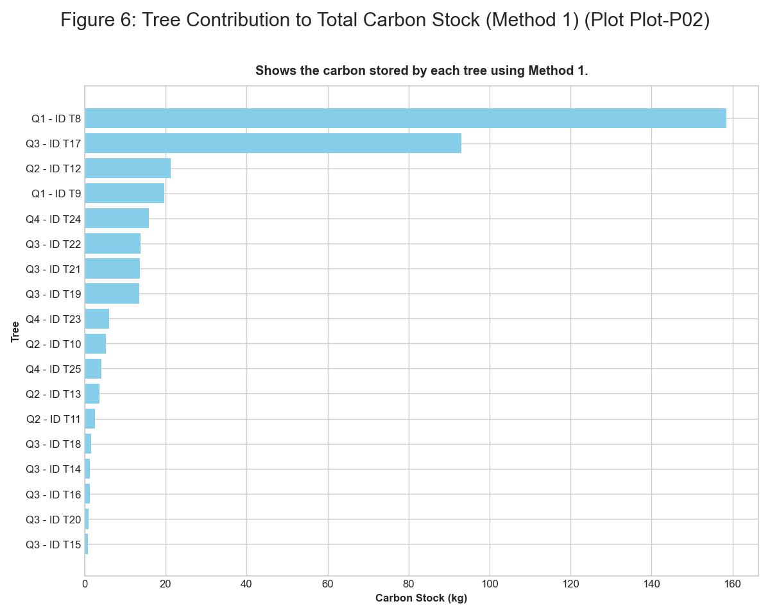 *Figure: figure 6 tree contribution to carbon stock m1*

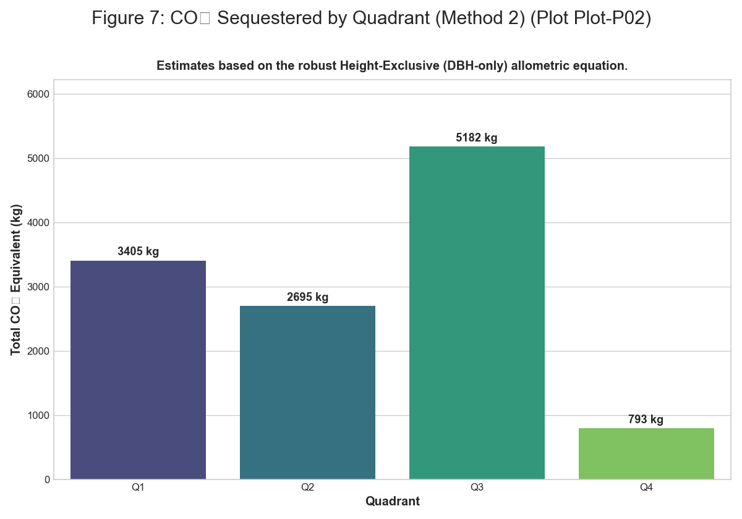 *Figure: figure 7 co2 sequestered by quadrant m2*

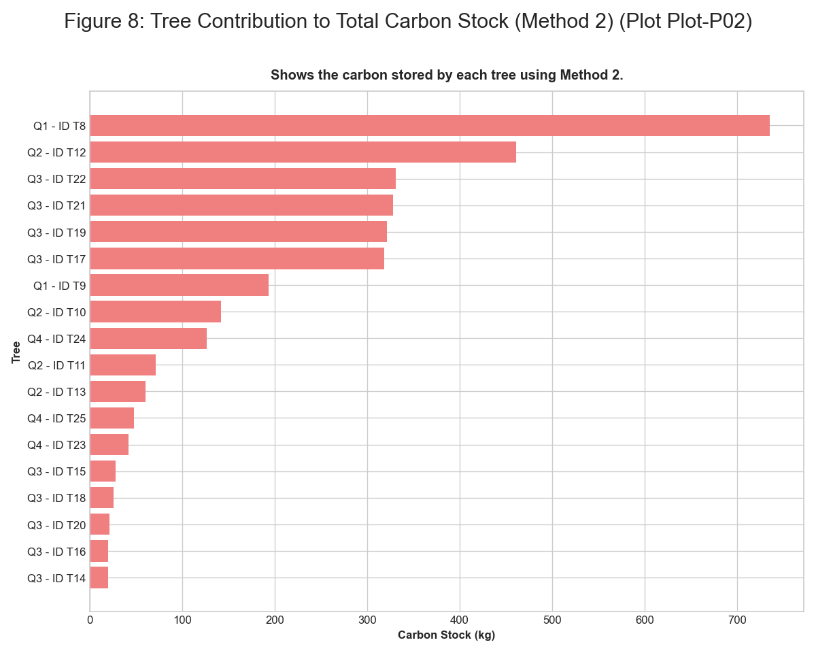 *Figure: figure 8 tree contribution to carbon stock m2*

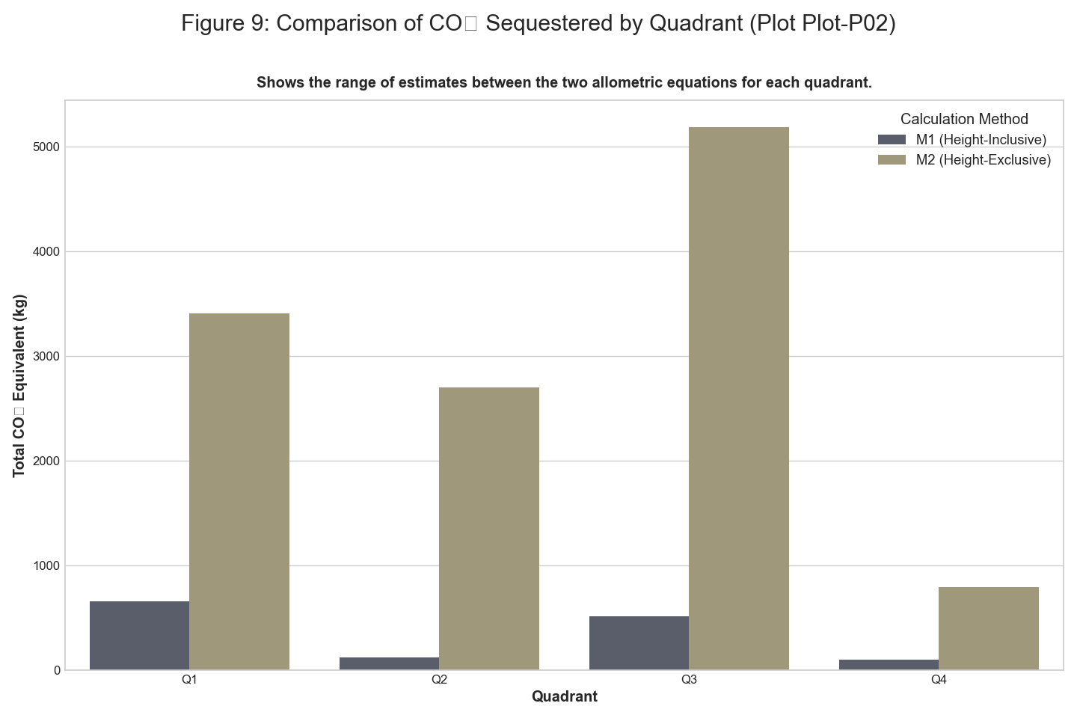 *Figure: figure 9 comparison of co2 sequestered by quadrant*

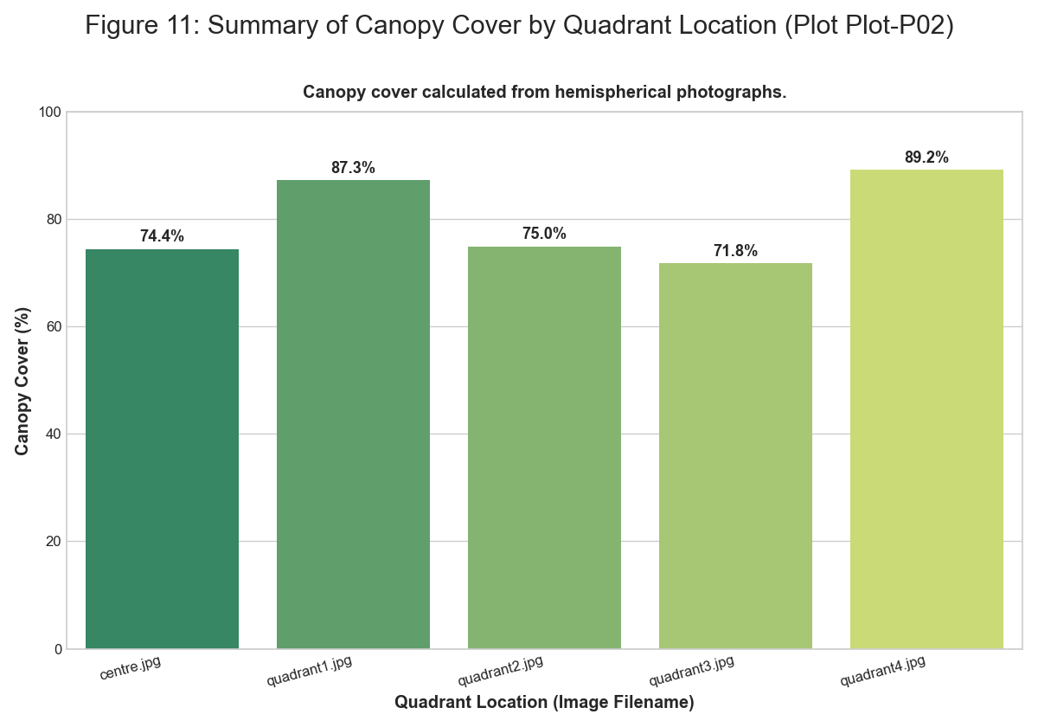 *Figure: figure 11 summary of canopy cover*

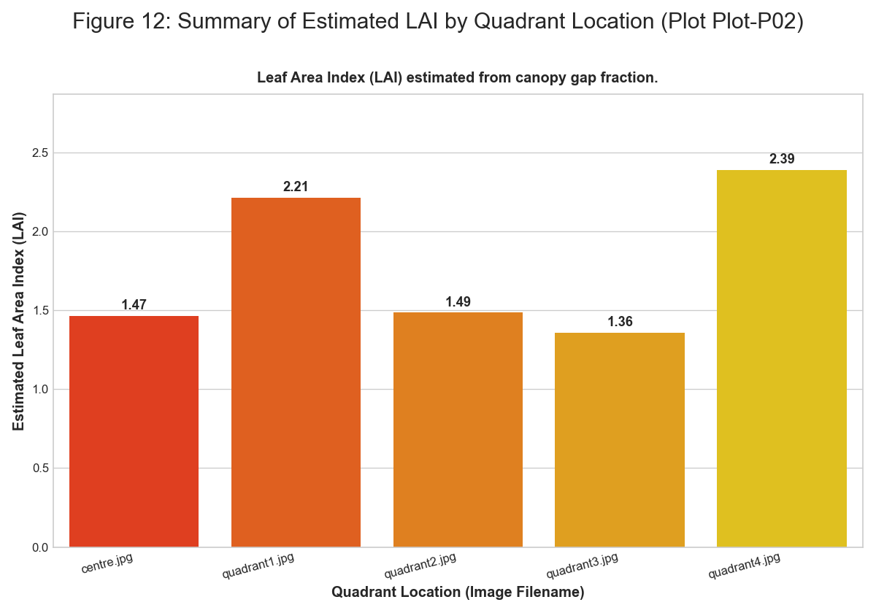 *Figure: figure 12 summary of estimated lai*

### Plot-P03

**Summary Statistics** | Quadrant | Type | Number | Species | |:———–|:———-|———:|:—————————| | Q1 | Tree | 1 | Gliricidia sepium | | Q2 | Tree | 1 | Gliricidia sepium | | Q2 | Tree | 1 | Boswellia serrata | | Q3 | Tree | 1 | Terminalia elliptica (Ain) | | Q4 | Tree | 1 | Anogeissus latifolia | | Q1 | Herb | 24 | Mixed Herbs | | Q1 | Grass | 14 | Mixed Grasses | | Q1 | Litter | 50 | Decomposing Matter | | Q1 | Bare Soil | 10 | Bare Ground | | Q2 | Herb | 12 | Mixed Herbs | | Q2 | Grass | 19 | Mixed Grasses | | Q2 | Litter | 23 | Decomposing Matter | | Q2 | Bare Soil | 45 | Bare Ground | | Q3 | Herb | 12 | Mixed Herbs | | Q3 | Grass | 13 | Mixed Grasses | | Q3 | Litter | 19 | Decomposing Matter | | Q3 | Bare Soil | 51 | Bare Ground | | Q4 | Herb | 36 | Mixed Herbs | | Q4 | Grass | 23 | Mixed Grasses | | Q4 | Litter | 42 | Decomposing Matter | | Q4 | Bare Soil | 11 | Bare Ground |

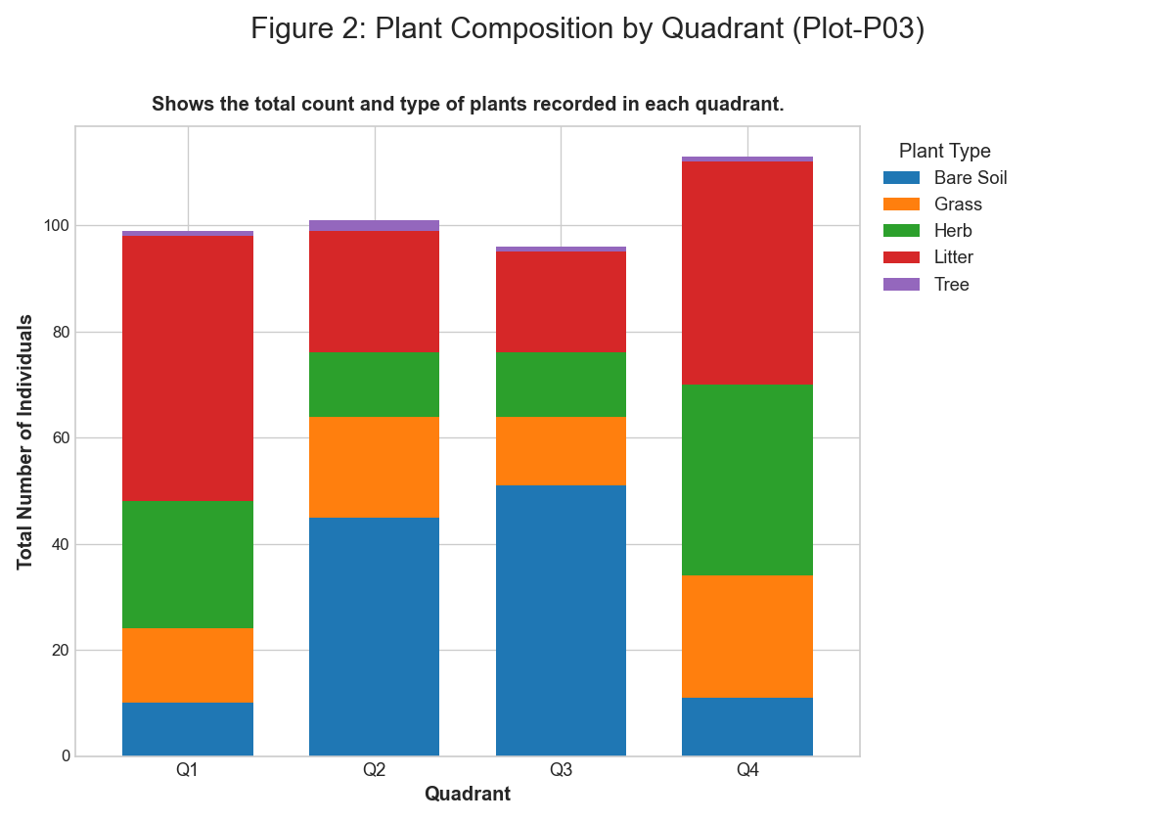 *Figure: figure 2 plant composition by quadrant*

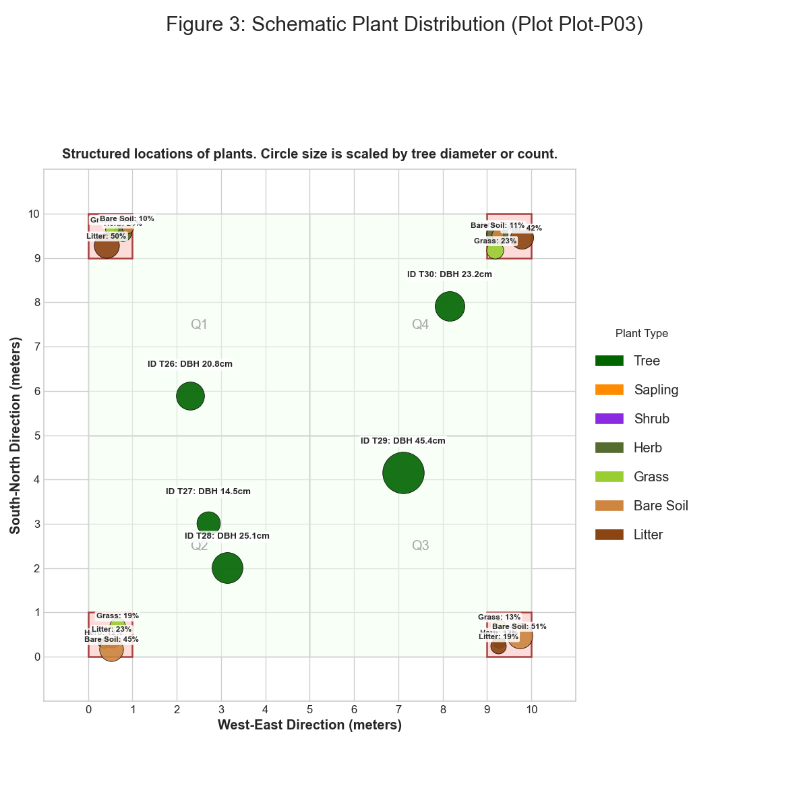 *Figure: figure 3 schematic plant distribution*

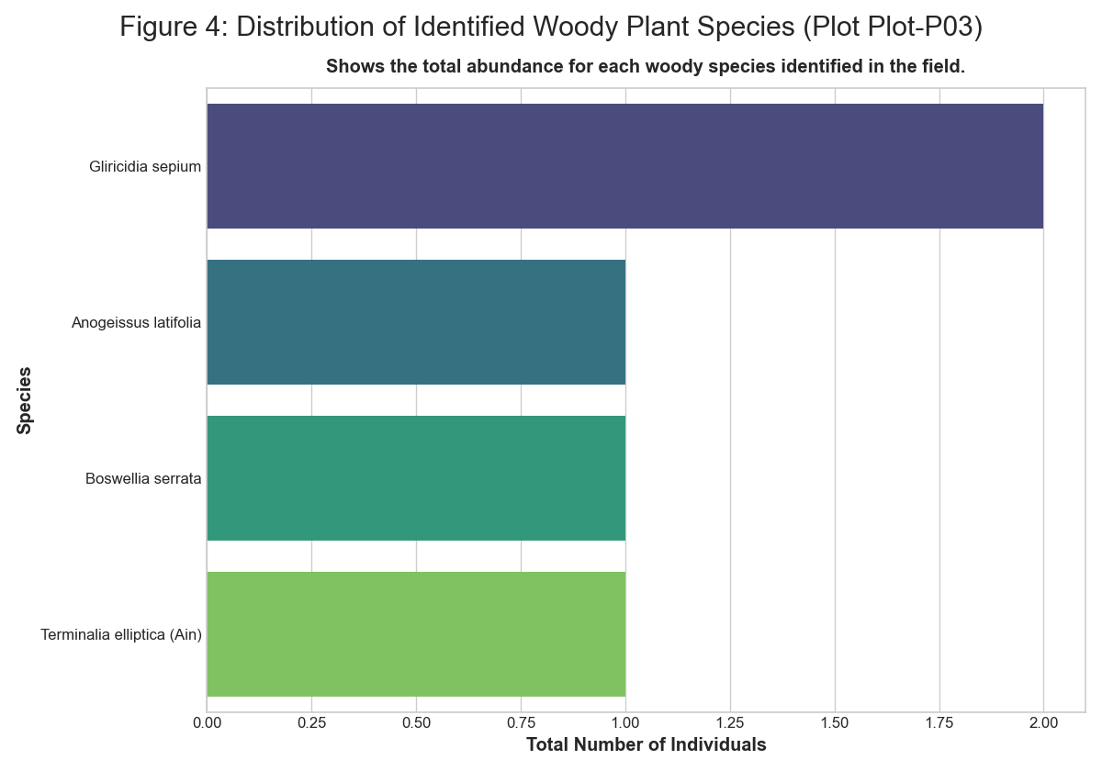 *Figure: figure 4 distribution of identified plant species*

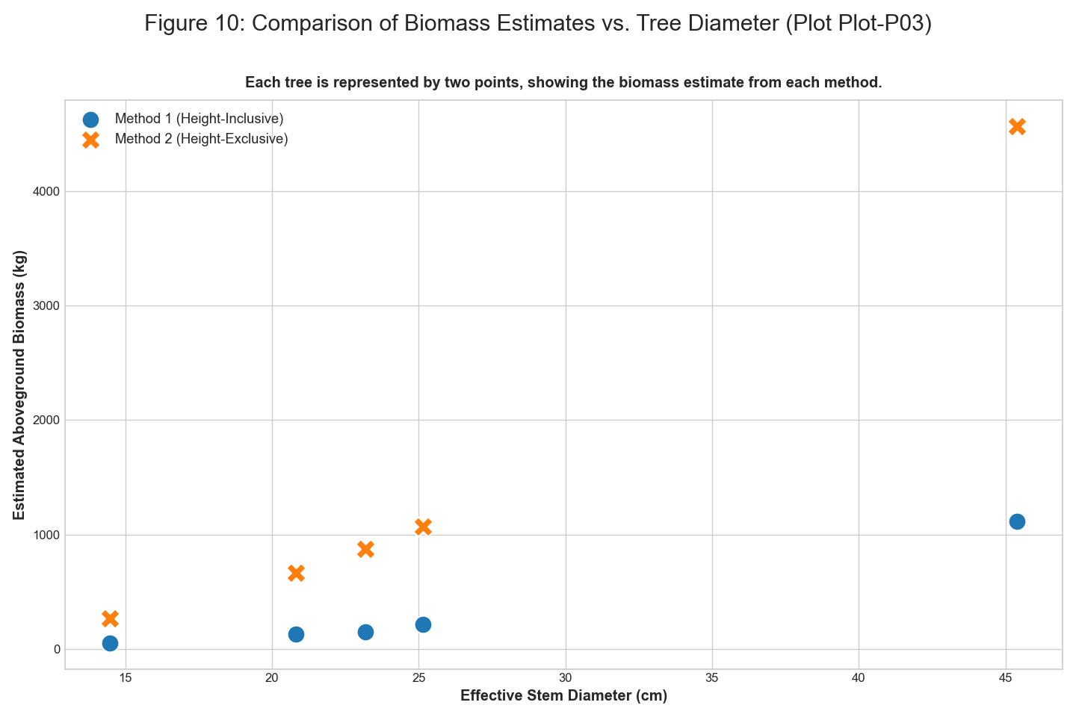 *Figure: figure 10 comparison of biomass estimates vs tree diameter*

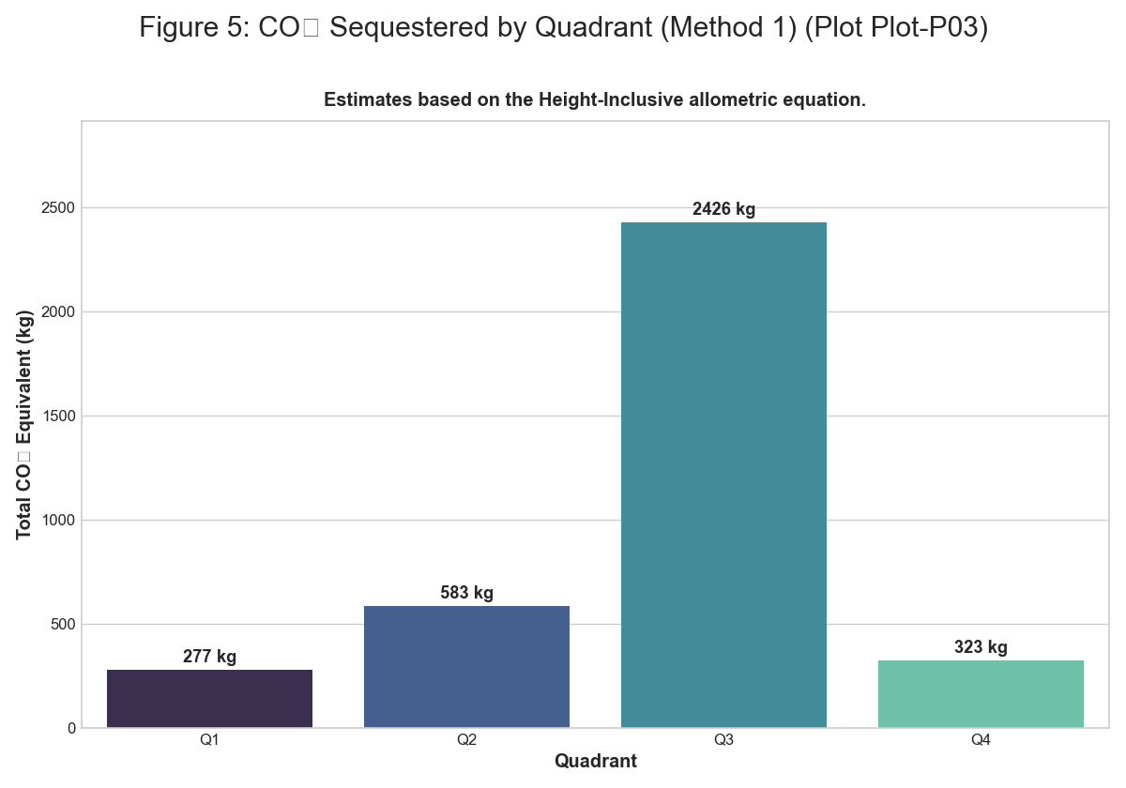 *Figure: figure 5 co2 sequestered by quadrant m1*

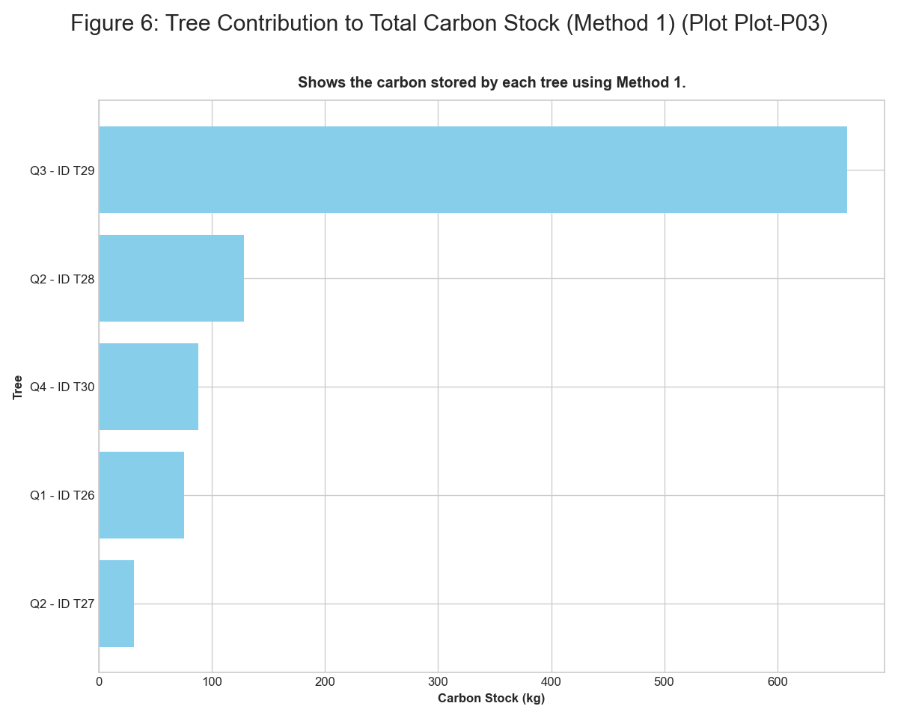 *Figure: figure 6 tree contribution to carbon stock m1*

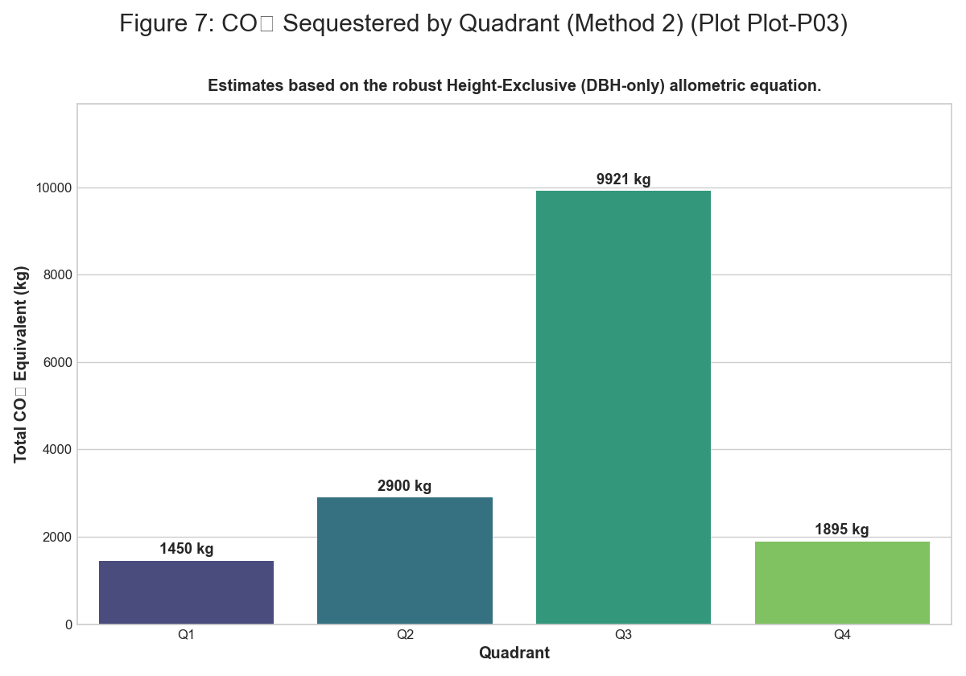 *Figure: figure 7 co2 sequestered by quadrant m2*

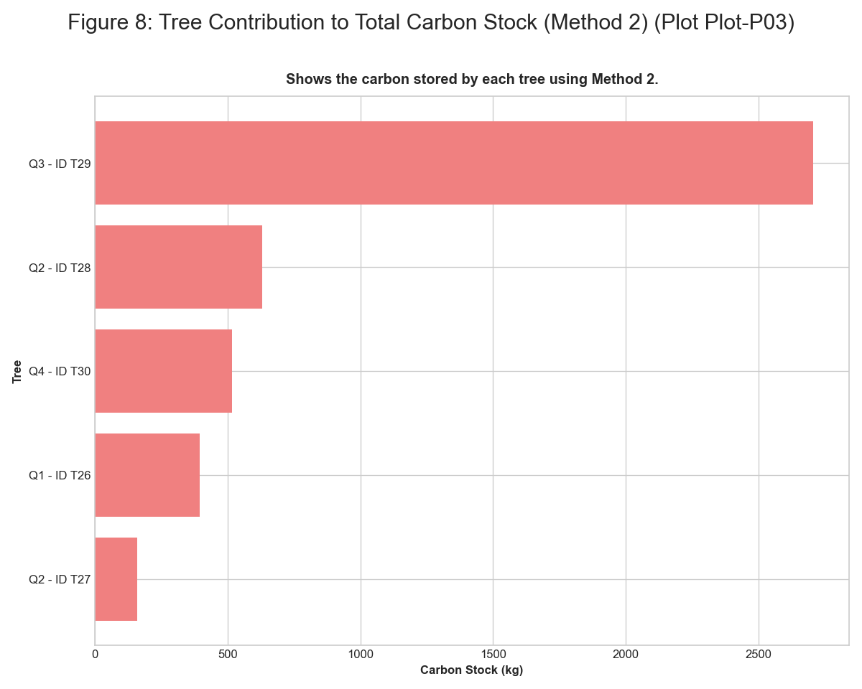 *Figure: figure 8 tree contribution to carbon stock m2*

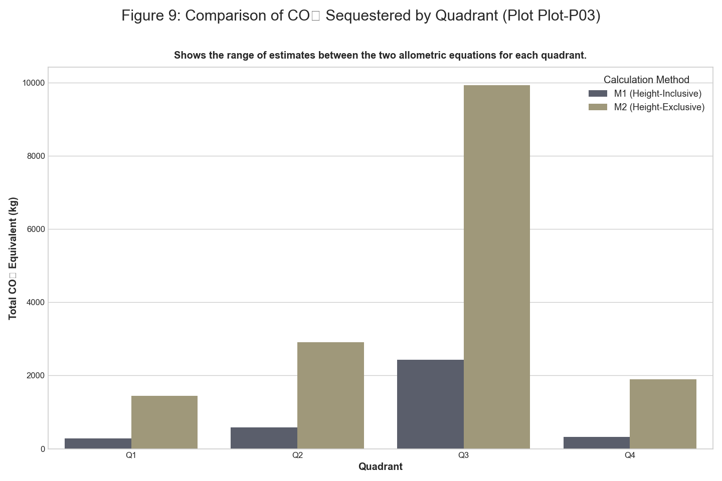 *Figure: figure 9 comparison of co2 sequestered by quadrant*

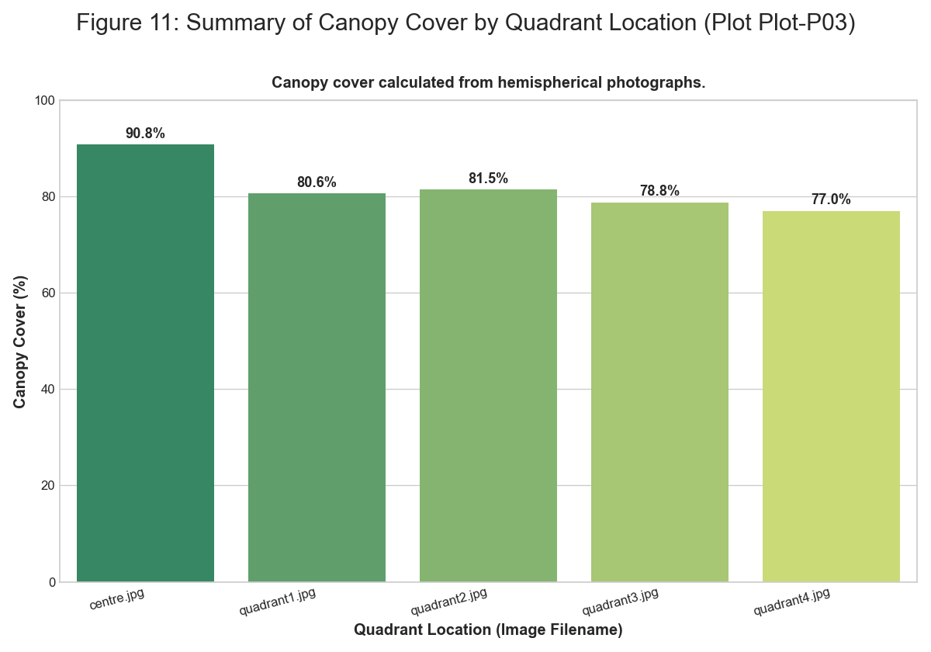 *Figure: figure 11 summary of canopy cover*

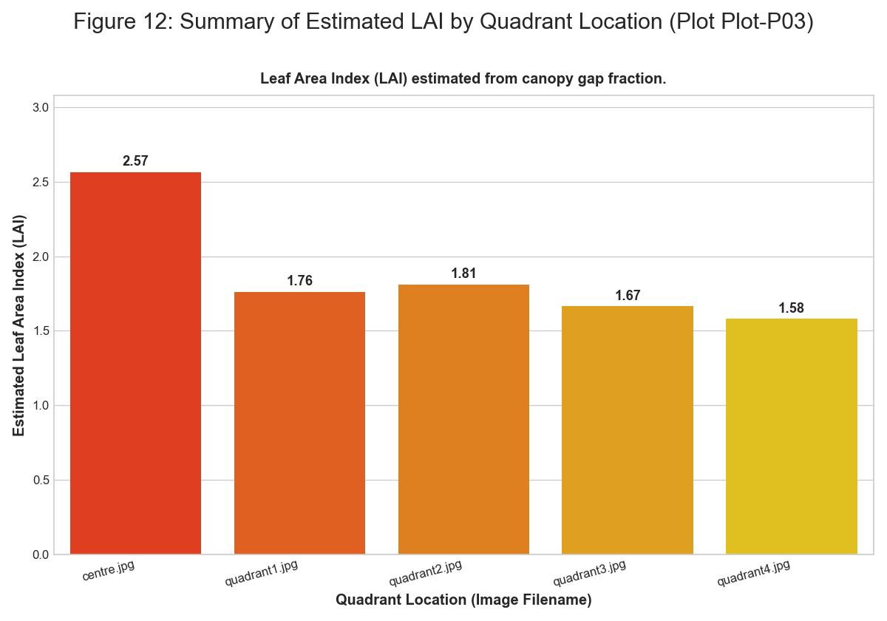 *Figure: figure 12 summary of estimated lai*

### Plot-P04

**Summary Statistics** | Quadrant | Type | Number | Species | |:———–|:———-|———:|:——————-| | Q1 | Tree | 1 | Gliricidia sepium | | Q2 | Tree | 1 | Gliricidia sepium | | Q3 | Tree | 1 | Boswellia serrata | | Q4 | Tree | 1 | Ficus racemosa | | Q1 | Herb | 14 | Mixed Herbs | | Q1 | Grass | 27 | Mixed Grasses | | Q1 | Litter | 43 | Decomposing Matter | | Q1 | Bare Soil | 22 | Bare Ground | | Q2 | Herb | 12 | Mixed Herbs | | Q2 | Grass | 13 | Mixed Grasses | | Q2 | Litter | 46 | Decomposing Matter | | Q2 | Bare Soil | 40 | Bare Ground | | Q3 | Herb | 45 | Mixed Herbs | | Q3 | Grass | 18 | Mixed Grasses | | Q3 | Litter | 22 | Decomposing Matter | | Q3 | Bare Soil | 13 | Bare Ground | | Q4 | Herb | 23 | Mixed Herbs | | Q4 | Grass | 24 | Mixed Grasses | | Q4 | Litter | 20 | Decomposing Matter | | Q4 | Bare Soil | 44 | Bare Ground |

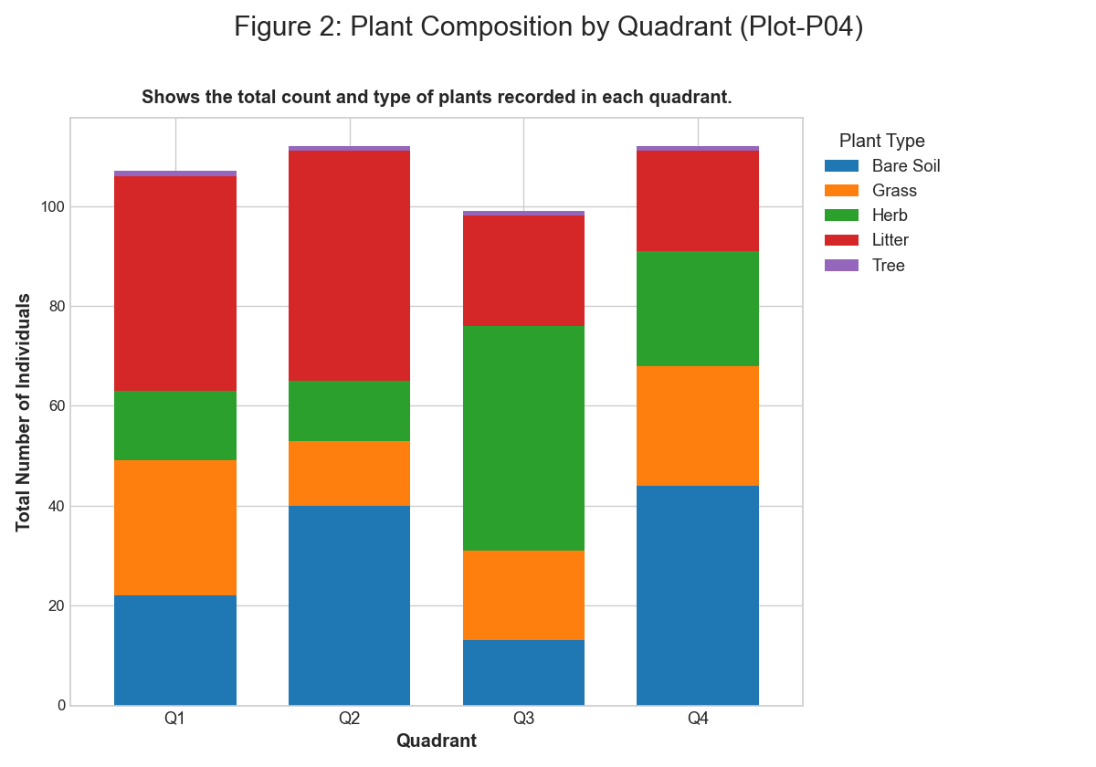 *Figure: figure 2 plant composition by quadrant*

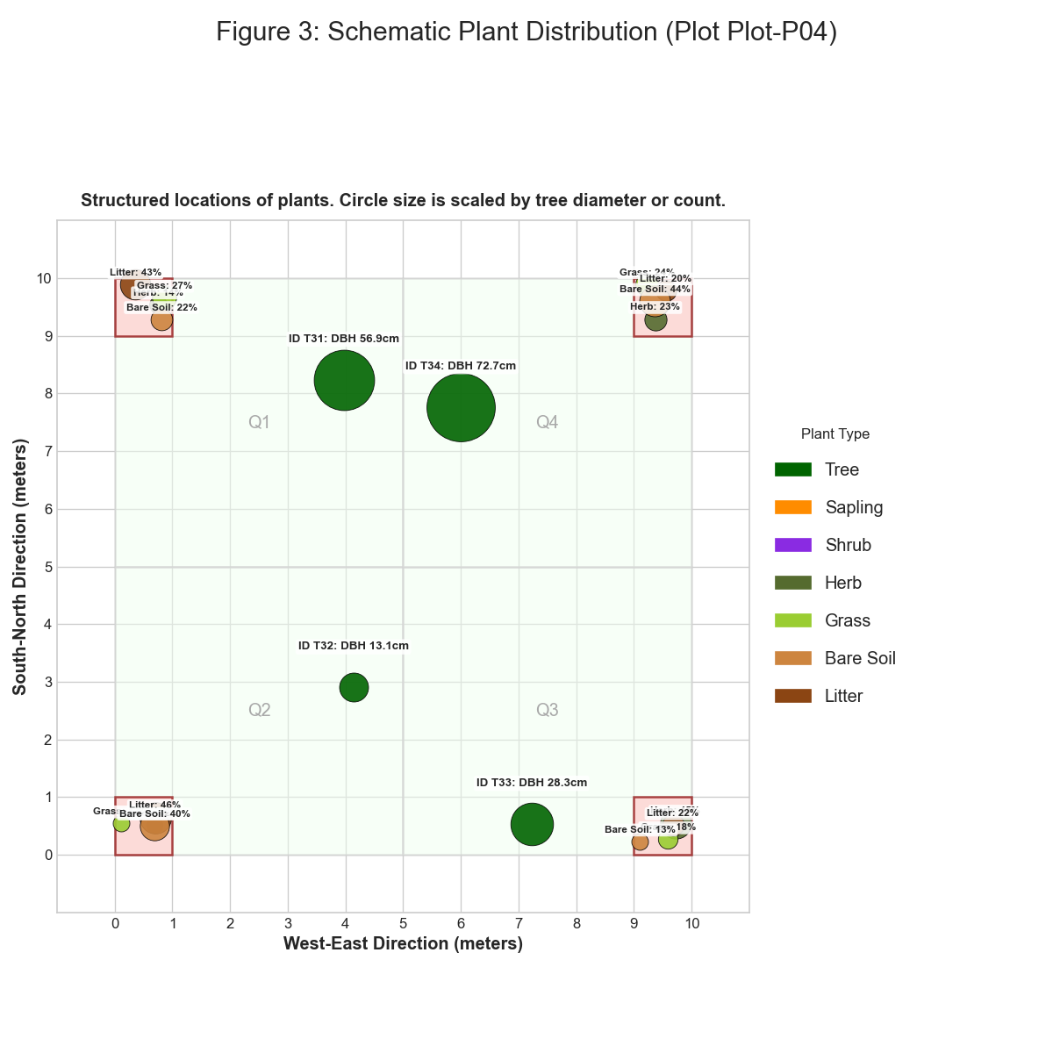 *Figure: figure 3 schematic plant distribution*

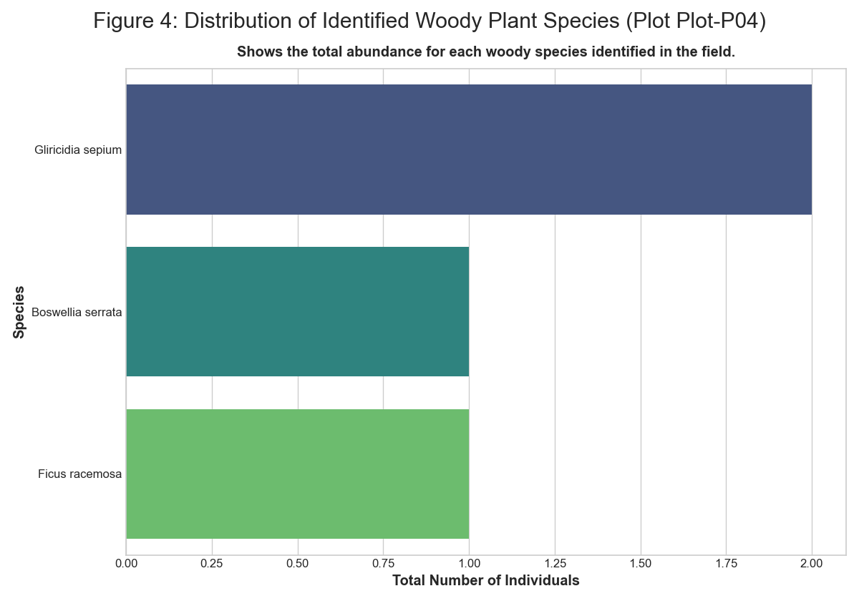 *Figure: figure 4 distribution of identified plant species*

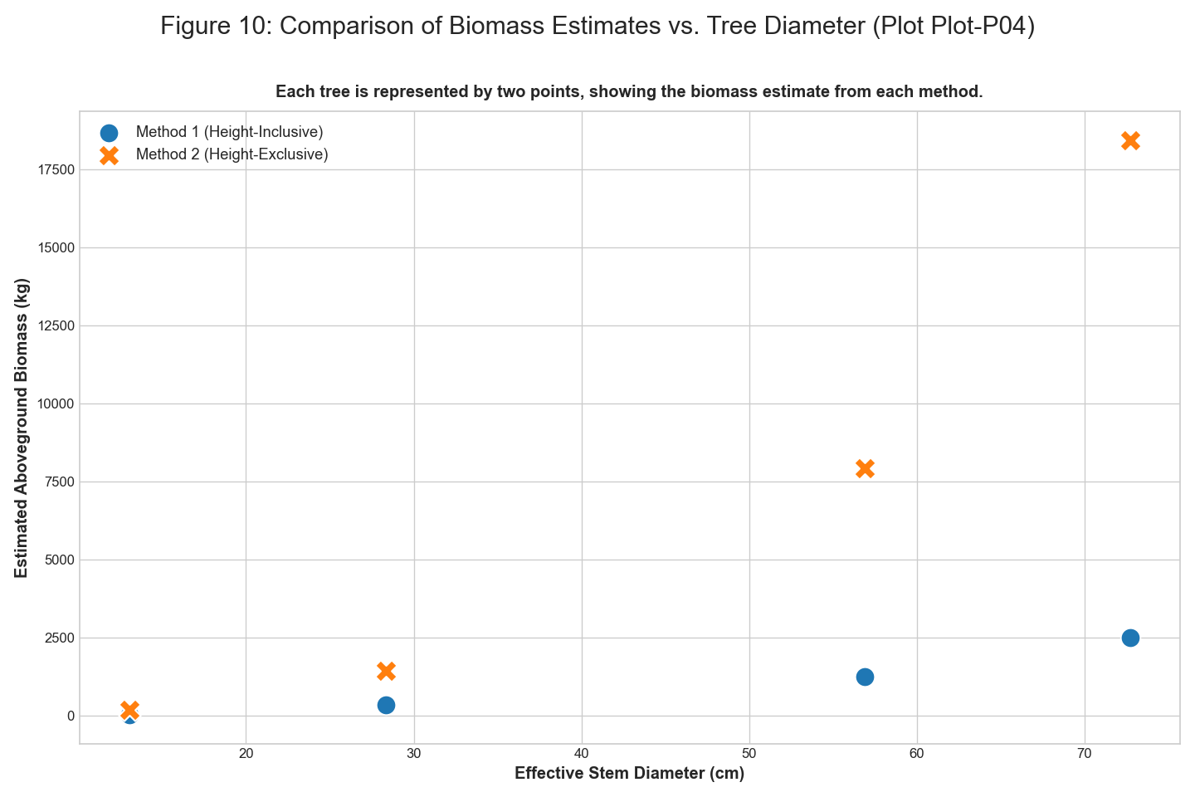 *Figure: figure 10 comparison of biomass estimates vs tree diameter*

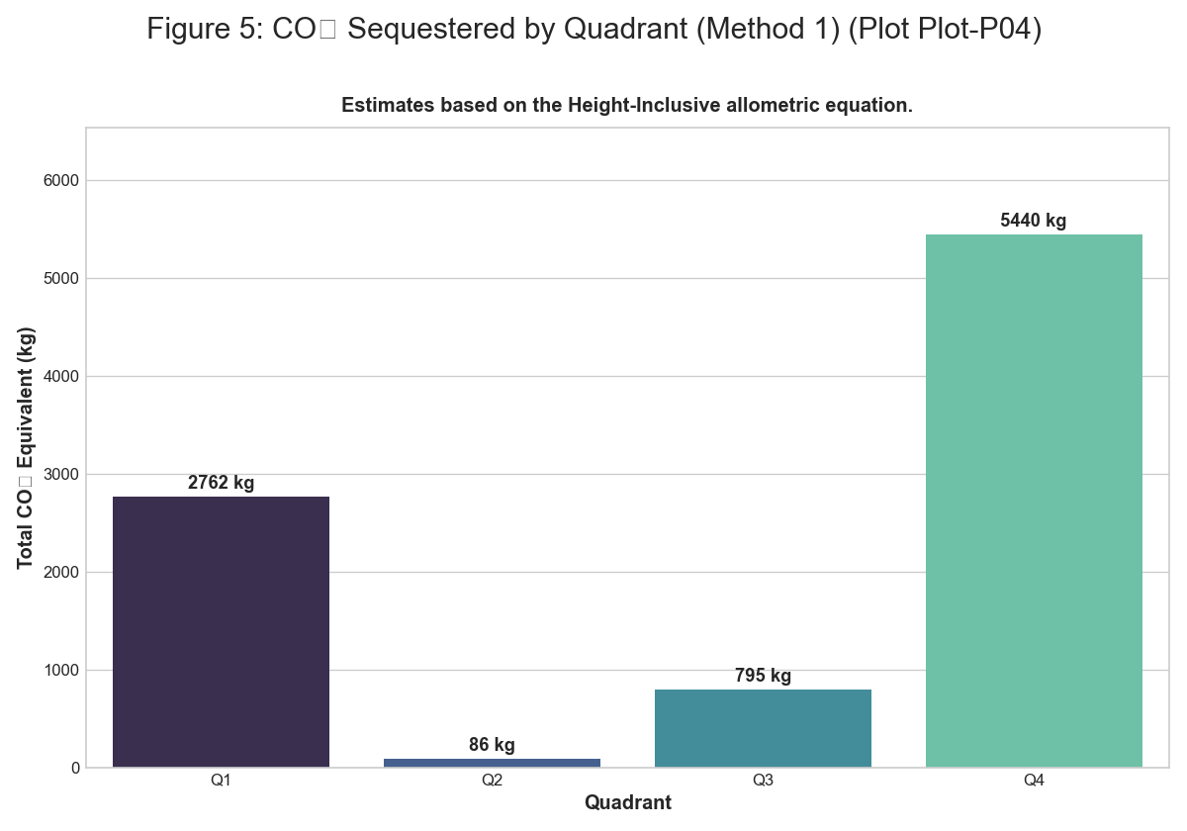 *Figure: figure 5 co2 sequestered by quadrant m1*

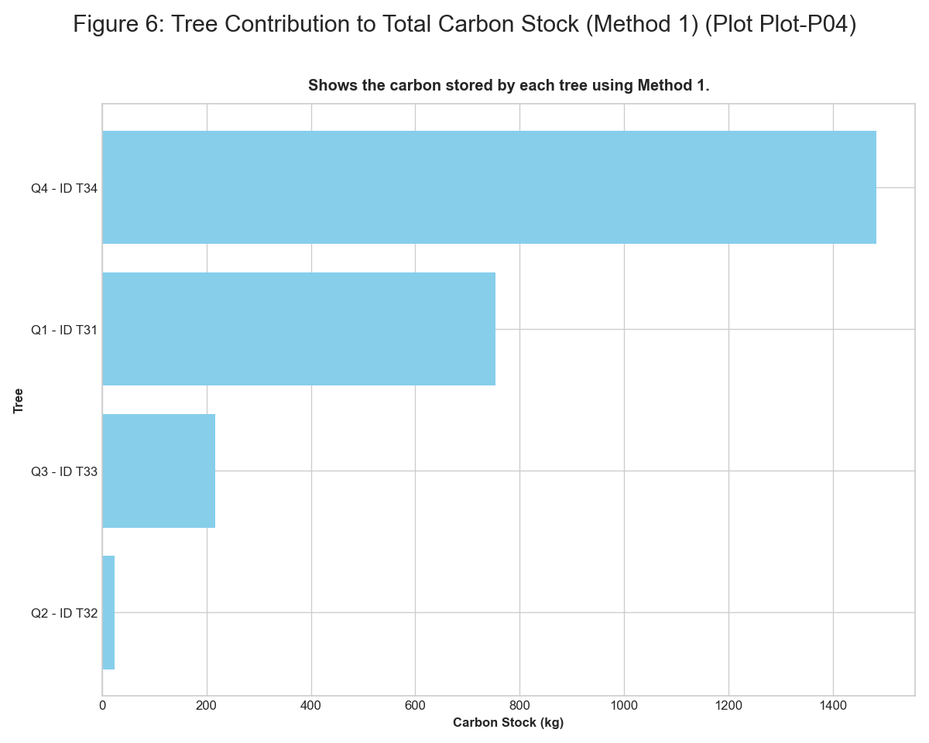 *Figure: figure 6 tree contribution to carbon stock m1*

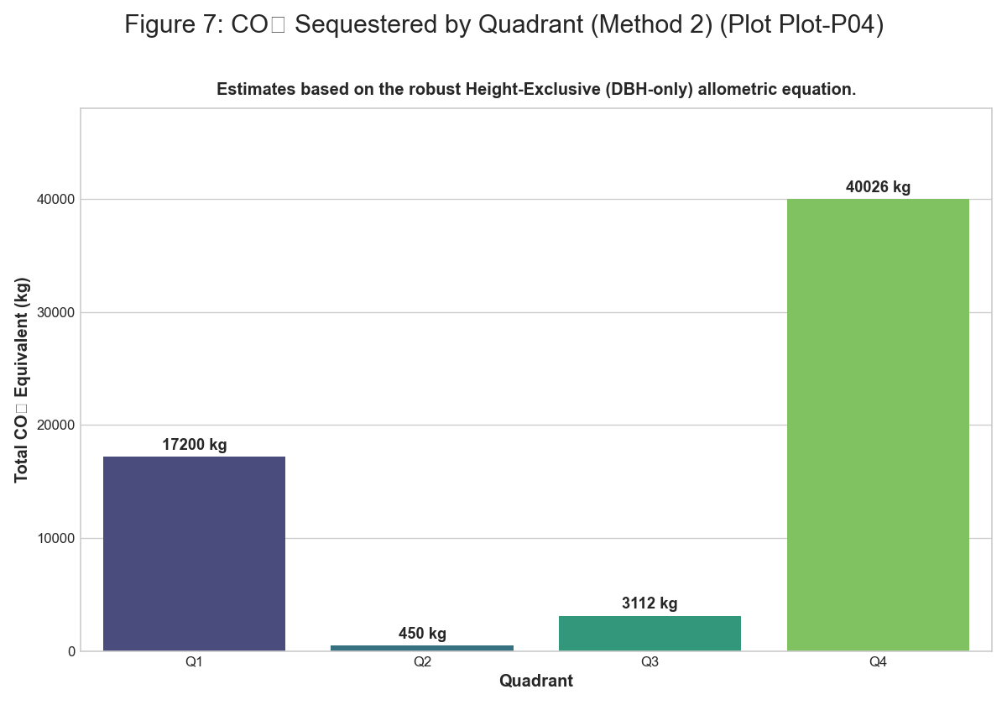 *Figure: figure 7 co2 sequestered by quadrant m2*

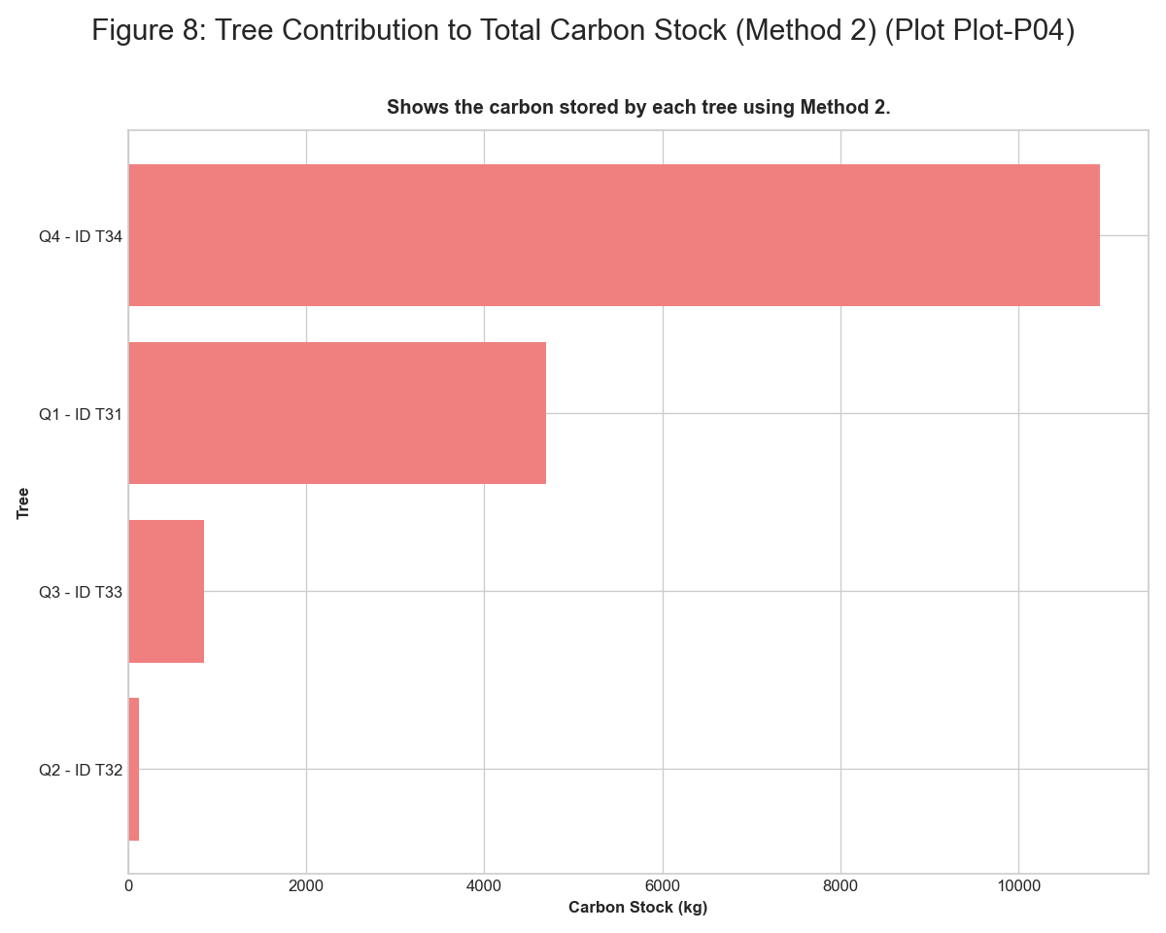 *Figure: figure 8 tree contribution to carbon stock m2*

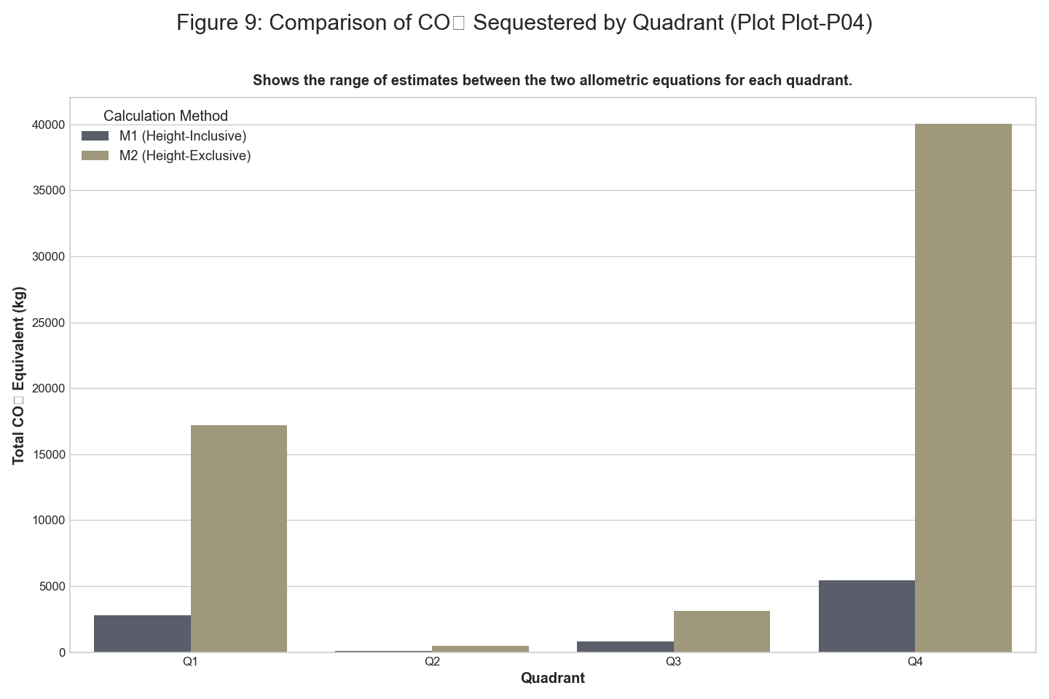 *Figure: figure 9 comparison of co2 sequestered by quadrant*

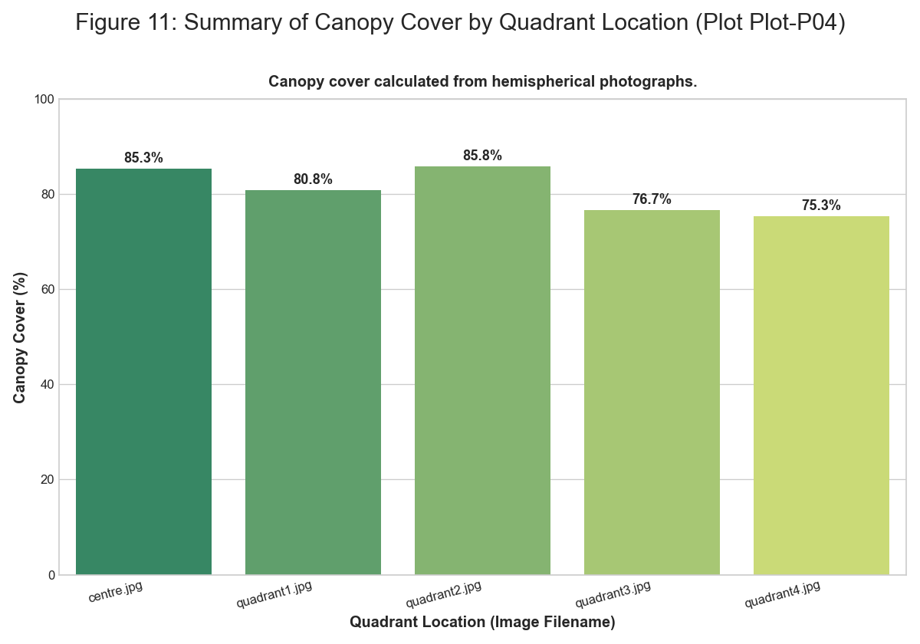 *Figure: figure 11 summary of canopy cover*

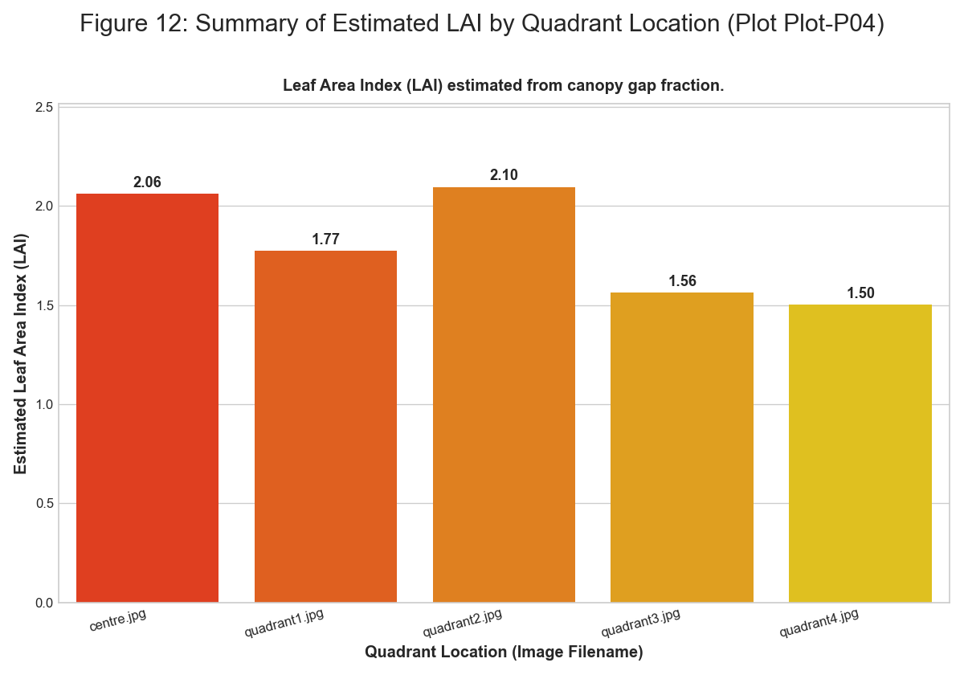 *Figure: figure 12 summary of estimated lai*

### Plot-P05

**Summary Statistics** | Quadrant | Type | Number | Species | |:———–|:———-|———:|:—————————| | Q1 | Tree | 1 | Syzygium cumini (Jambul) | | Q1 | Tree | 1 | Terminalia elliptica (Ain) | | Q1 | Tree | 1 | Ficus racemosa | | Q2 | Tree | 1 | Garcinia indica (Kokum) | | Q2 | Tree | 1 | Phyllanthus emblica (Amla) | | Q2 | Tree | 1 | Mangifera indica | | Q3 | Tree | 1 | Ficus benghalensis | | Q3 | Tree | 1 | Alstonia scholaris | | Q4 | Tree | 1 | Mallotus philippensis | | Q4 | Tree | 1 | Syzygium caryophyllatum | | Q1 | Herb | 31 | Mixed Herbs | | Q1 | Grass | 21 | Mixed Grasses | | Q1 | Litter | 14 | Decomposing Matter | | Q1 | Bare Soil | 30 | Bare Ground | | Q2 | Herb | 32 | Mixed Herbs | | Q2 | Grass | 12 | Mixed Grasses | | Q2 | Litter | 20 | Decomposing Matter | | Q2 | Bare Soil | 45 | Bare Ground | | Q3 | Herb | 32 | Mixed Herbs | | Q3 | Grass | 23 | Mixed Grasses | | Q3 | Litter | 39 | Decomposing Matter | | Q3 | Bare Soil | 5 | Bare Ground | | Q4 | Herb | 35 | Mixed Herbs | | Q4 | Grass | 17 | Mixed Grasses | | Q4 | Litter | 46 | Decomposing Matter | | Q4 | Bare Soil | 17 | Bare Ground |

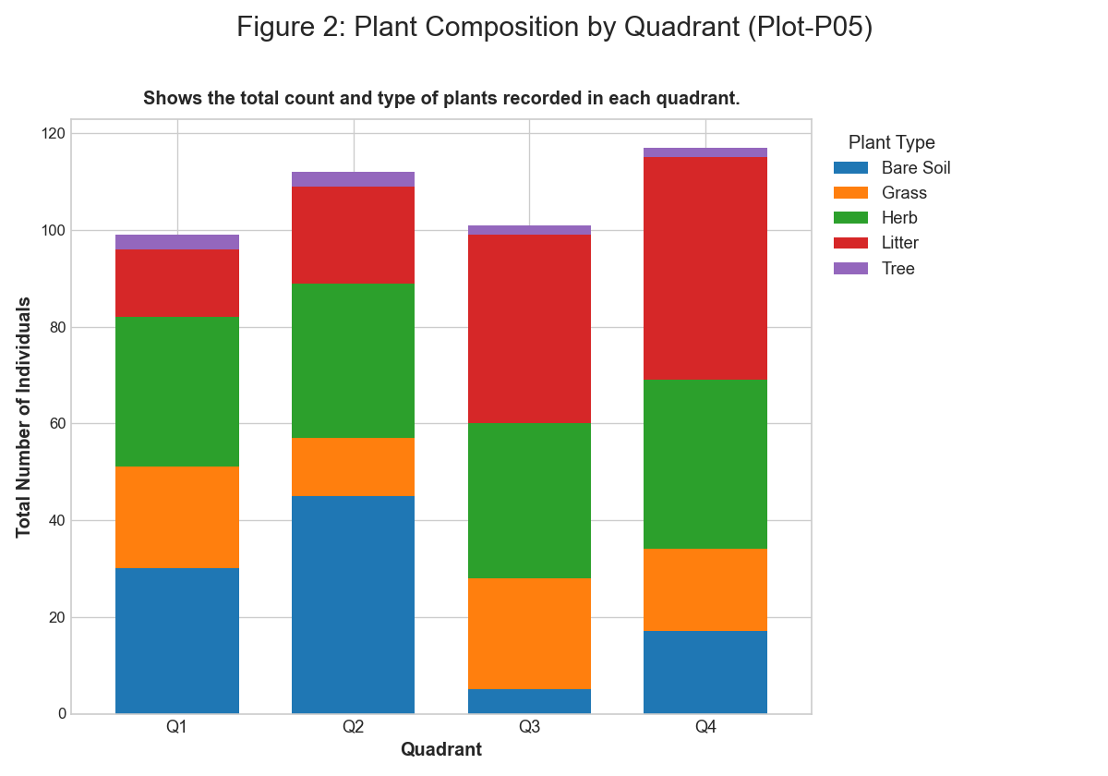 *Figure: figure 2 plant composition by quadrant*

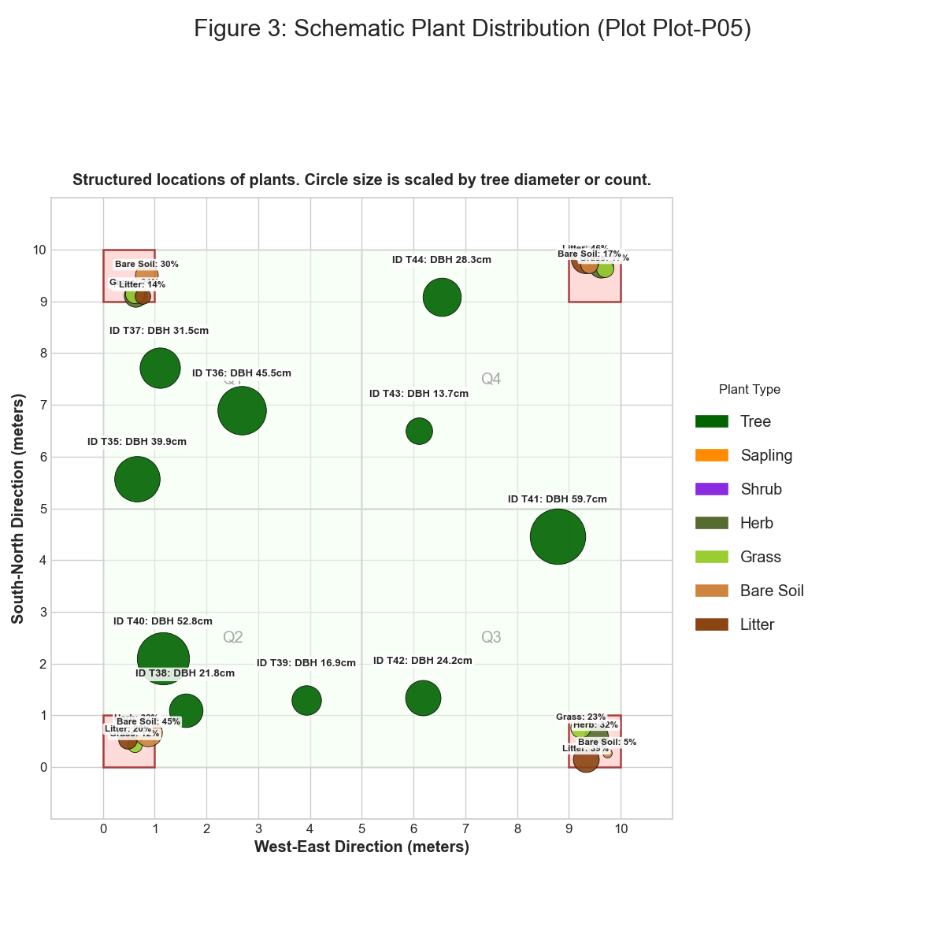 *Figure: figure 3 schematic plant distribution*

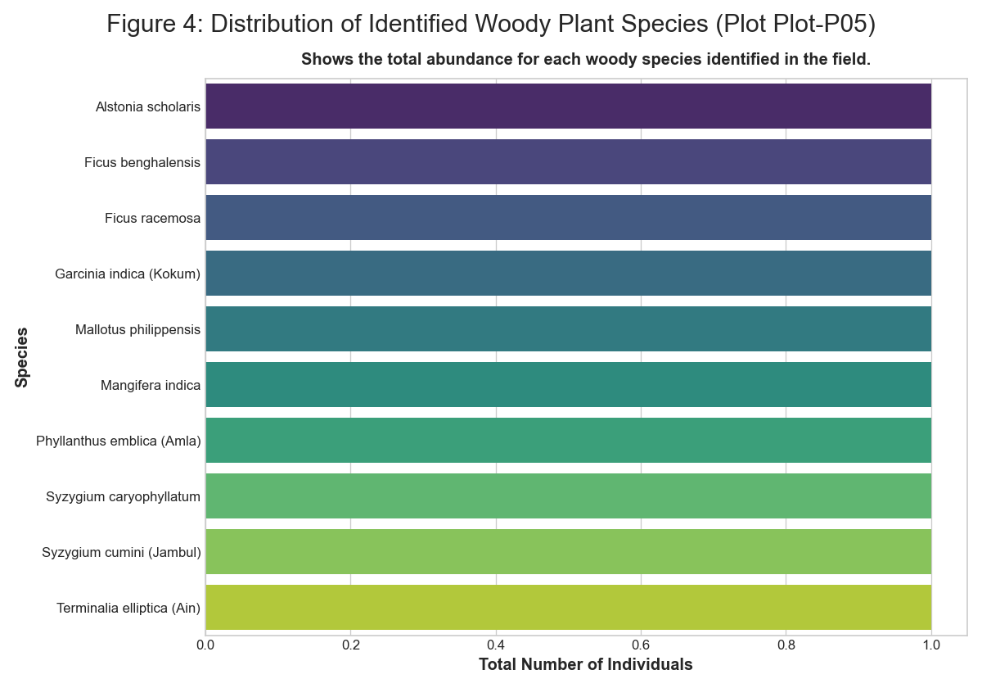 *Figure: figure 4 distribution of identified plant species*

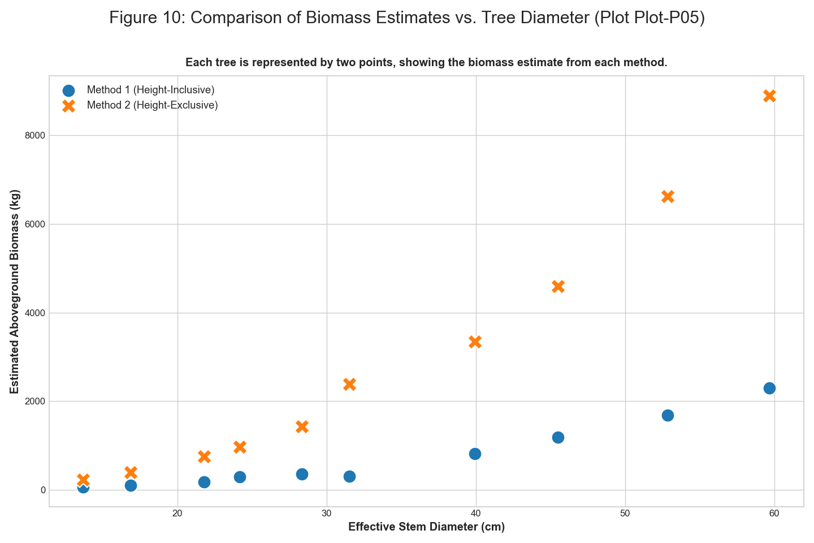 *Figure: figure 10 comparison of biomass estimates vs tree diameter*

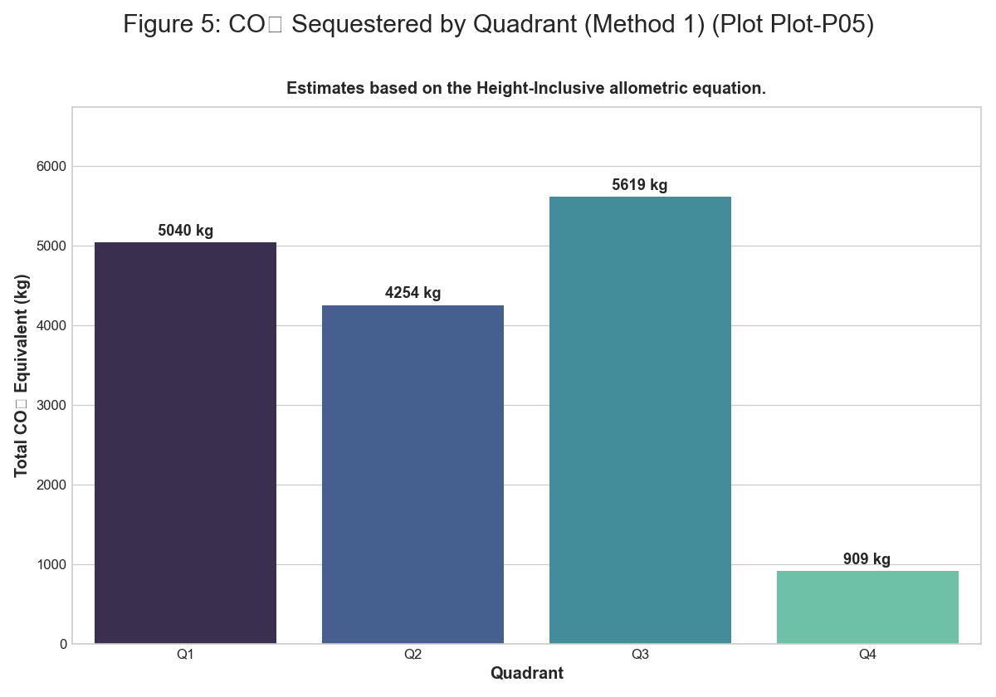 *Figure: figure 5 co2 sequestered by quadrant m1*

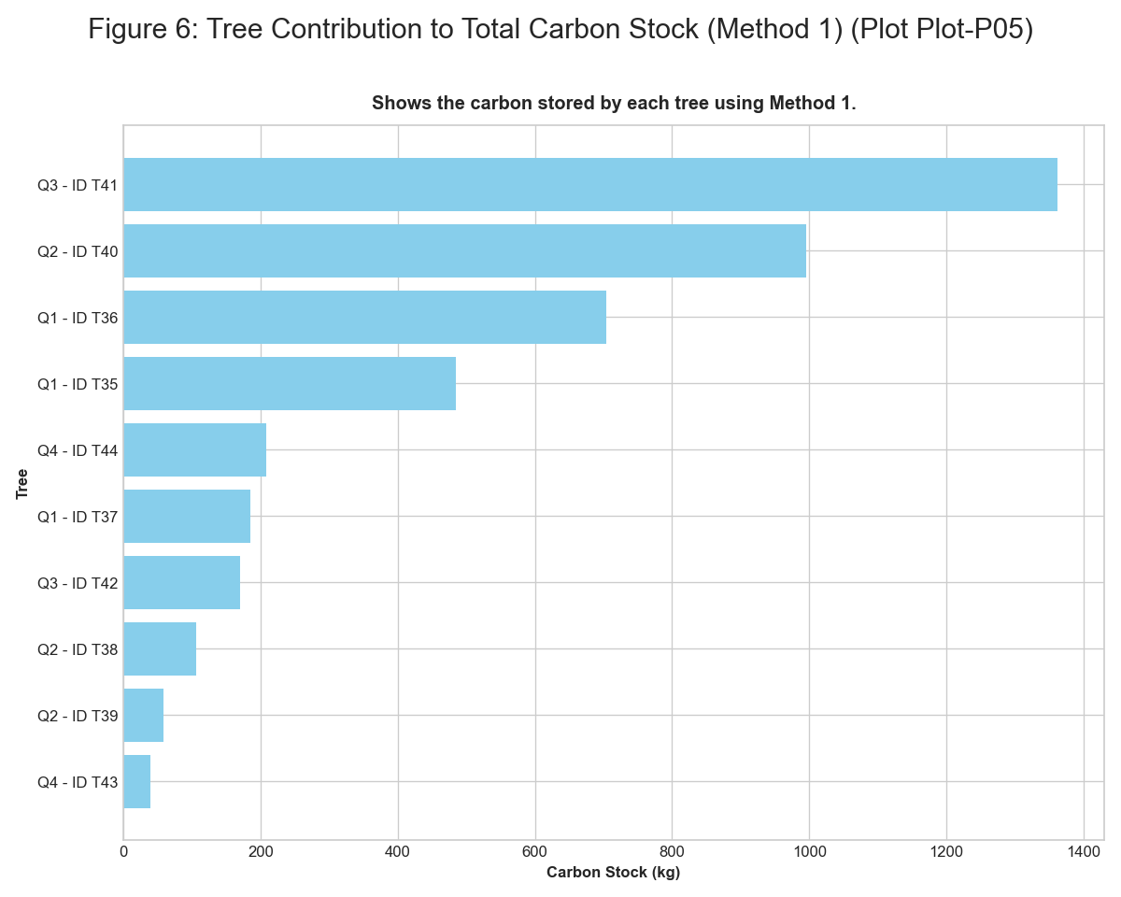 *Figure: figure 6 tree contribution to carbon stock m1*

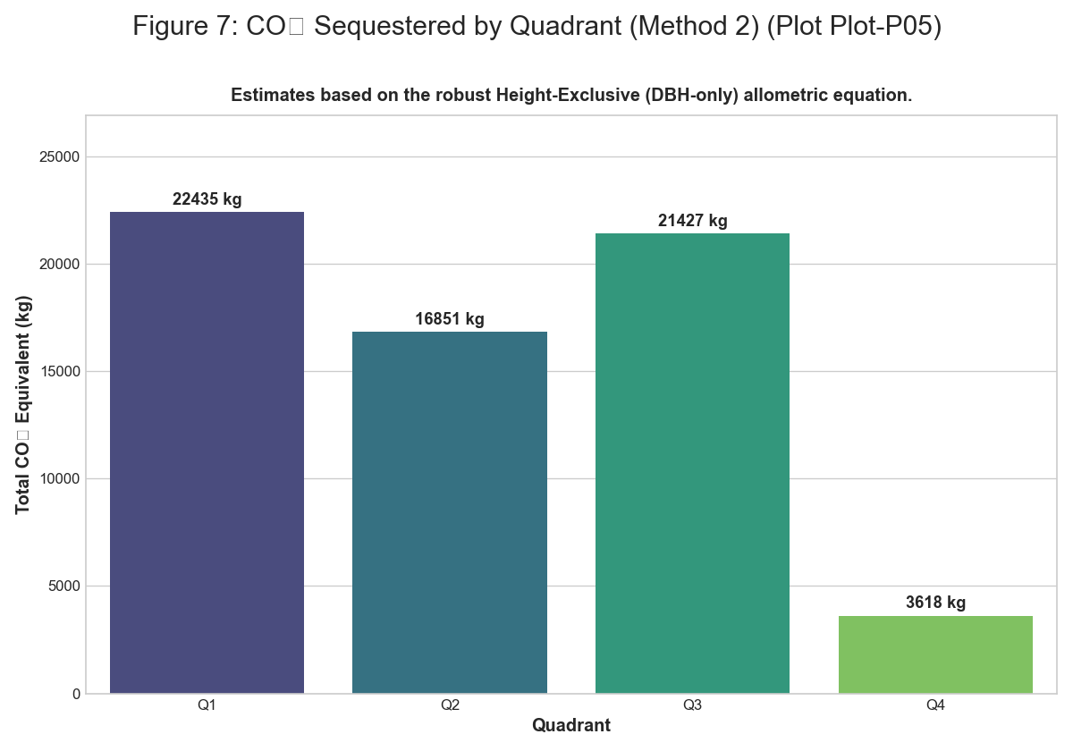 *Figure: figure 7 co2 sequestered by quadrant m2*

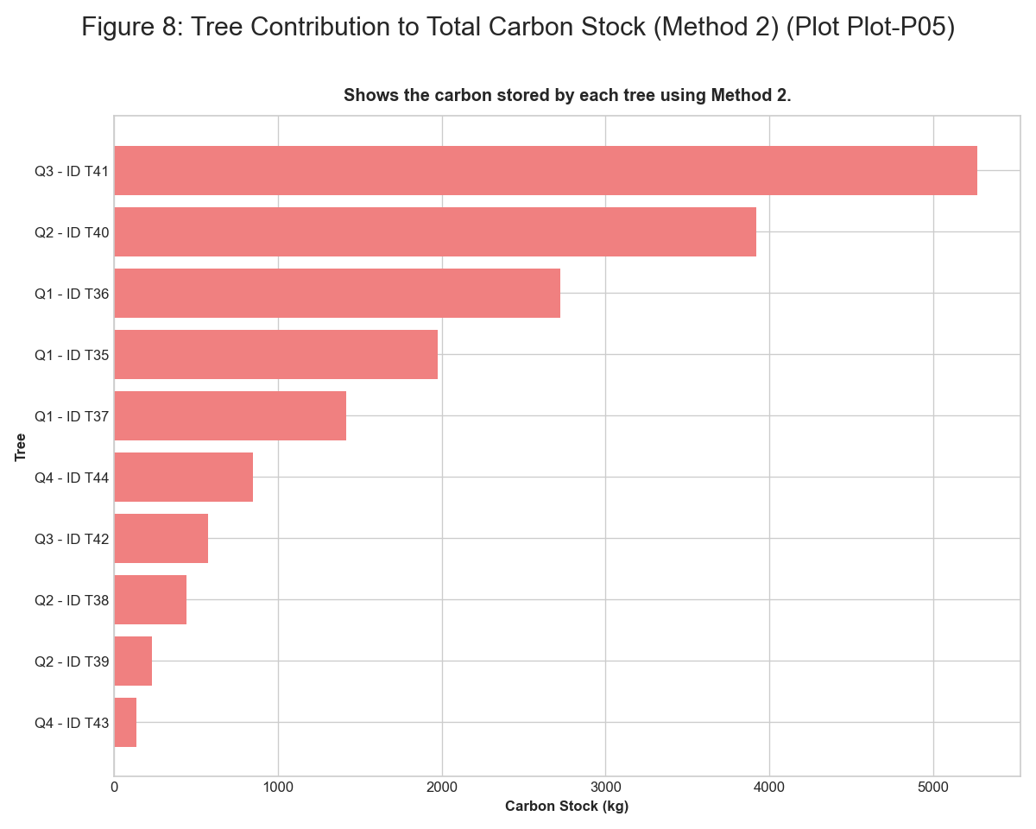 *Figure: figure 8 tree contribution to carbon stock m2*

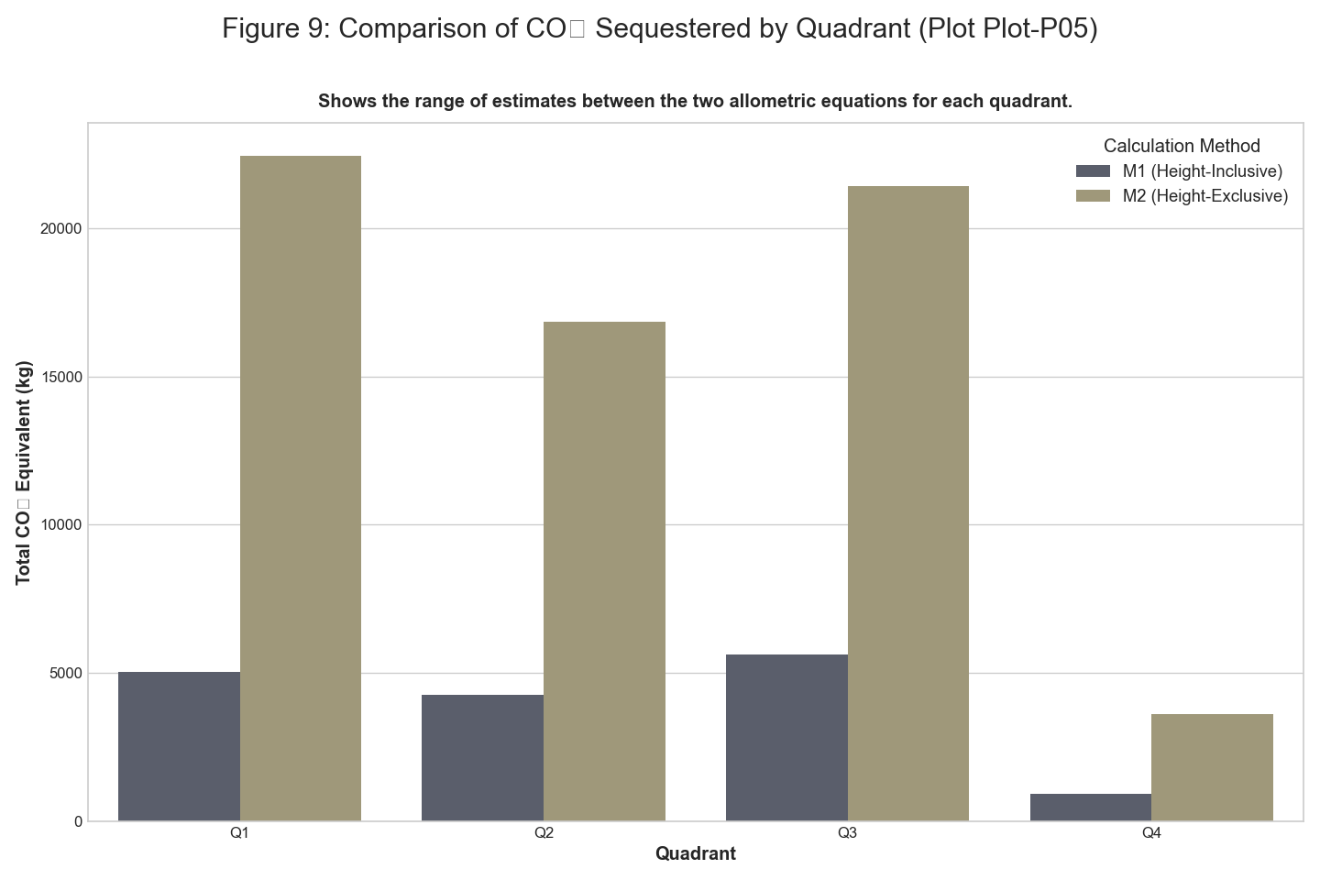 *Figure: figure 9 comparison of co2 sequestered by quadrant*

### Plot-P06

**Summary Statistics** | Quadrant | Type | Number | Species | |:———–|:———-|———:|:————————–| | Q1 | Tree | 1 | Pongamia pinnata (Karanj) | | Q1 | Tree | 1 | Tectona grandis (teak) | | Q1 | Tree | 1 | Gliricidia sepium | | Q1 | Tree | 1 | Tectona grandis (teak) | | Q2 | Tree | 1 | Acacia nilotica | | Q3 | Tree | 1 | Pongamia pinnata (Karanj) | | Q3 | Tree | 1 | Gliricidia sepium | | Q4 | Tree | 1 | Tectona grandis (teak) | | Q4 | Tree | 1 | Ficus religiosa | | Q1 | Herb | 44 | Mixed Herbs | | Q1 | Grass | 40 | Mixed Grasses | | Q1 | Litter | 35 | Decomposing Matter | | Q1 | Bare Soil | 4 | Bare Ground | | Q2 | Herb | 11 | Mixed Herbs | | Q2 | Grass | 13 | Mixed Grasses | | Q2 | Litter | 30 | Decomposing Matter | | Q2 | Bare Soil | 46 | Bare Ground | | Q3 | Herb | 32 | Mixed Herbs | | Q3 | Grass | 25 | Mixed Grasses | | Q3 | Litter | 25 | Decomposing Matter | | Q3 | Bare Soil | 23 | Bare Ground | | Q4 | Herb | 13 | Mixed Herbs | | Q4 | Grass | 20 | Mixed Grasses | | Q4 | Litter | 21 | Decomposing Matter | | Q4 | Bare Soil | 49 | Bare Ground |

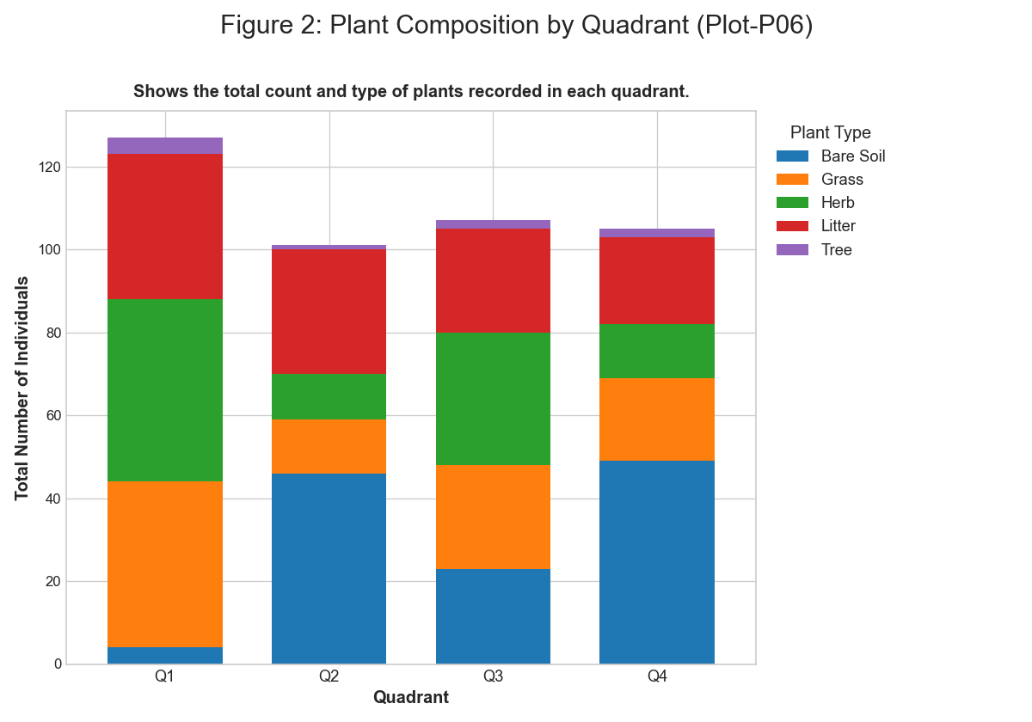 *Figure: figure 2 plant composition by quadrant*

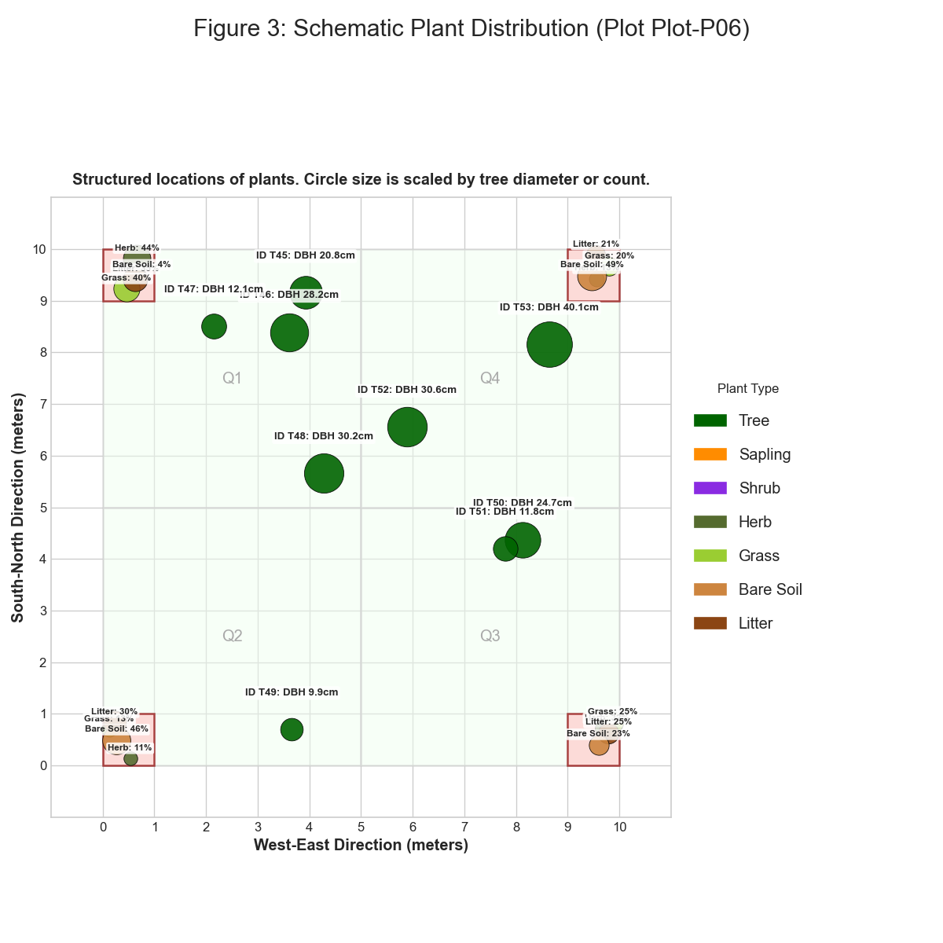 *Figure: figure 3 schematic plant distribution*

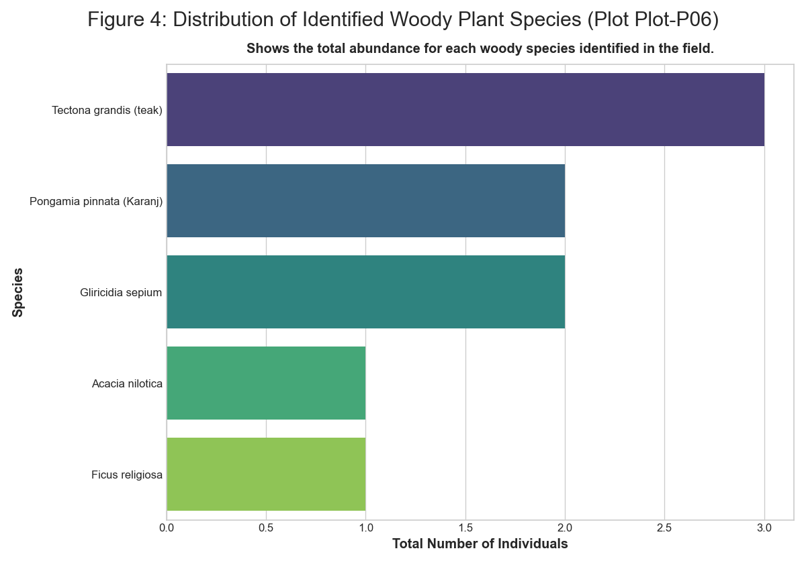 *Figure: figure 4 distribution of identified plant species*

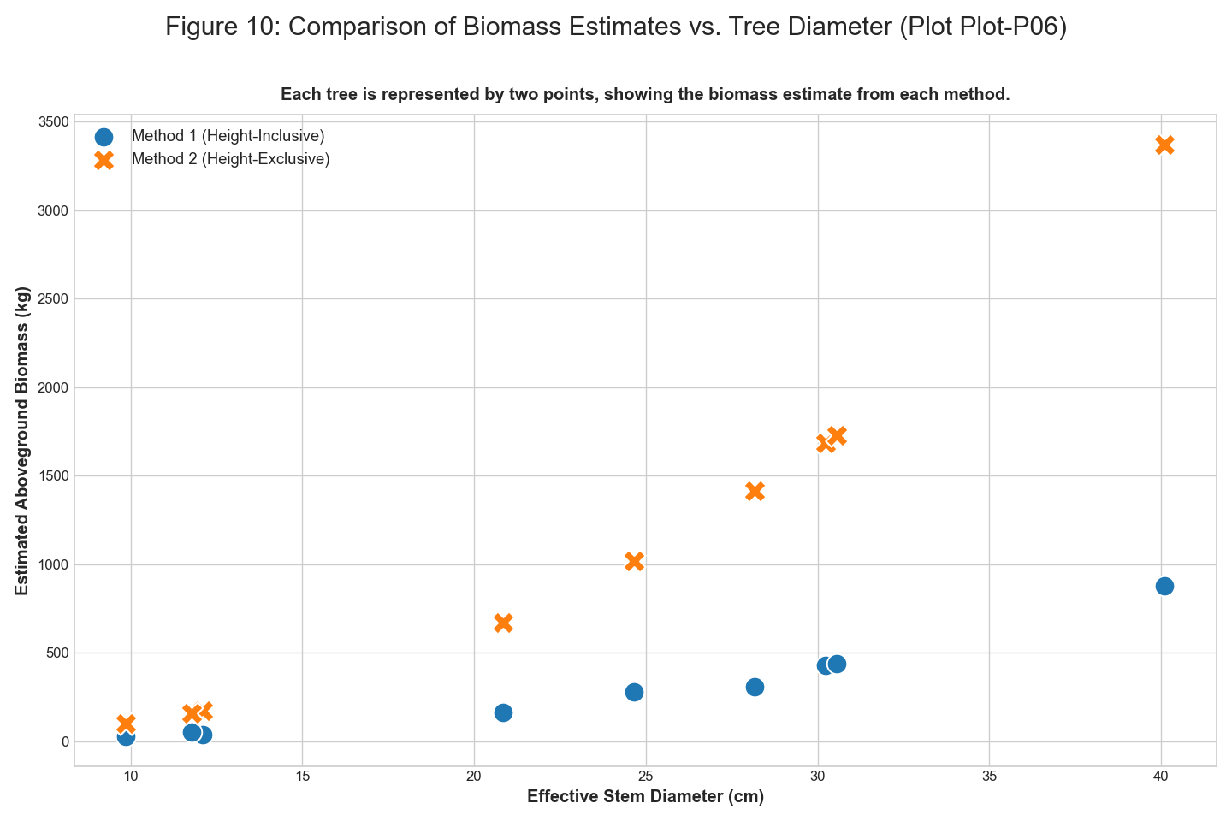 *Figure: figure 10 comparison of biomass estimates vs tree diameter*

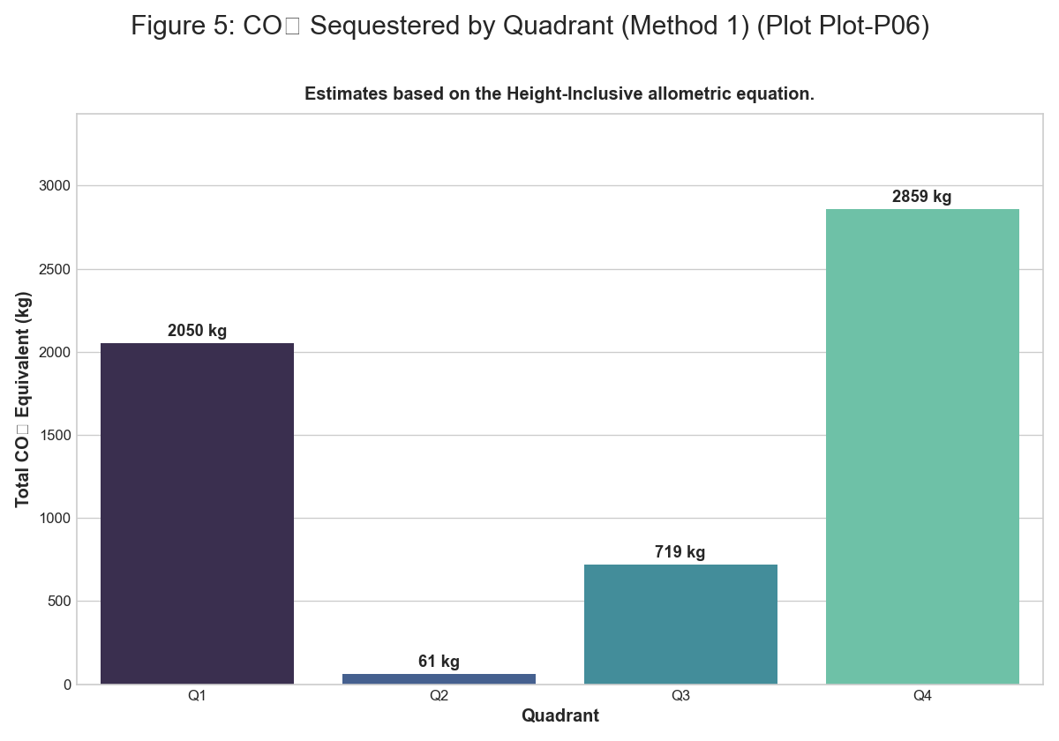 *Figure: figure 5 co2 sequestered by quadrant m1*

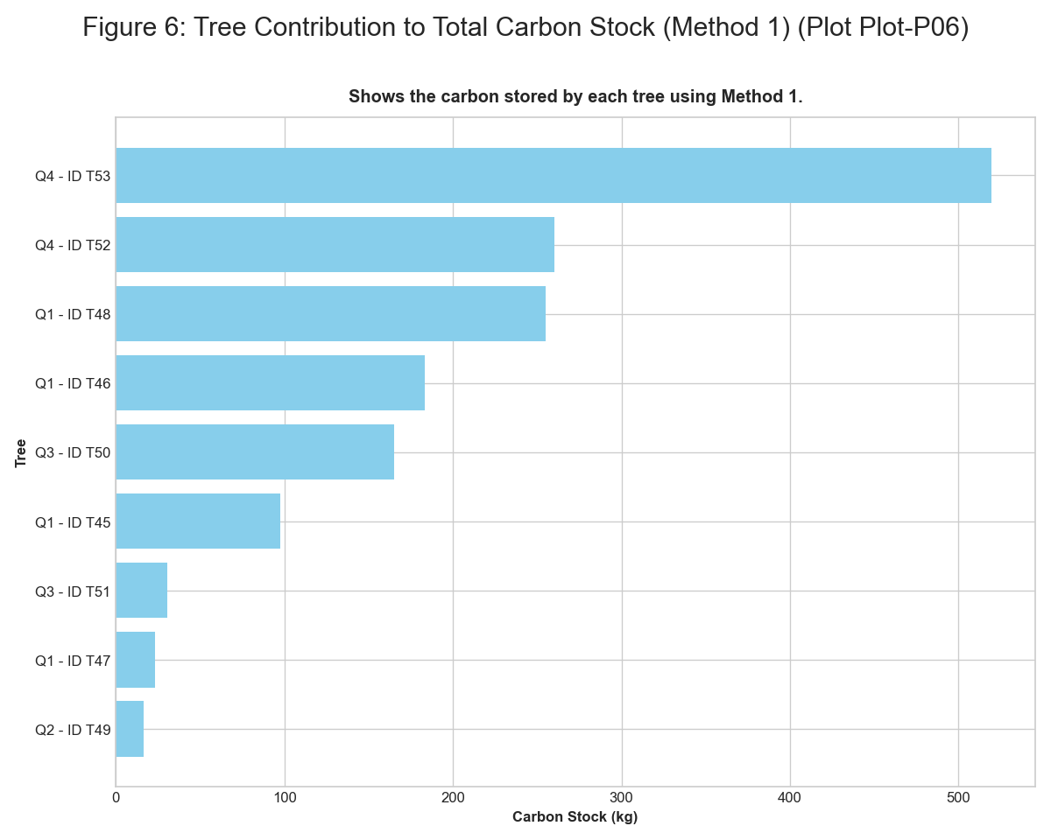 *Figure: figure 6 tree contribution to carbon stock m1*

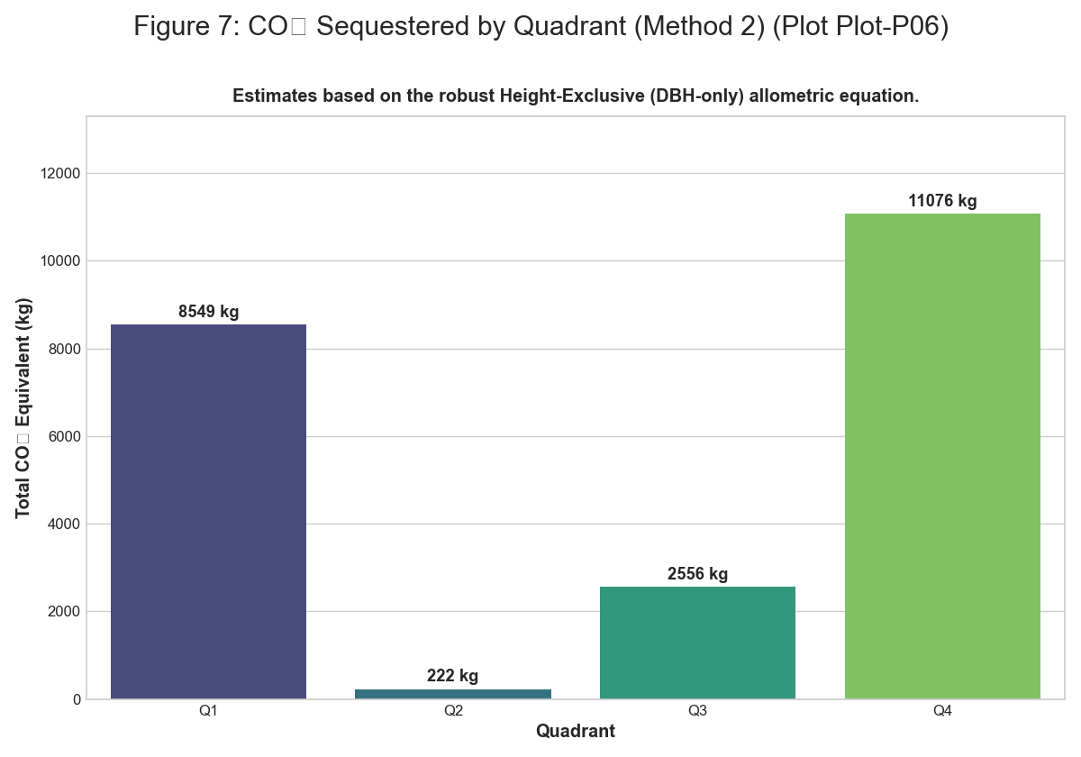 *Figure: figure 7 co2 sequestered by quadrant m2*

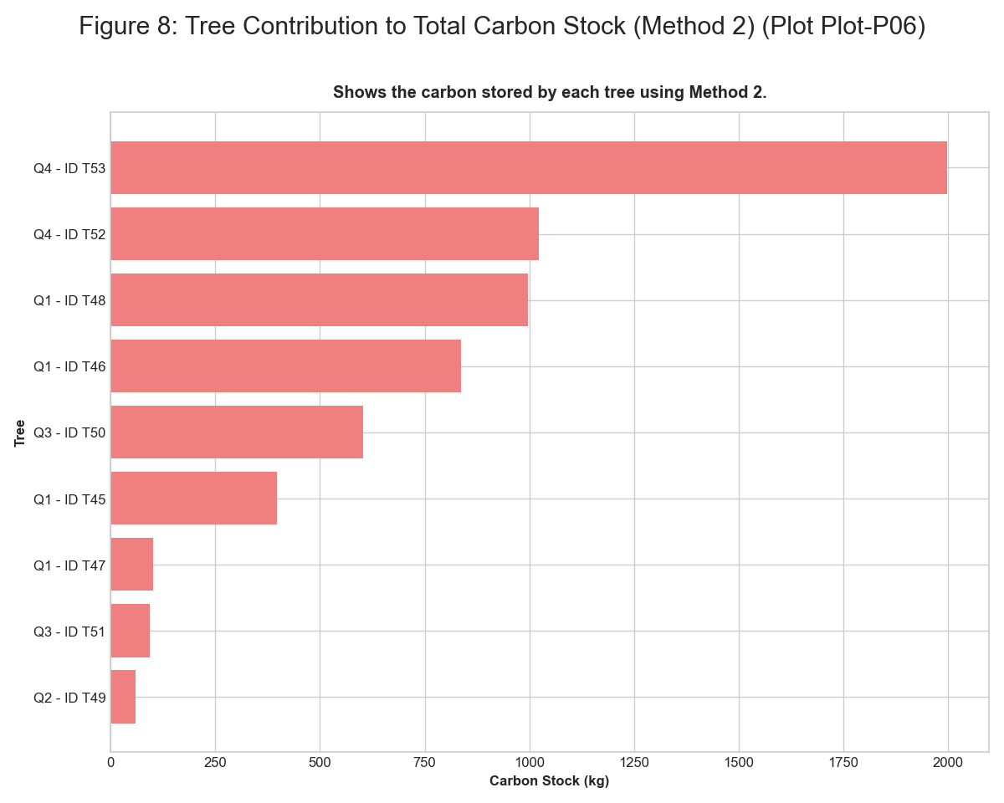 *Figure: figure 8 tree contribution to carbon stock m2*

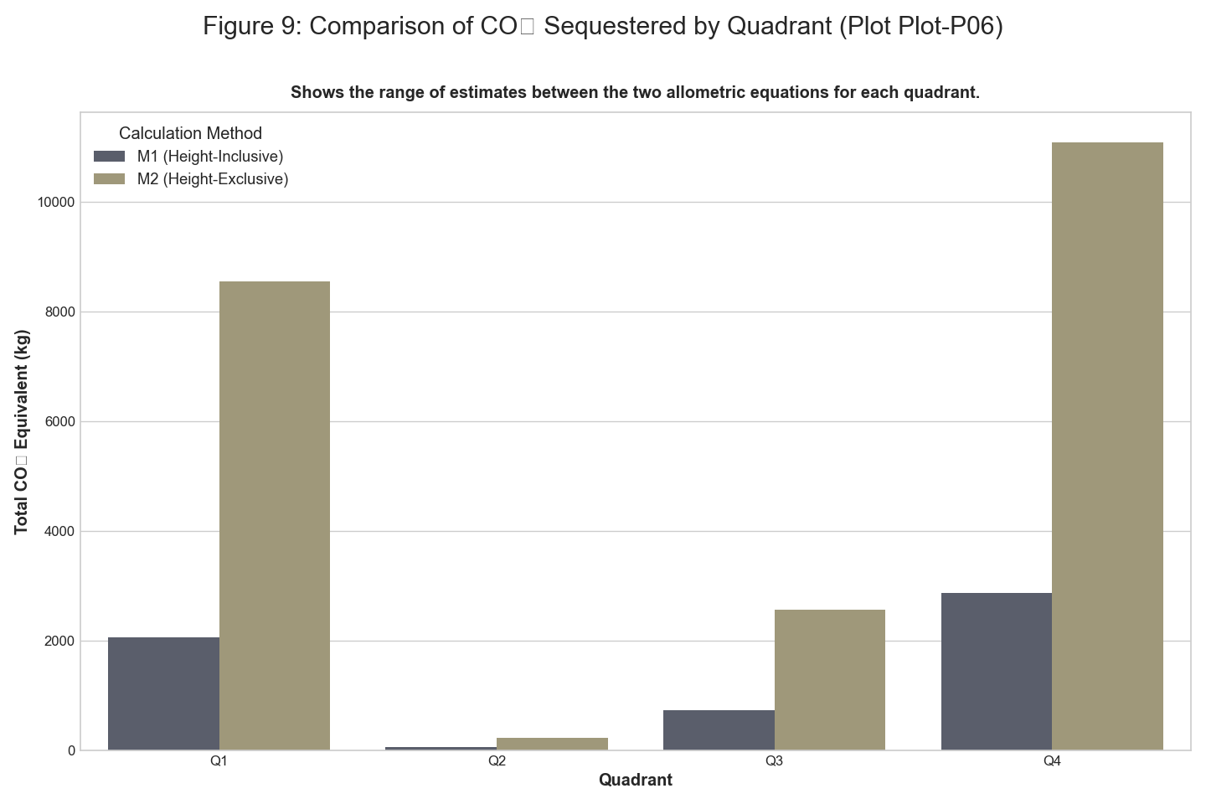 *Figure: figure 9 comparison of co2 sequestered by quadrant*

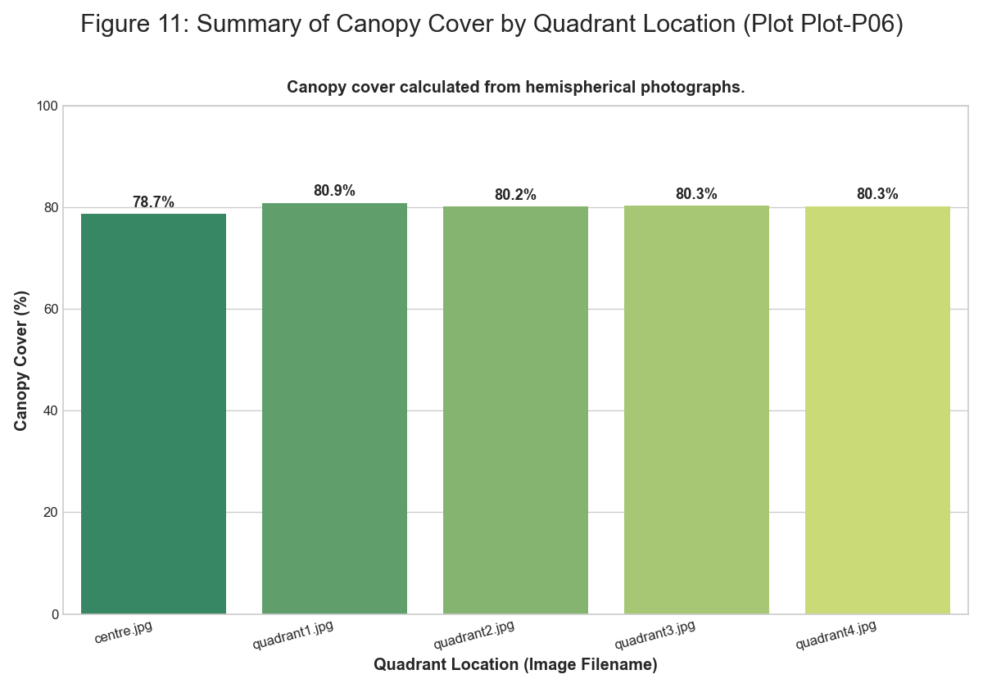 *Figure: figure 11 summary of canopy cover*

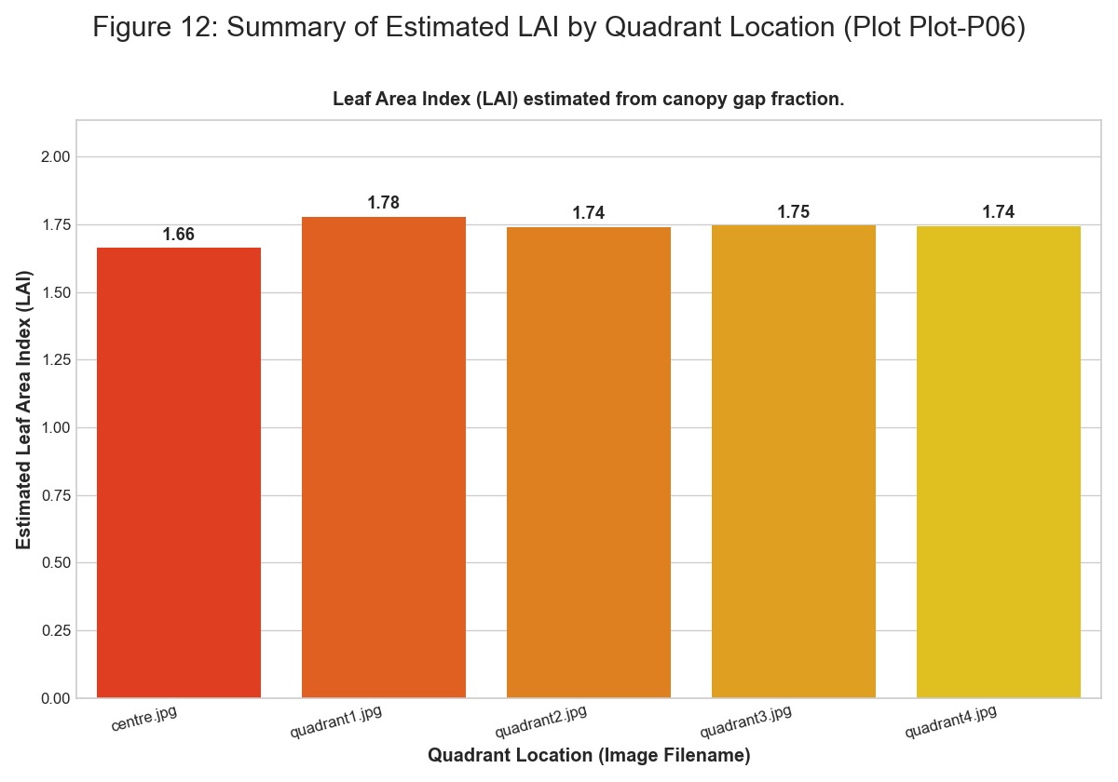 *Figure: figure 12 summary of estimated lai*

### Plot-P07

**Summary Statistics** | Quadrant | Type | Number | Species | |:———–|:———-|———:|:————————–| | Q1 | Tree | 1 | Gliricidia sepium | | Q2 | Tree | 1 | Pongamia pinnata (Karanj) | | Q3 | Tree | 1 | Anogeissus latifolia | | Q4 | Tree | 1 | Dalbergia latifolia | | Q1 | Herb | 16 | Mixed Herbs | | Q1 | Grass | 39 | Mixed Grasses | | Q1 | Litter | 32 | Decomposing Matter | | Q1 | Bare Soil | 20 | Bare Ground | | Q2 | Herb | 24 | Mixed Herbs | | Q2 | Grass | 38 | Mixed Grasses | | Q2 | Litter | 26 | Decomposing Matter | | Q2 | Bare Soil | 16 | Bare Ground | | Q3 | Herb | 24 | Mixed Herbs | | Q3 | Grass | 27 | Mixed Grasses | | Q3 | Litter | 42 | Decomposing Matter | | Q3 | Bare Soil | 5 | Bare Ground | | Q4 | Herb | 21 | Mixed Herbs | | Q4 | Grass | 11 | Mixed Grasses | | Q4 | Litter | 58 | Decomposing Matter | | Q4 | Bare Soil | 10 | Bare Ground |

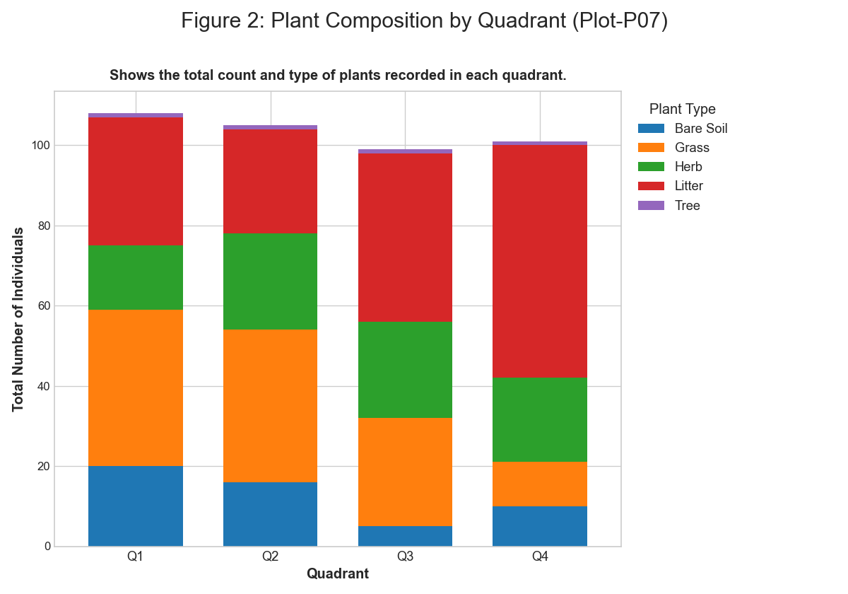 *Figure: figure 2 plant composition by quadrant*

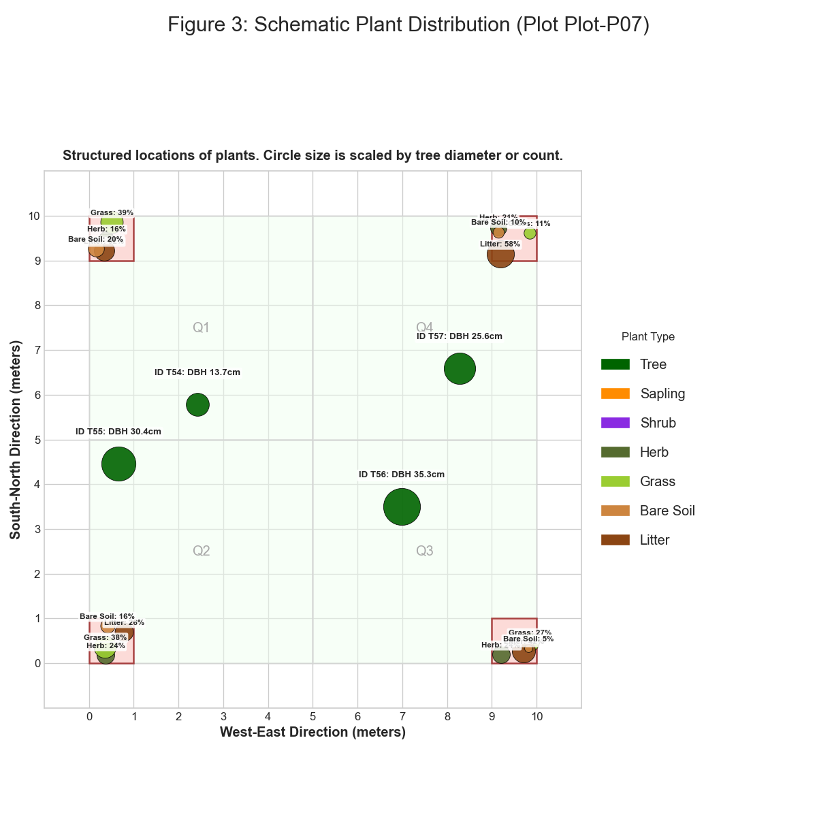 *Figure: figure 3 schematic plant distribution*

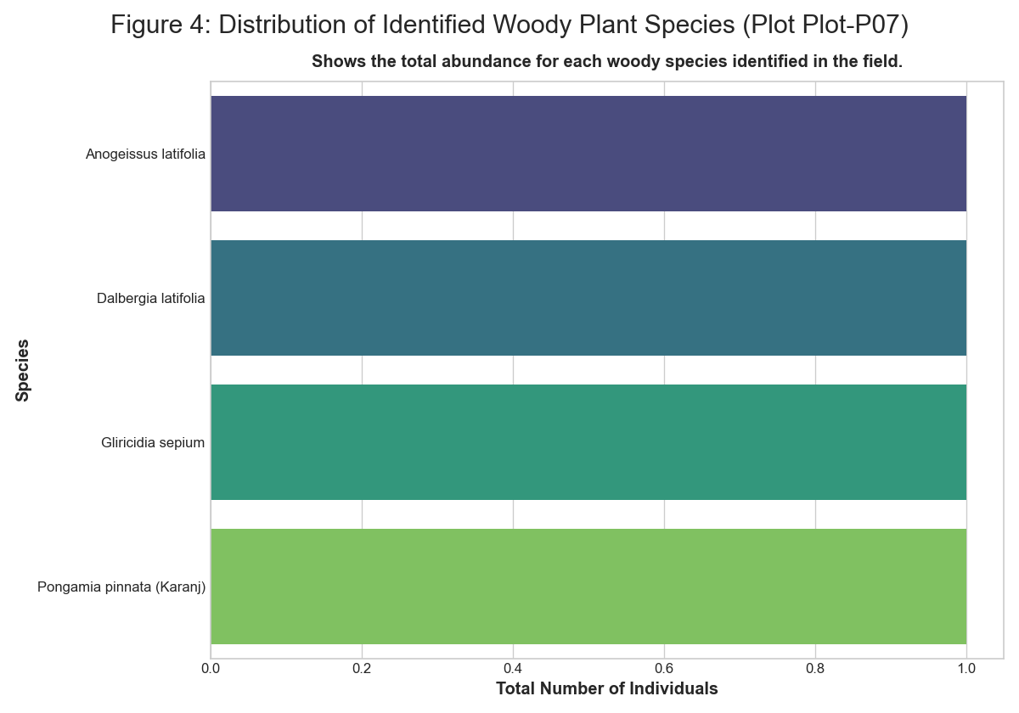 *Figure: figure 4 distribution of identified plant species*

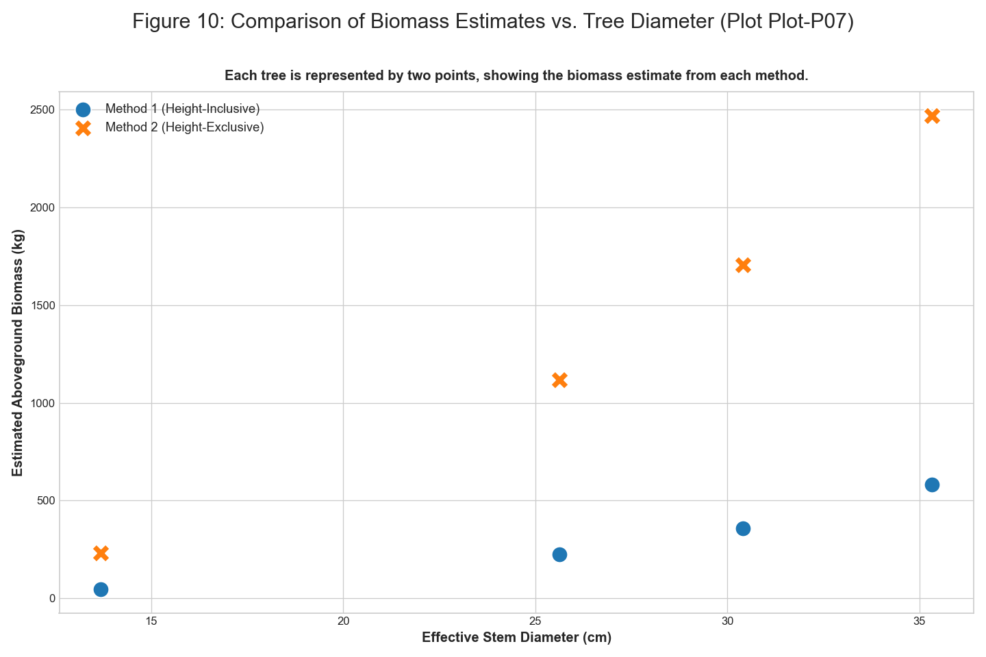 *Figure: figure 10 comparison of biomass estimates vs tree diameter*

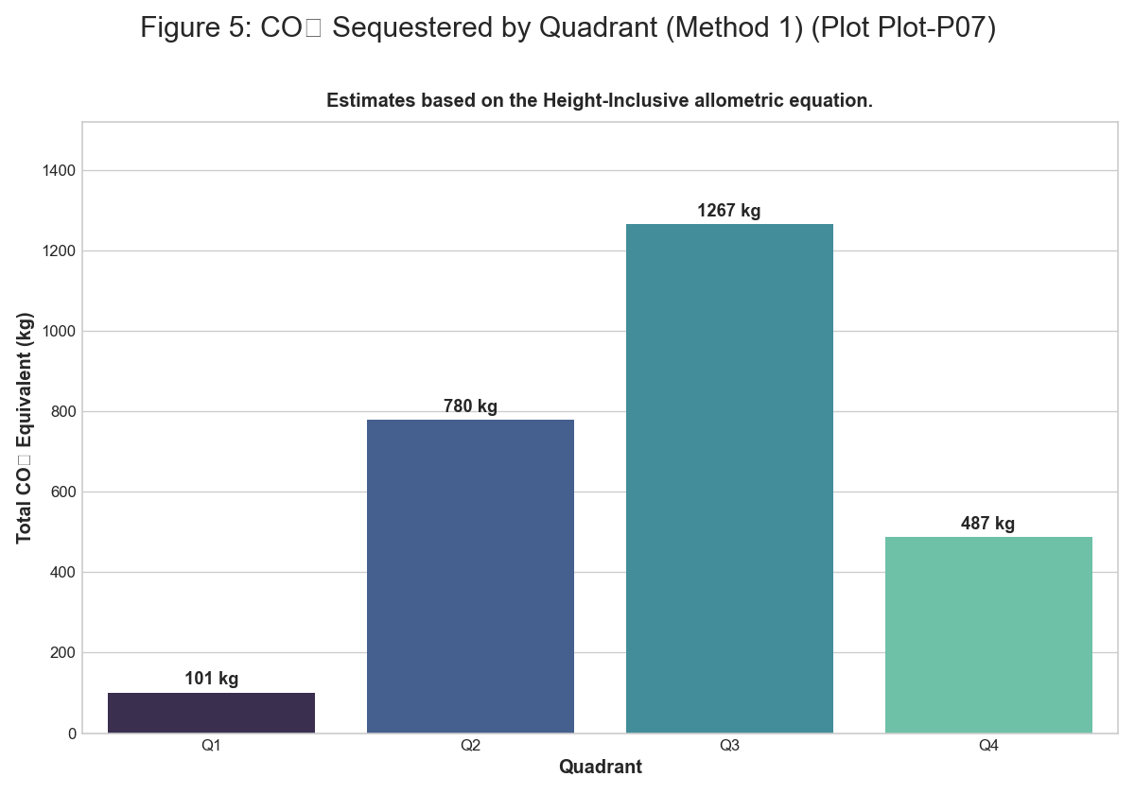 *Figure: figure 5 co2 sequestered by quadrant m1*

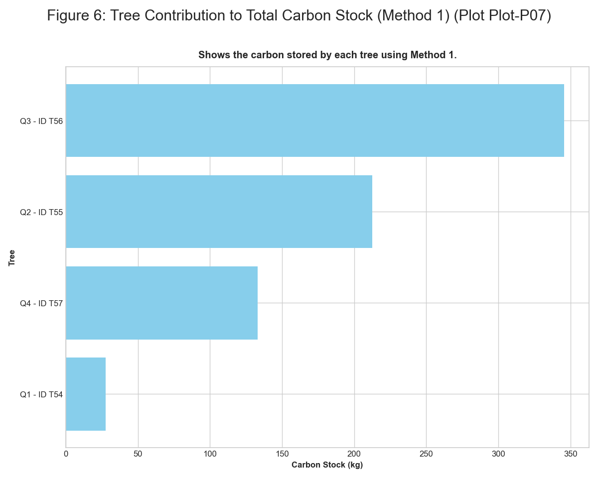 *Figure: figure 6 tree contribution to carbon stock m1*

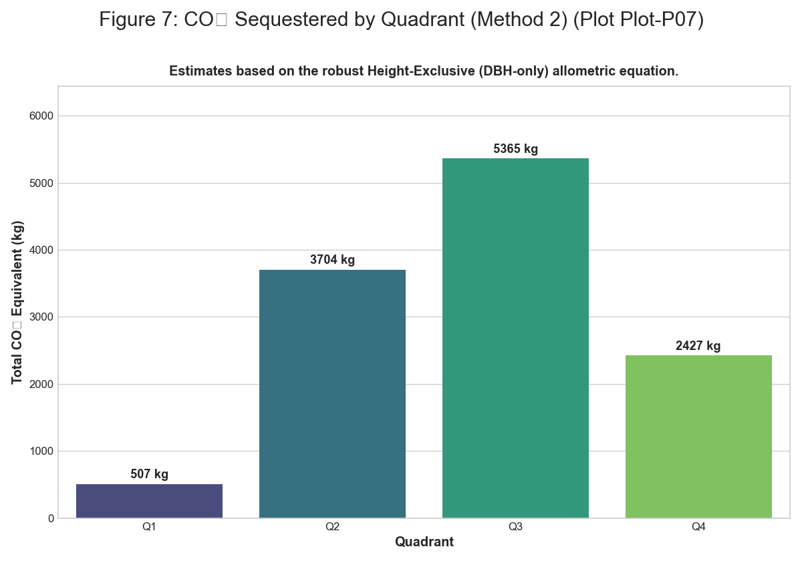 *Figure: figure 7 co2 sequestered by quadrant m2*

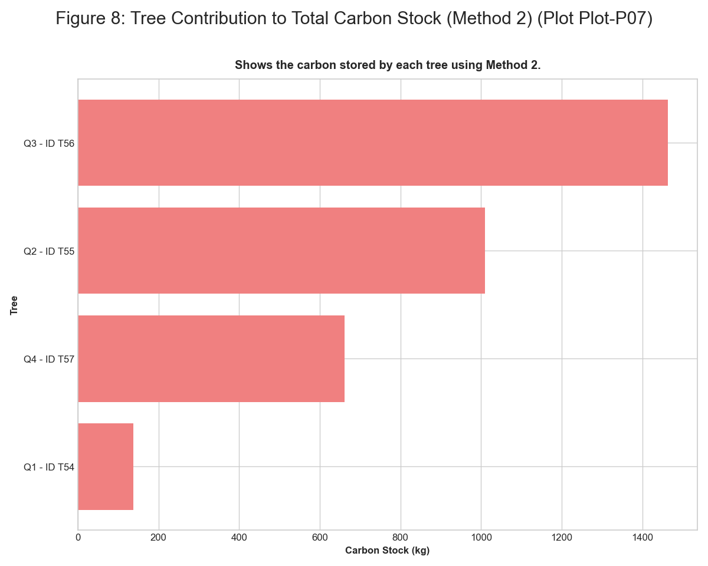 *Figure: figure 8 tree contribution to carbon stock m2*

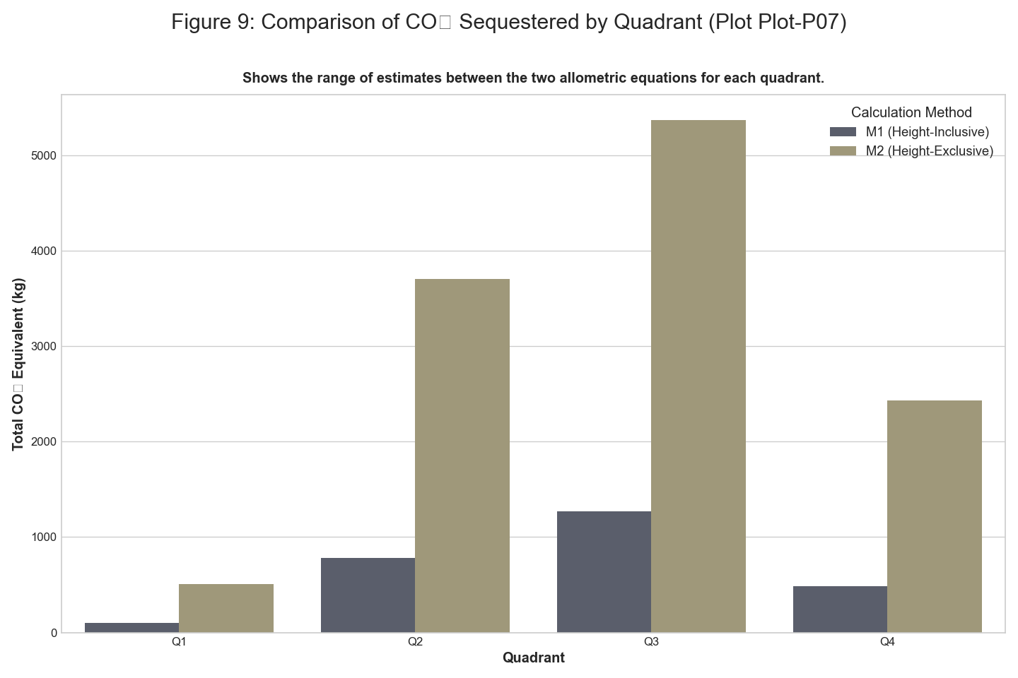 *Figure: figure 9 comparison of co2 sequestered by quadrant*

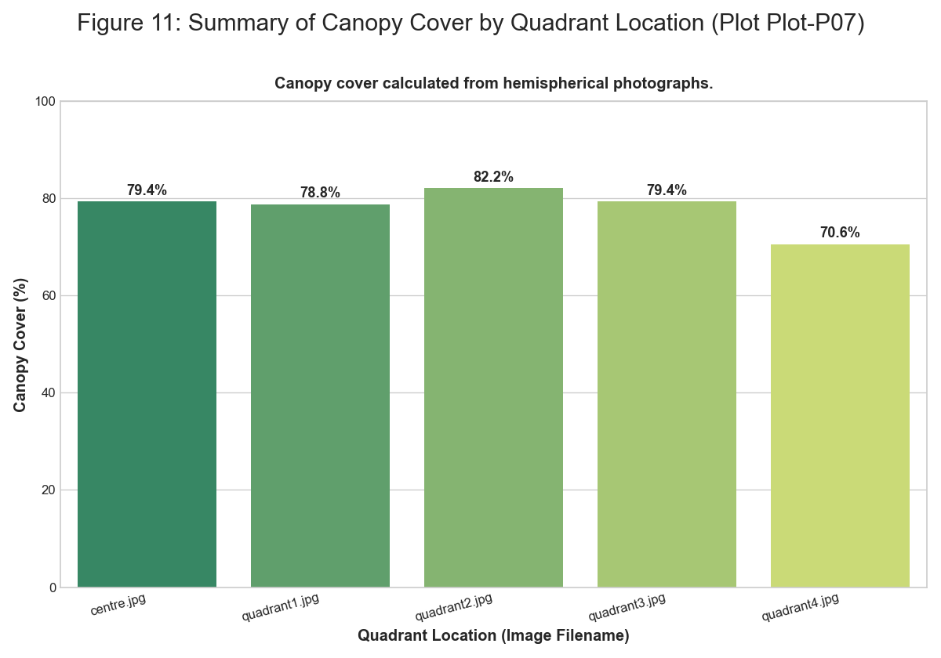 *Figure: figure 11 summary of canopy cover*

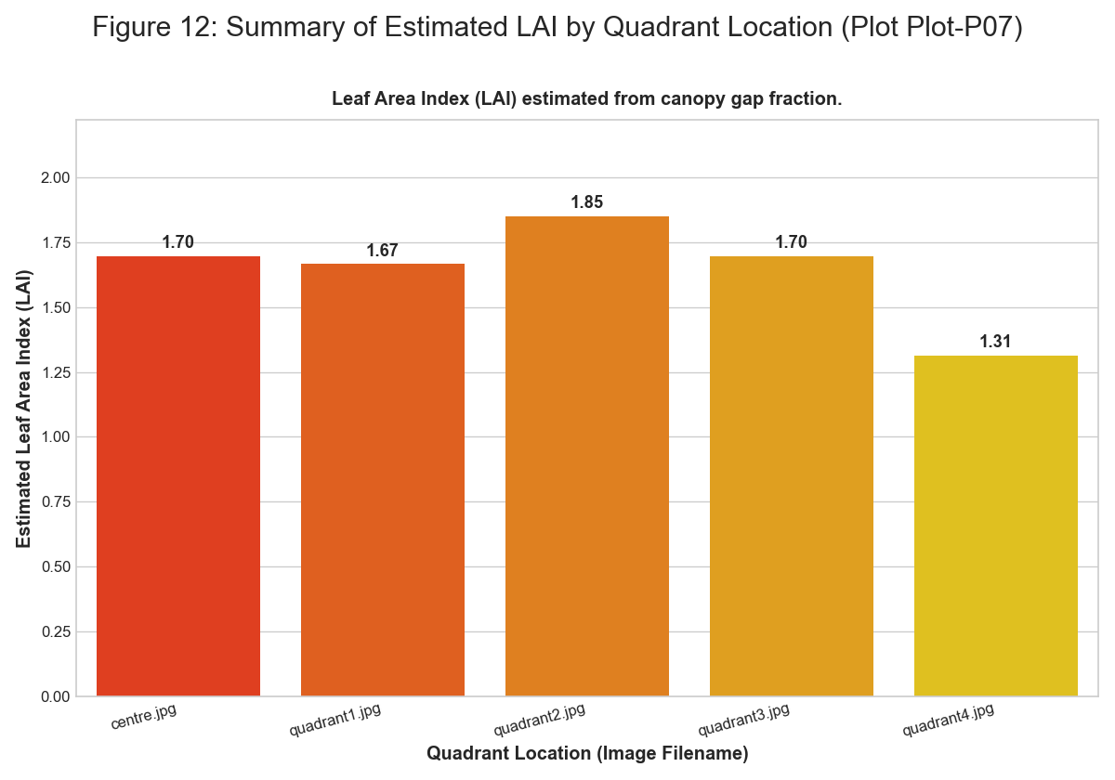 *Figure: figure 12 summary of estimated lai*

### Plot-P08

**Summary Statistics** | Quadrant | Type | Number | Species | |:———–|:———-|———:|:————————-| | Q1 | Tree | 1 | Boswellia serrata | | Q2 | Tree | 1 | Tectona grandis | | Q2 | Tree | 1 | Gliricidia sepium | | Q3 | Tree | 1 | Lagerstroemia microcarpa | | Q4 | Tree | 1 | Albizia lebbeck | | Q4 | Tree | 1 | Ficus racemosa | | Q1 | Herb | 19 | Mixed Herbs | | Q1 | Grass | 33 | Mixed Grasses | | Q1 | Litter | 27 | Decomposing Matter | | Q1 | Bare Soil | 21 | Bare Ground | | Q2 | Herb | 21 | Mixed Herbs | | Q2 | Grass | 29 | Mixed Grasses | | Q2 | Litter | 29 | Decomposing Matter | | Q2 | Bare Soil | 31 | Bare Ground | | Q3 | Herb | 28 | Mixed Herbs | | Q3 | Grass | 20 | Mixed Grasses | | Q3 | Litter | 52 | Decomposing Matter | | Q3 | Bare Soil | 2 | Bare Ground | | Q4 | Herb | 18 | Mixed Herbs | | Q4 | Grass | 12 | Mixed Grasses | | Q4 | Litter | 38 | Decomposing Matter | | Q4 | Bare Soil | 32 | Bare Ground |

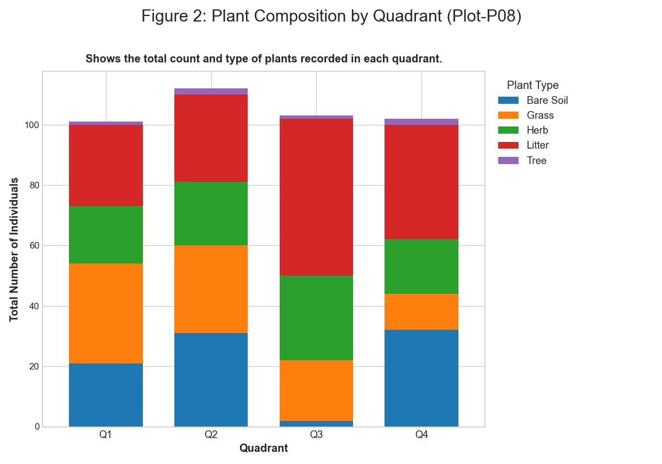 *Figure: figure 2 plant composition by quadrant*

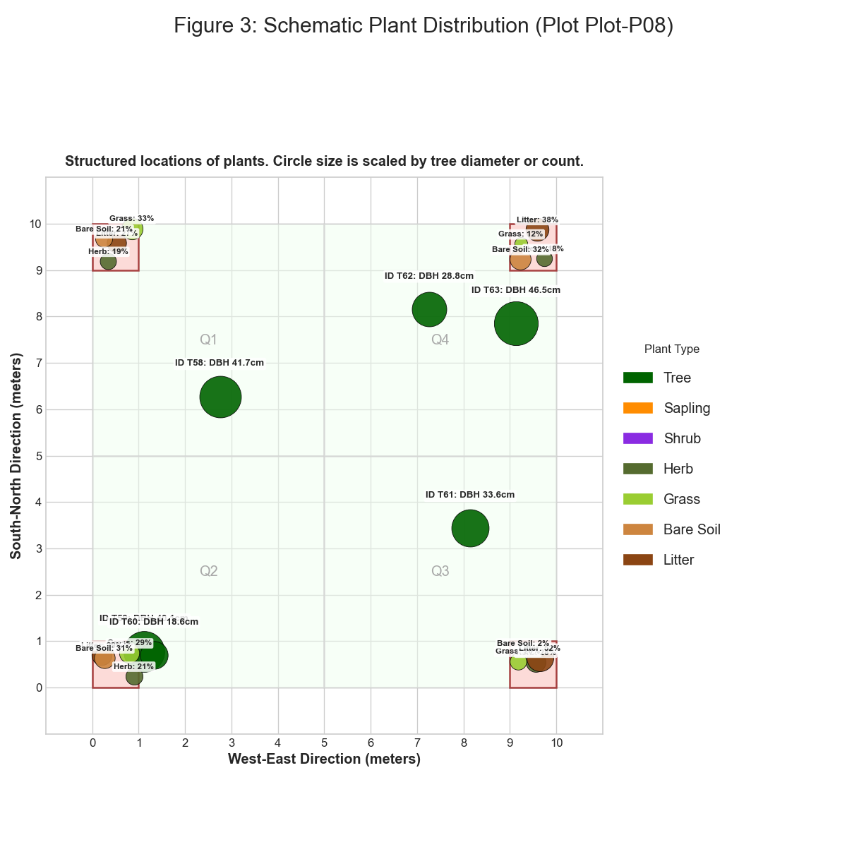 *Figure: figure 3 schematic plant distribution*

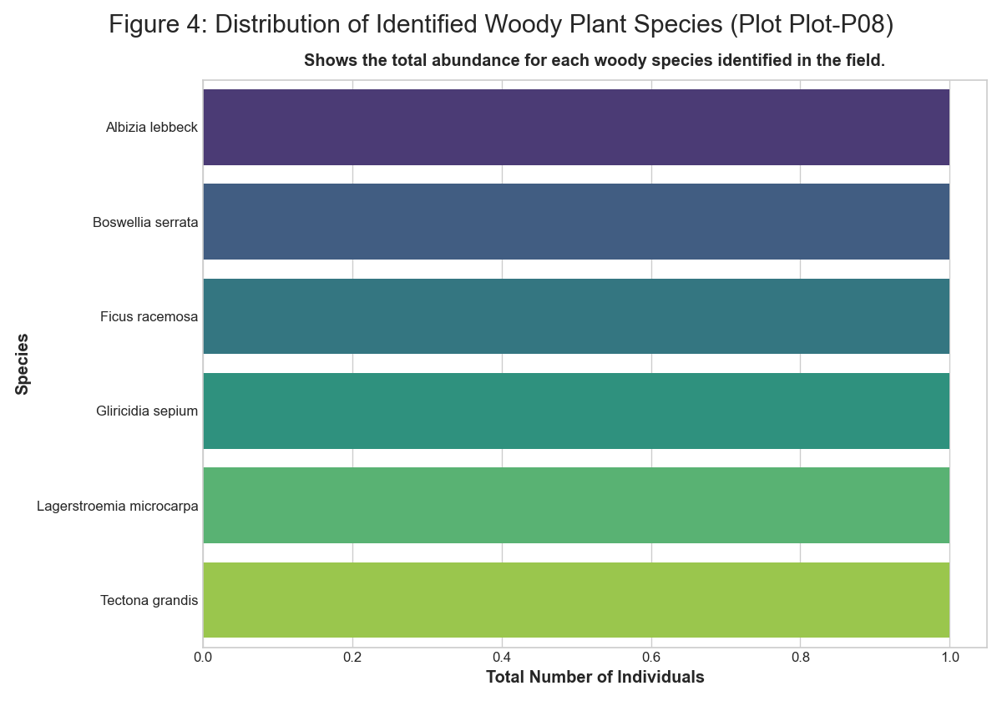 *Figure: figure 4 distribution of identified plant species*

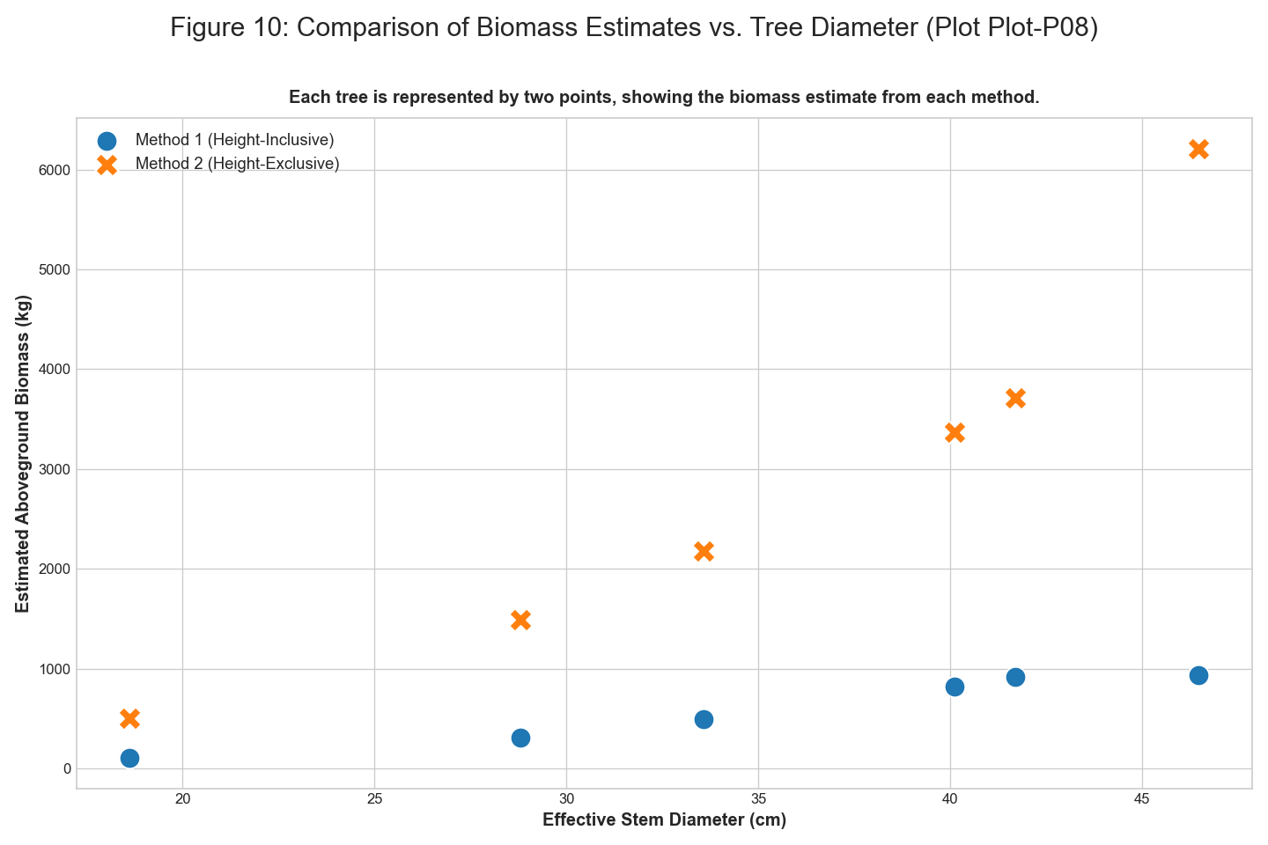 *Figure: figure 10 comparison of biomass estimates vs tree diameter*

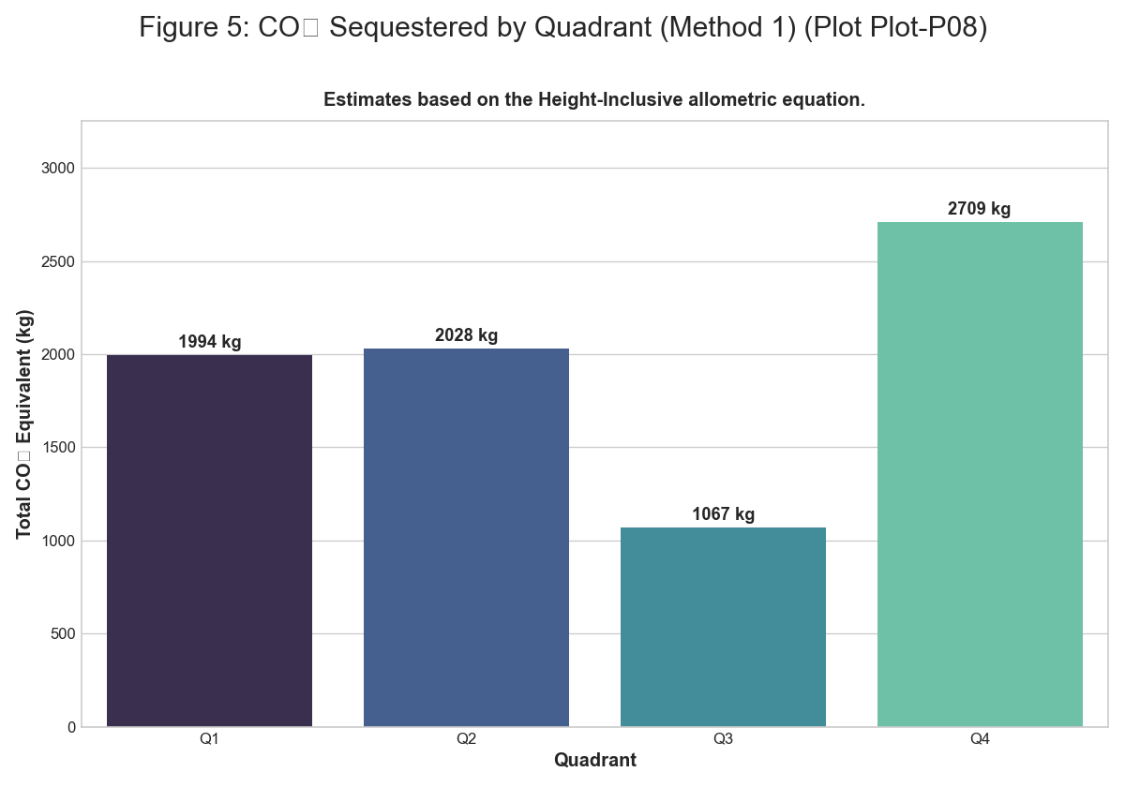 *Figure: figure 5 co2 sequestered by quadrant m1*

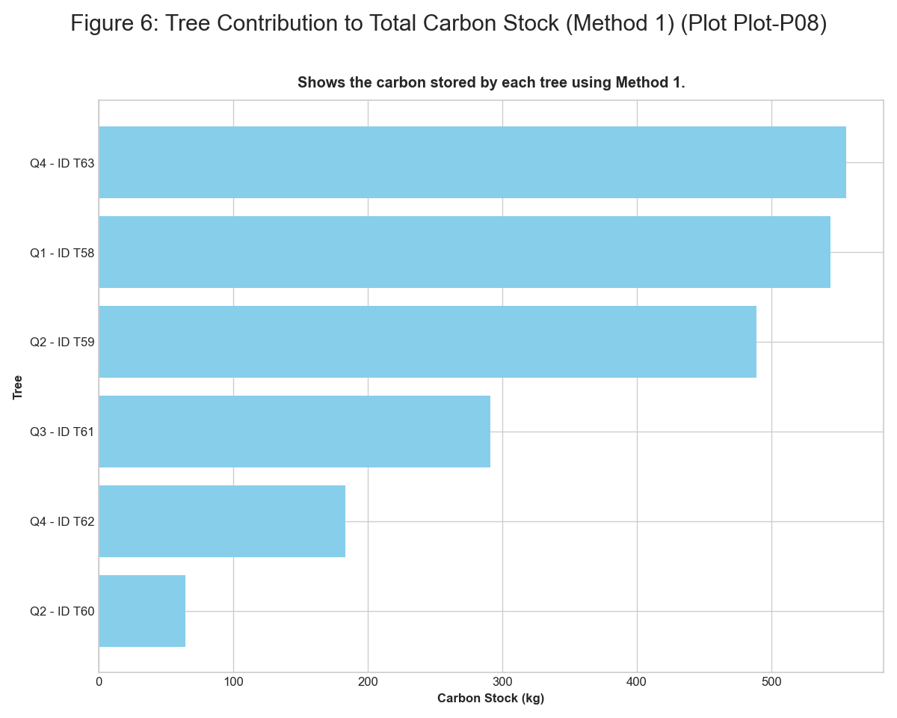 *Figure: figure 6 tree contribution to carbon stock m1*

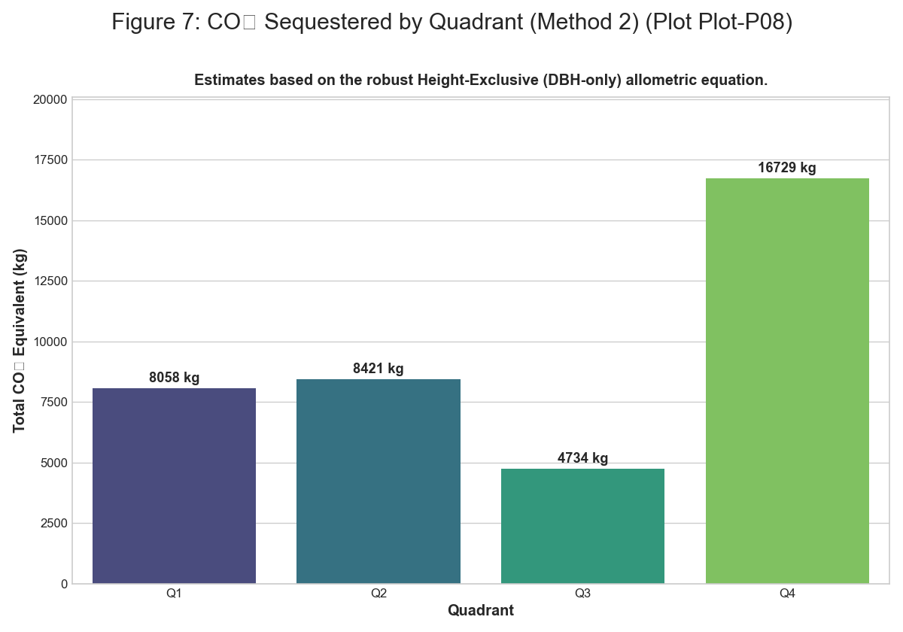 *Figure: figure 7 co2 sequestered by quadrant m2*

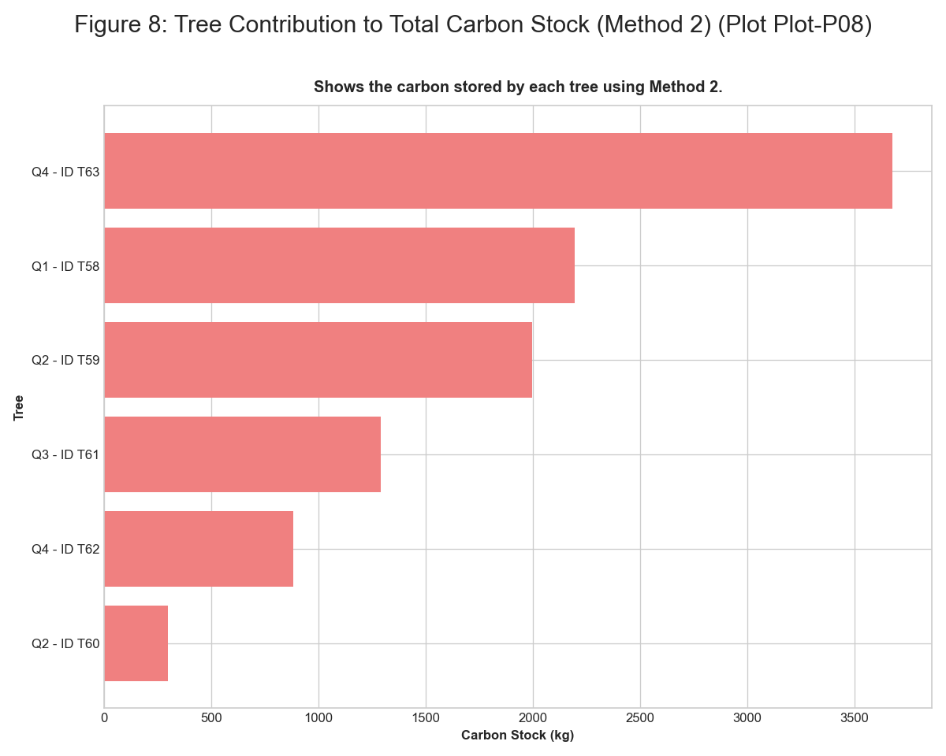 *Figure: figure 8 tree contribution to carbon stock m2*

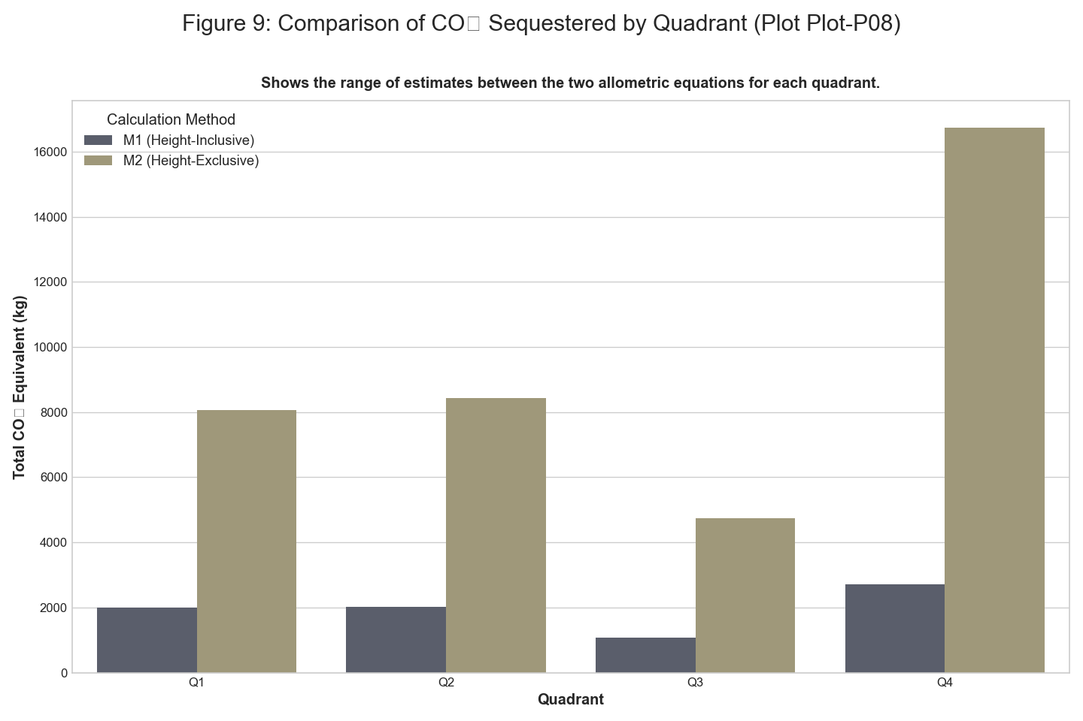 *Figure: figure 9 comparison of co2 sequestered by quadrant*

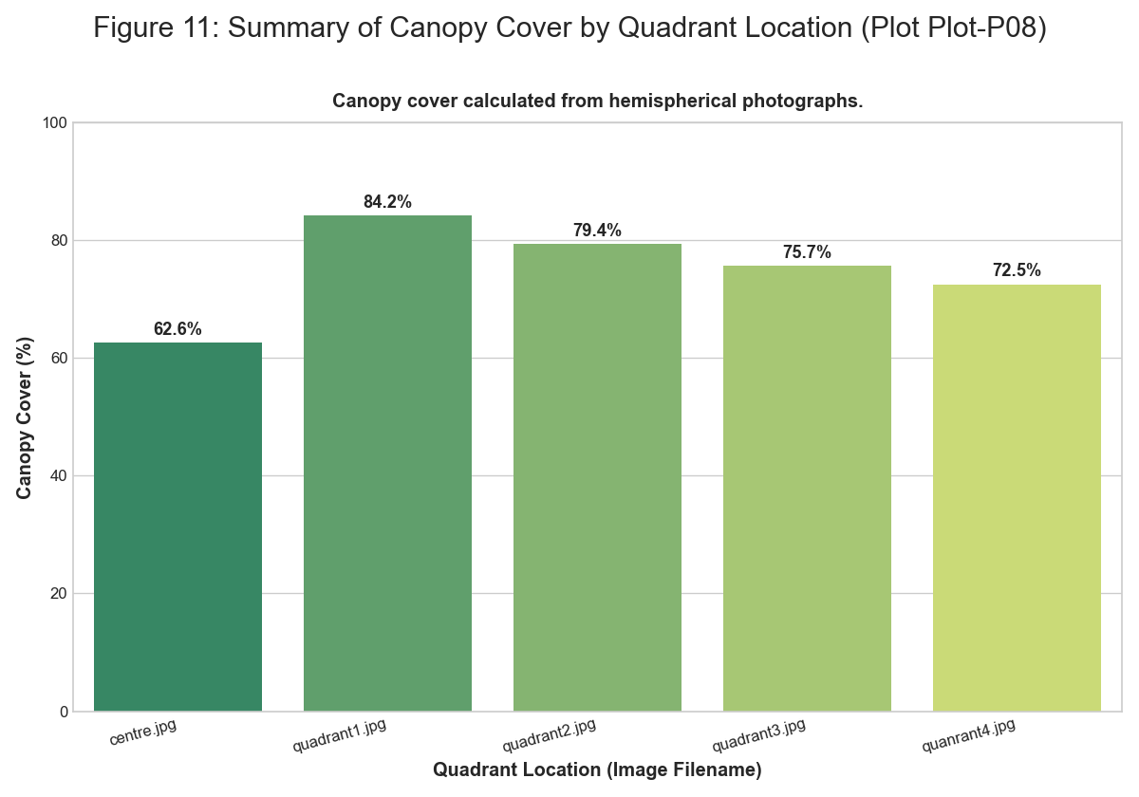 *Figure: figure 11 summary of canopy cover*

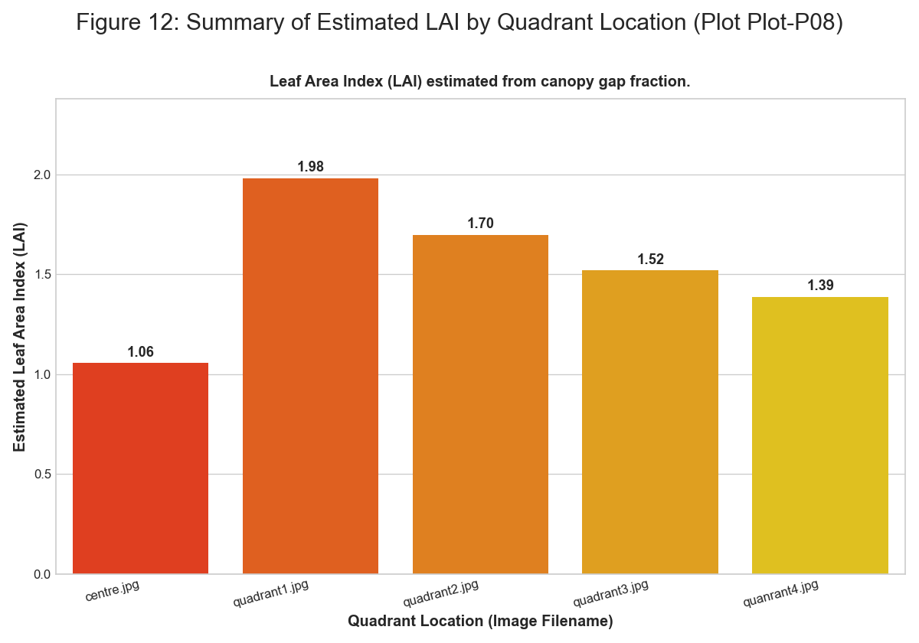 *Figure: figure 12 summary of estimated lai*

### Plot-P09

**Summary Statistics** | Quadrant | Type | Number | Species | |:———–|:———-|———:|:——————-| | Q1 | Tree | 1 | Mangifera indica | | Q3 | Tree | 1 | Ficus religiosa | | Q1 | Herb | 40 | Mixed Herbs | | Q1 | Grass | 25 | Mixed Grasses | | Q1 | Litter | 18 | Decomposing Matter | | Q1 | Bare Soil | 17 | Bare Ground | | Q2 | Herb | 45 | Mixed Herbs | | Q2 | Grass | 30 | Mixed Grasses | | Q2 | Litter | 55 | Decomposing Matter | | Q2 | Bare Soil | 10 | Bare Ground | | Q3 | Herb | 15 | Mixed Herbs | | Q3 | Grass | 10 | Mixed Grasses | | Q3 | Litter | 36 | Decomposing Matter | | Q3 | Bare Soil | 47 | Bare Ground | | Q4 | Herb | 20 | Mixed Herbs | | Q4 | Grass | 19 | Mixed Grasses | | Q4 | Litter | 54 | Decomposing Matter | | Q4 | Bare Soil | 18 | Bare Ground |

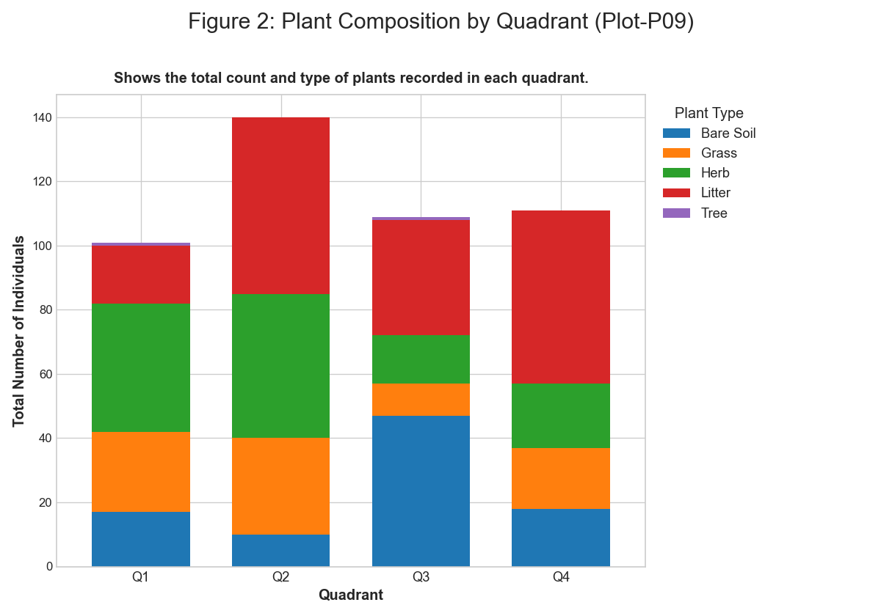 *Figure: figure 2 plant composition by quadrant*

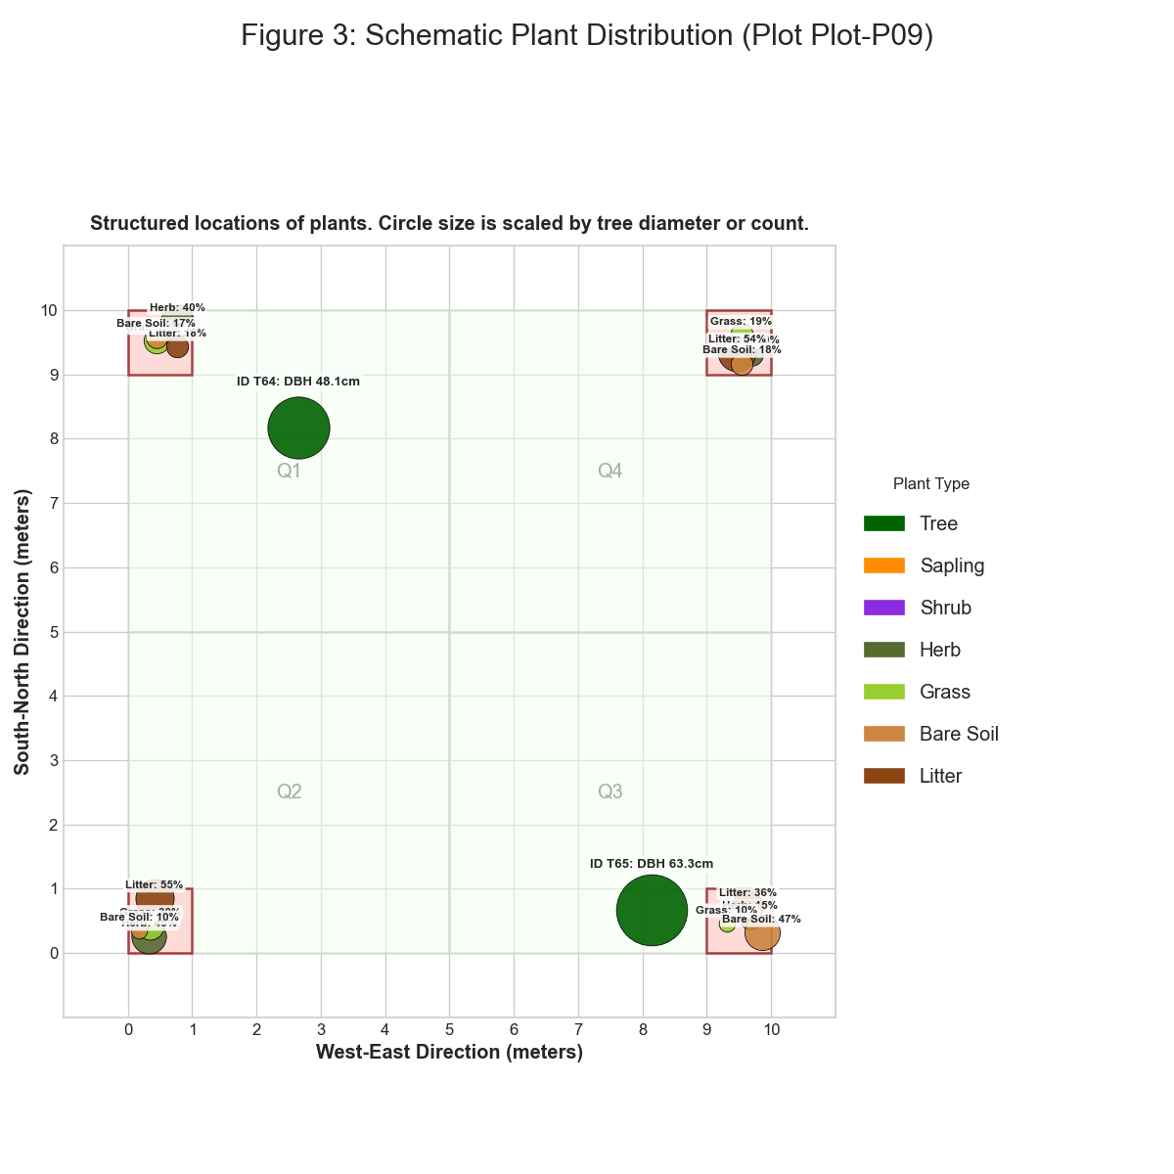 *Figure: figure 3 schematic plant distribution*

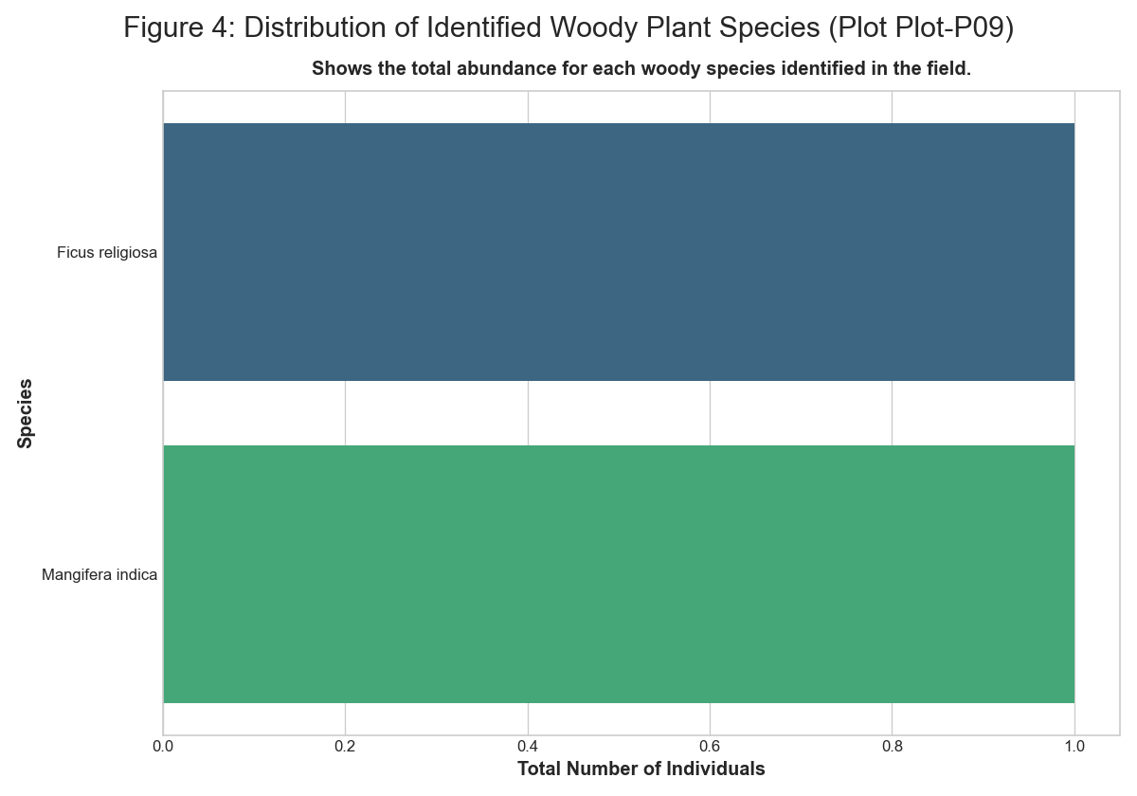 *Figure: figure 4 distribution of identified plant species*

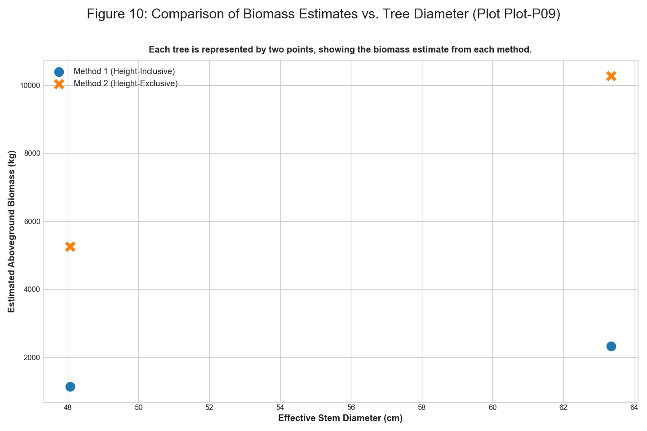 *Figure: figure 10 comparison of biomass estimates vs tree diameter*

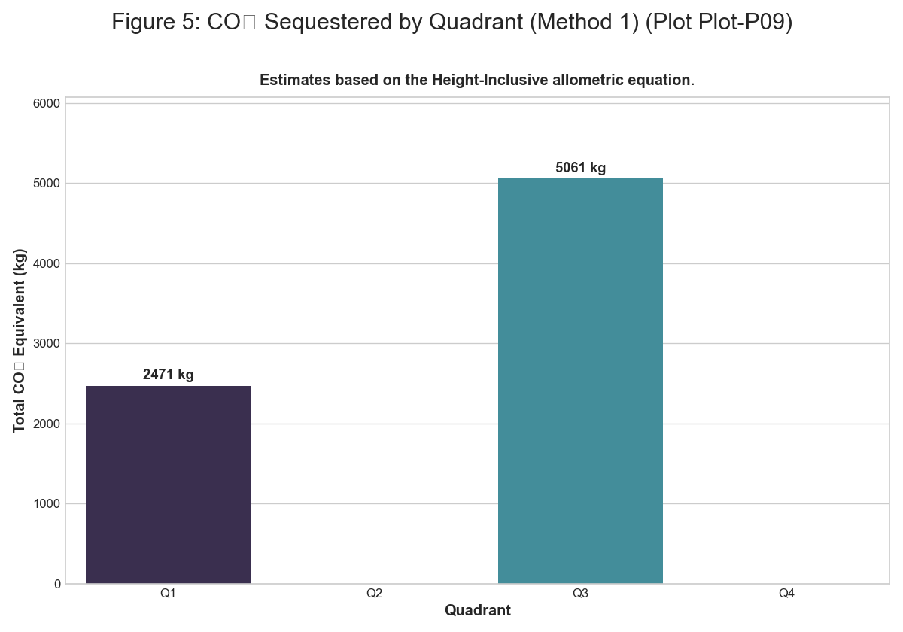 *Figure: figure 5 co2 sequestered by quadrant m1*

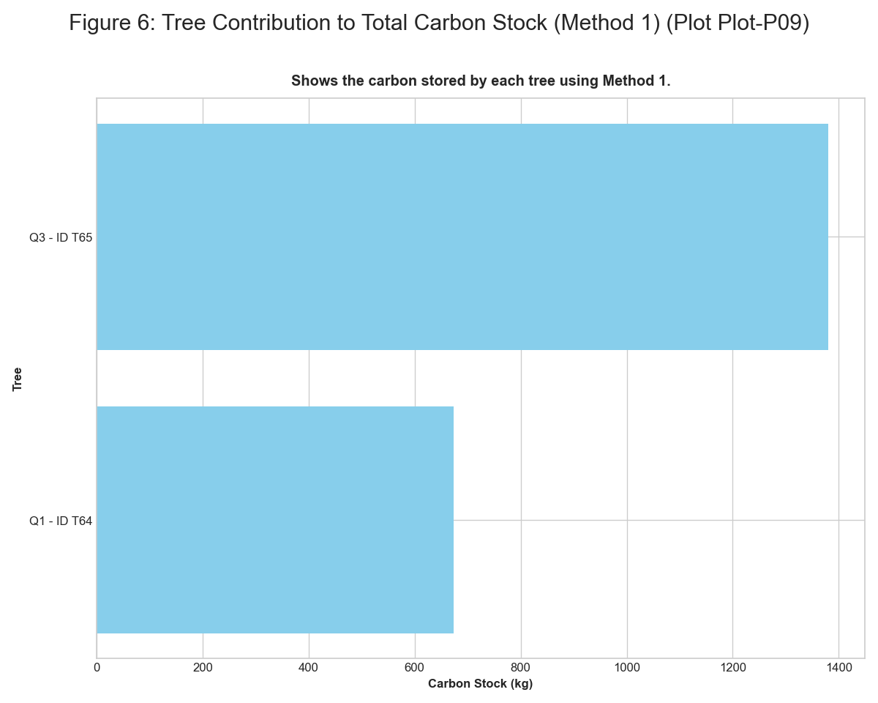 *Figure: figure 6 tree contribution to carbon stock m1*

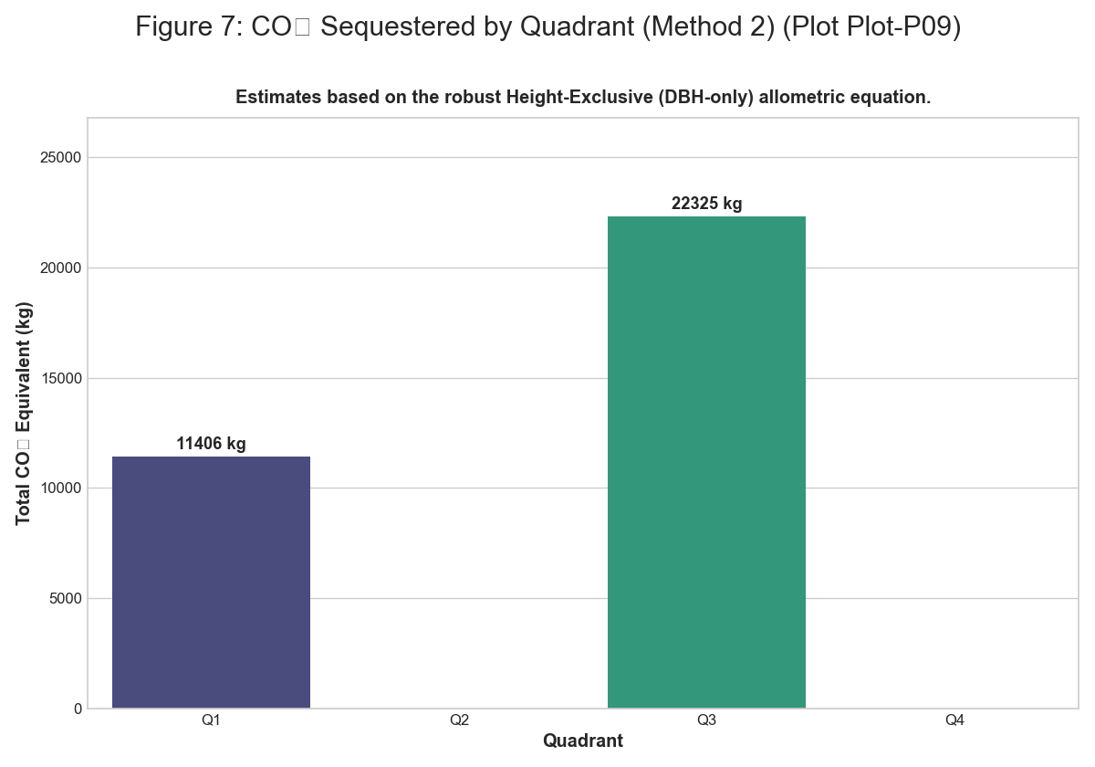 *Figure: figure 7 co2 sequestered by quadrant m2*

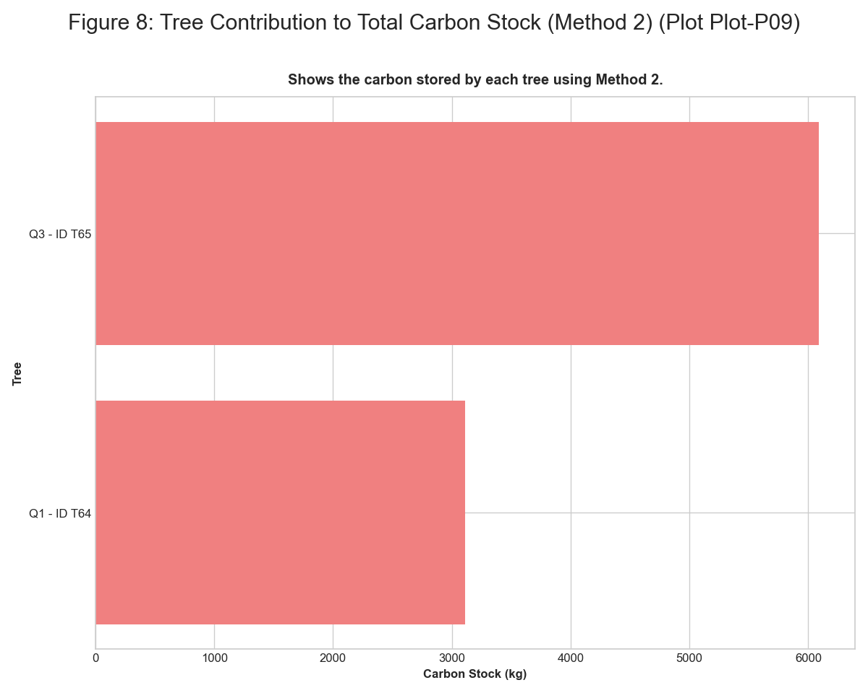 *Figure: figure 8 tree contribution to carbon stock m2*

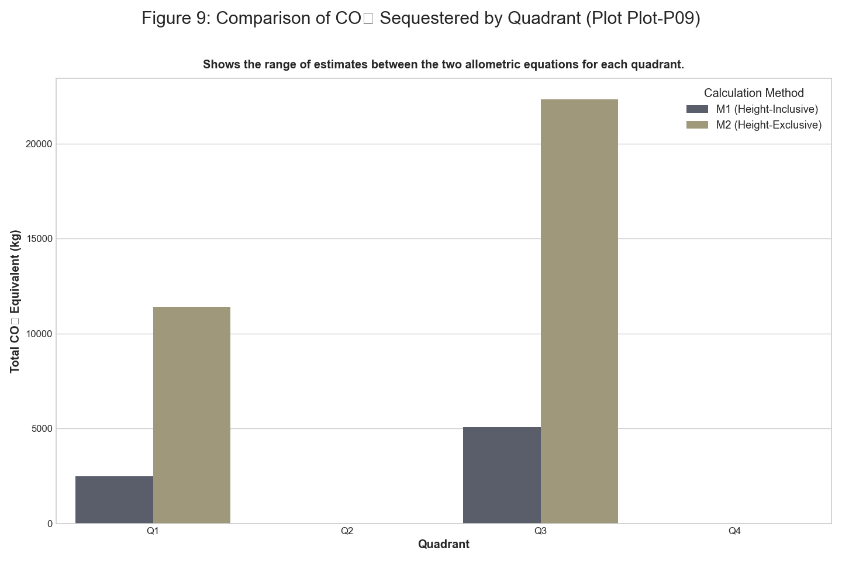 *Figure: figure 9 comparison of co2 sequestered by quadrant*

## 4. Conclusion

This report provides a detailed analysis of the vegetation structure and carbon sequestration potential of the surveyed plots. The plot-by-plot breakdown of results allows for a granular understanding of the ecological variations within the study area. The findings can be a valuable resource for monitoring vegetation health, assessing carbon stocks, and making informed decisions for sustainable land management.

Further research could involve:

* Long-term monitoring of the plots to track changes in vegetation dynamics.
* Inclusion of below-ground biomass for a more complete carbon stock assessment.
* Correlation of the findings with other environmental factors such as soil type and microclimate.